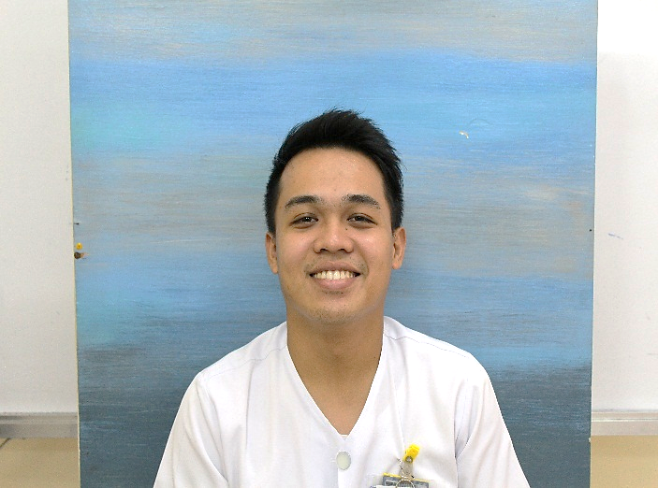
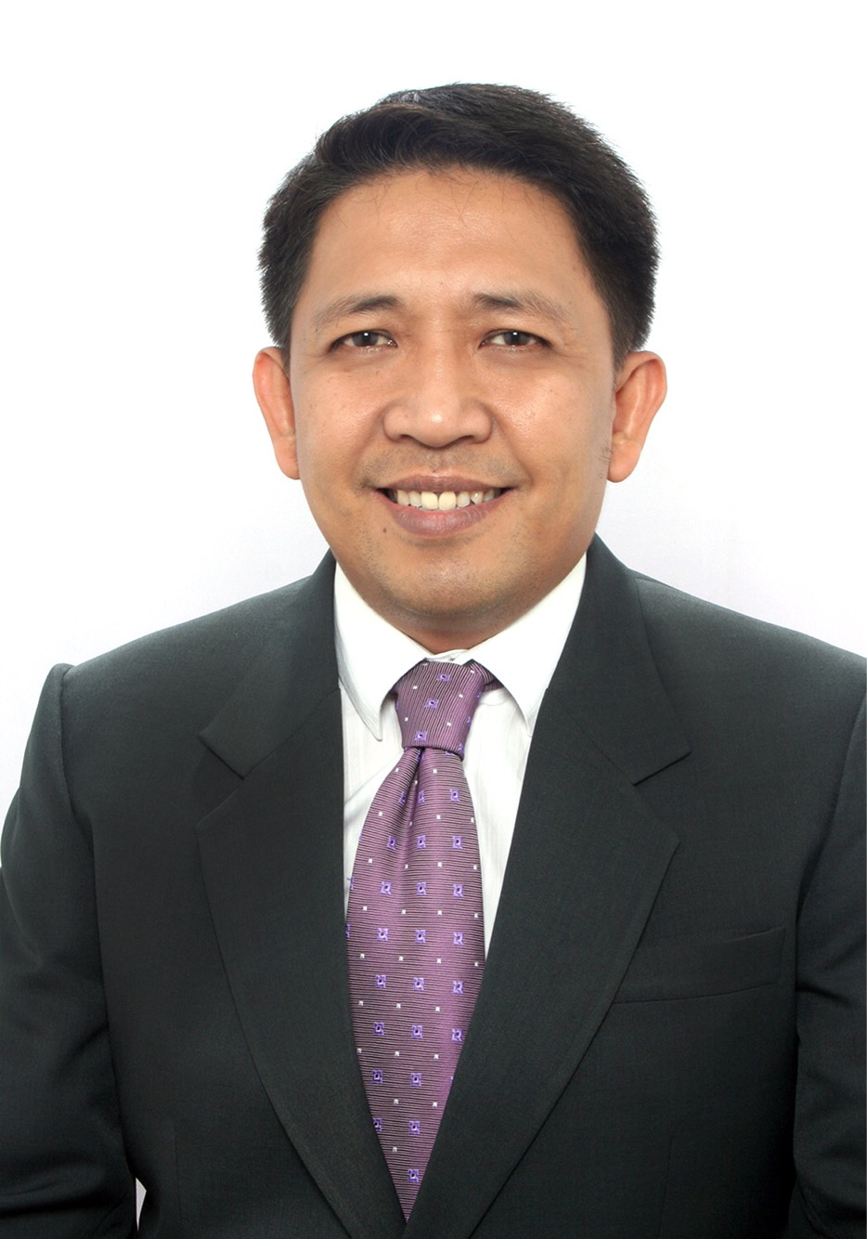
RAYMOND G. CERVANTES, RN

RODOLFO C. BORROMEO, RN, Ed.D.

Title: CAMP- ME (Collaborative Assembly of Managers Proactively Moved by Engagement) as an Effective Strategy in Raising Delegation, Teamwork and Collaboration

Principal Investigator’s Name: Rodolfo C. Borromeo, RN. Ed.D.
Co-Investigator’s Name: Raymond G. Cervantes, RN.
San Juan De Dios Educational Foundation Inc. - Hospital, 2772 Roxas Boulevard, Pasay City, Manila

The potencies and ascendancies in utilizing practical strategies to empower nursing leaders in facing the realities of the nursing profession are paramount to the challenges of the 21st century. In San Juan De Dios Educational Foundation Inc. (Hospital), the Nursing Service Division implemented the CAMP-ME, which proactively transformed the mind-set of the nurse managers’ towards teamwork and collaborative engagements and their delegation capacities. This study determined the association of the nurse managers’ teamwork and collaborative engagements and their preparedness to delegate. This study utilized the quantitative descriptive-correlational research design. Convenience sampling was used in this study. All 126 Staff Nurses evaluated their Charge Nurses in the unit; 33 Charge Nurses evaluated their Unit Managers; and 14 Unit Managers evaluated their Section Managers from the 21 nursing units of the hospital. The first part of the survey consisted the dimensions of Collaboration and Teamwork; the second part of the survey was the Nurse Managers’ Preparedness to Delegate (Sub-Scale 1); and the third part was the Nurse Managers’ Preparedness to Delegate (Sub-Scale 2). The extent of the nurse managers’ teamwork and collaborative engagements to take responsibilities were highly effective (x=3.58) and their preparedness to delegate (x=3.47) in the execution of their tasks to achieve specific goals. In terms of the association between the Teamwork and Collaboration and the Nurse Managers’ Preparedness to Delegate (sub-scale 1 and 2), findings revealed that there is significant correlation (p=0.01) between the 2 major parameters.

Biography

Principal Investigator:

Rodolfo C. Borromeo has completed his Doctoral degree, major in Educational Management at the Philippine Women’s University. He is currently the Director of Nursing Service Division of San Juan de Dios Educational Foundation, Inc. – Hospital since 2005. He is also the Vice President of the Association of Nursing Service Administrators of the Philippines (ANSAP) and is a member of the Ethics Committee and Chairman of the Research Committee of the same organization.

Co-Investigator:
Raymond G. Cervantes completed his Bachelor of Science in Nursing from Catanduanes State University and is currently taking his Master’s of Science in Nursing Major in Nursing Administration at Concordia College- Manila. He is also the Unit Manager of the Critical Care Unit of San Juan De Dios Educational Foundation Inc. (Hospital). He is the Committee Chairman of the Proactive Review of Opportunity-Based Enhancements (P.R.O.B.E) Team, previously the Research Team of San Juan De Dios Educational Foundation Inc. (Hospital). He presented a study about the Assessment of Medication and Treatment Administration Barriers: Leading to Monthly
Medication Administration and Treatment Safety Huddle at the Association of Nursing Service Administrators of the Philippines (ANSAP). He has also one poster presentation about the CAMP- ME (Collaborative Assembly of Managers Proactively Moved by Engagement) as an Effective Strategy in Raising Delegation, Teamwork and Collaboration at ANSAP.

Presenting author details
Full name: RAYMOND G. CERVANTES
Contact number: +639274514870
Twitter account: n/a
Linked In account: cervantesraymond92@gmail.com
Session name/ number: Nursing Management
Category: Oral presentation

