49th World Congress on Nursing and Health Care
August 22 – 23, 2018 Singapore

Exploring the experiences of elderly people who are brought to live in shelter homes in Karachi, Pakistan.
Laila Akber Cassum RN, Post RN BScN, MScN, Aga Khan University School of Nursing and Midwifery, Karachi Pakistan.

Abstract
Background: The traditional joint family system in a culturally diverse Pakistani society shows great respect and care for older population by the families and their generations. However, in the recent years the phenomenon of population ageing in Pakistan is rapidly increasing due to demographic shift influencing life expectancy, along with changes in socio-cultural values. This transition has resulted in institutionalization of the elderly as an emerging shelter alternative. The aim of this study was to explore the experiences of the elderly people and to identify the reason which compelled them to reside in these shelter homes. Methods: A qualitative methodology, with a descriptive exploratory design, was adopted for the study. A purposive sample of 14 elderly males and females were selected, from two different shelter homes in Karachi, Pakistan. Semi-structured interviews were audio recorded and transcribed. Content analysis was done to extract the themes and comprehend the data. Results: Content analysis of the data revealed five major themes: circumstances of leaving home, experiences, challenges, coping with challenges, and decision to live in a shelter home. The analysis discovered that the elderly were experiencing lack of physical, psychological, emotional, and financial support from their family and children. It also indicated that migration of children for better career and employment opportunities, entrance of women into the workforce, and insensitive behavior of children, left the senior citizens neglected and helpless. The findings also uncovered the challenges of unemployment and family disputes that the elderly had to face made them dependent, distressed, helpless, and lonely resulting in both their apparently willing and forceful decision to reside in shelter homes. Conclusions: The study indicated the emerging notion of institutionalization of the elderly in Karachi, Pakistan. The findings point to need for further investigation of the identified areas in this study through qualitative and quantitative researches. There is a dire need for increasing public awareness through the social, electronic, and print media, and providing capacity building training to HCPs for the care of the elderly. The lobbying group can act as a catalyst in persuading the government officials for the execution of a policy on retirement, day care centers, and subsidized provision of health services for the betterment of the elderly.

Image
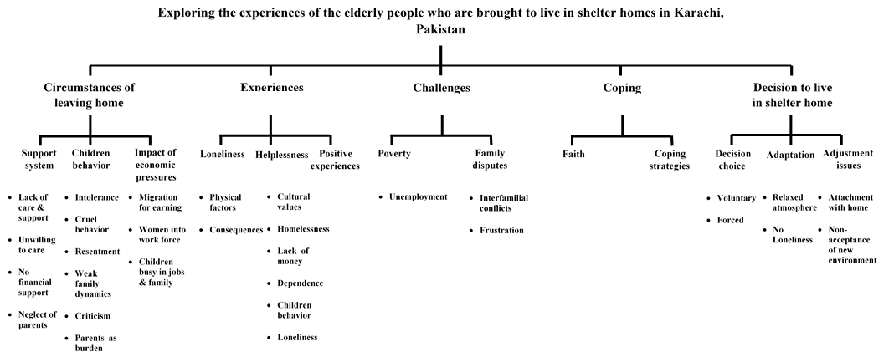
Recent Publication
- Cassum, L.A., Shah, M. (2014). Comparative Assessment of Health Care Delivery
Systems of Developing Countries: Pakistan versus Cuba, International Journal of
Science and Research, 3(8), 984 -990.
- Cassum, L.A. (2014). Elderly Depression in Pakistan: An Emerging Public Health
Challenge. International Journal of Innovative Research and development, 3(5),
698-701.
- Cassum, L.A., Saleem, M.T. (2014). Organizational Analysis of Private Nursing
Educational Institution in Karachi, Pakistan. International Journal of Science and
Research, 3(9), 1404 – 1408.
- Cassum, L.A. (2014). Refusal to Autopsy: A social practice in Pakistani Context.
Journal of Clinical Research and Bioethics, 5(5), 1-4.
- Cassum, L.A. (2014). Verbal Violence at workplace: A reality from Pakistani Context.
Journal of Nursing Education and Practice, 4(8), 20 – 25.

- Asad, N., Karmaliani, R., Somani, R., Hirani, S., Pasha, A., Hirani, S., Cassum, L.,
McFarlane, J. (2013). Preventing Abuse and Trauma to Internally Displaced Children Living in Camps Due to Disasters in Pakistan, Child Care in Practice, 19(3), 267 – 274. DOI: 10.1080/13575279.2013.785936.

- Karmaliani,R.K.,Pasha,A.,Hirani,S.,Somani,R.,Hirani,S.,Asad,N., Cassum, L.A.,
McFarlane, J. (2012). Violence against Women in Pakistan: Contributing Factors
and Interventions, Issues in Mental Health Nursing, 33, 820-826.

Biography 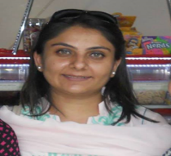

This is Laila Akber Cassum, and working as a Senior Instructor at Aga Khan University School Of Nursing and Midwifery in Karachi Pakistan. I have done my Master’s Of Science in Nursing (MScN) in 2015, Baccalaureate of Science in Nursing (Post RN – BScN) in 2003, and Diploma in Nursing in 1998 from the same institution. I have worked as a Critical Care Nurse (CCN) for three years in Cardiac Intensive Care Unit (CICU) at Aga Khan University Hospital Karachi Pakistan (AKUH). Then, I pursued my career as a Nurse Educator in facilitating the coming generation of students in field of Nursing. I have also worked in the domain of research in the capacity of Research Assistant and then as a Research Coordinator in different research studies. I have completed my undergraduate nursing education with high achievements and awards. I am the author of papers in reputed peer reviewed and indexed journals.

