The Impact of Social Support Network on Self - efficacy of health practices of the Elderly
Fan Wu, PhD candidate, School of Nursing, PUMC, China
Yu Sheng, PhD, School of Nursing, PUMC, China

Abstract (300 word limit)
Statement of the Problem: The relationship between older people's social support networks and health is receiving more and more attention. This study aimed to investigate the impact of social support networks of the elderly on their self-efficacy in health practices. Methodology & Theoretical Orientation: A cross-sectional, descriptive study design was used. Data were obtained in three different cities in China through self-written general information questionnaire, the Lubben Social Network Scale-18, Self-Rated Abilities for Health Practices Scale. Possible relationships among social demographic data, social support network and self-rated abilities for health practices were analyzed by using ANOVA (analysis of variance) and multiple linear regressions. Findings: 492 community-dwellings aged 60 years and older were involved in this study. The exercise self-efficacy of the elderly was affected by the living status (P<0.05), the monthly personal income (P<0.05) and the network of neighbors (P<0.05). Nutritional self-efficacy was influenced by age (P<0.01), gender (P<0.01), disease status (P <0.05), education level (P<0.01), monthly economic income (P<0.01), family relationship network (P<0.01), neighbor relationship network (P<0.05). Self-efficacy of health practice responsibility was influenced by education level (P<0.05), monthly personal income (P<0.01), family relationship network (P<0.01), and friends network (P<0.05). The factors affecting the psychological self-efficacy of the elderly include gender (P<0.01), education level (P<0.05), monthly personal income (P<0.01), living status (P<0.01), friends network (P<0.01). The network of neighbors had a positive effect on self-efficacy such as exercise (β=0.13, P <0.05), nutrition (β=0.13, P<0.05), Psychological Well Being (β=0.12, P<0.05). Family relationships would help improving the self-efficacy such as nutrition (β=0.17, P<0.01), Responsible Health Practice (β=0.06, P<0.01). Friendship network, on the other hand, contributed more to the self-efficacy of Responsible Health Practice (β=0.05, P<0.05) and Psychological Well Being (β=0.16, P<0.01). Conclusion & Significance: The role of family networks in the health self-efficacy of the elderly is gradually diminishing, while the influence of neighbors has become increasingly prominent. Due to the urbanization and empty nesting in China, friends and neighbors interact more closely with the elderly. Community nursing practice in the future needs to consider making full use of the network of neighbors and friends to promote healthy aging.

Image

Multiple Regression Analysis on Relevant Factors of Health Practice Self - Efficacy
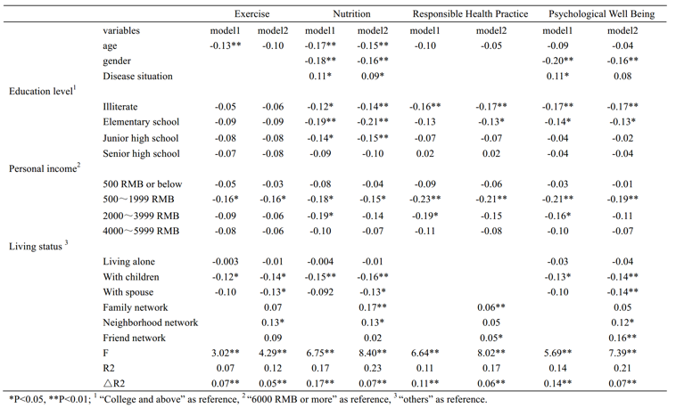
Recent Publications (minimum 5)
- Bélanger, E., Ahmed, T., Vafaei, A., Curcio, C.L., Phillips, S.P., Zunzunegui, M.V., 2016. Sources of social support associated with health and quality of life: a cross-sectional study among Canadian and Latin American older adults. BMJ Open 6 (6), 1-10.
- Li, T., Zhang, Y., 2015. Social network types and the health of older adults: Exploring reciprocal associations. Social Science & Medicine 130, 59-68.
- Lim, J.T., Park, J., Lee, J., Oh, J., Kim, Y., 2013. The Relationship Between the Social Network of Community-living Elders and Their Health-related Quality of Life in Korean Province. Journal of Preventive Medicine & Public Health 46 (1), 28-38.
4. Perkins, J.M., Subramanian, S.V., Christakis, N.A., 2015. Social networks and health: A systematic review of sociocentric network studies in low- and middle-income countries. Social Science & Medicine 125, 60-78.
5. Tsai, A.C., Pierce, C.M., Papachristos, A.V., 2014. From social networks to health: Durkheim after the turn of the millennium. Social Science & Medicine 125 (2015), 1-7.

Biography (150 word limit)
Wu Fan is a PhD candidate from School of Nursing, Peking Union Medical College. She received her bachelor's degree from Huazhong University of Science and Technology. Her specialty is in the field of community nursing in China. In 2017, as a project executive, she completed a project which funded by the Chinese Nurse Association (ZHKY201609). This program focused on the mechanism of social support network’s influence on healthy aging among the elderly in urban communities. She demonstrated the current status of healthy aging in China and explored the changes of social networks of the elderly. Her research will provide the basis for the improvement of Chinese community nursing in the future.
Email: wufan11416@163.com

Notes/Comments: Dr. Yu Sheng is the corresponding author.

