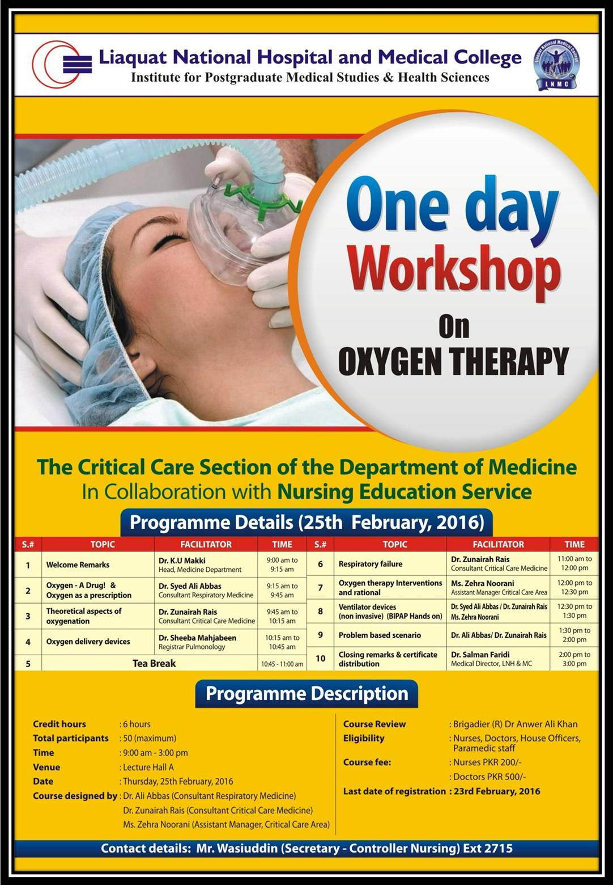
Department of Nursing
“Impact of Continuing Nursing Education (CNE) on Nurses Knowledge and Patient Satisfaction”
A Study in Pakistan’s Tertiary Care Hospital
Author: Ms Zohra Javed, Co author: Brig ® Dr Anwer Ali Khan

Background: Continuous nursing education can build up nursing knowledge and enhance patient satisfaction. For improving in nursing knowledge and practices this educational project was under taken for all staff nurses. The aim of the study is to ensure that nurses have adequate knowledge of nursing practices and thus improves patient satisfaction.

This study was conducted in Liaquat National Hospital & Medical College (LNH& MC), a largest private sector tertiary care hospital in Pakistan.

Objectives
- To assess staff nurses professional knowledge and implement continuous nursing educational module.
- To determine the impact of this module on nurses Knowledge and Patient satisfaction.

Methodology: Pre-test for all 750 nurses were conducted to assess base line knowledge. Class room based teaching organized at Research and skill lab development center and Clinical teaching on their floor was established. 10days CNE Program conduct for 8 months for all nurses in a group of 30.

Results: In pre test 450 nurses has achieved less than 30% scores. In post test 85% of staff was able to achieve more than 50% marks. We have also improved patient satisfaction data, previously it was 20% excellent, 40% good, 30% satisfactory and 10% need improvement and after this project we found 55% excellent, 30% good, 10% Satisfactory and 5% Need Improvement.

Conclusions: After CNE module implementation, we achieved better results in post tests and increase patient satisfaction ratio.

Words Limits: 228
Biography:
Ms. Zohra Javed has completed Masters of Science in Bioethics from The Aga Khan University Hospital in 2014 and Post RN BScN from The Aga Khan University Hospital Pakistan. She is working as a Deputy Manager, Nursing Education Services at Liaquat National Hospital. She published many papers in reputed Journals.
Brig ® Dr Anwer Ali Khan has completed MBBS in 1984 from Dow Medical College. He pursues his MSc in 2005 and then MBA in 2007 and finally competed MHP in 2015. He is working as a controller Nursing Administration at Liaquat National Hospital. He also led team of senior healthcare professional on foreign assignments. He published many papers in reputed Journals.

