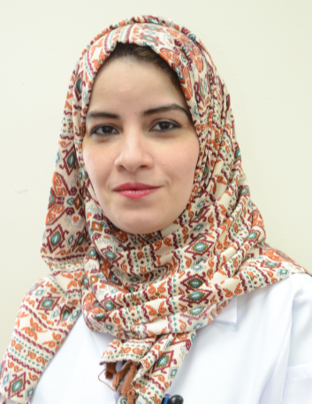

Title: Human Factor future of patient safety culture
Reem Magadmi, MSN, RN, FISQua ˡ ²

ˡ Security Forces Hospital Program Dammam, KSA
² Director of Nursing Services

Abstract
Understanding the science of safety and the core principles of high reliability are first steps in creating a true culture of safety wherein human factor can contribute in the improvement in healthcare delivery. In the world of healthcare, very little training in human factors is provided to staff, unlike the other safety-critical industries. Human factors research examines the environmental, organizational and job factor of human interacting with the system as well as physiological and psychological characteristics that influence behavior at work. Principle of safety science is a commitment to zero harm. Understanding and implementing the best practices can build high reliability organizations a roadmap to achieve exemplary clinical outcome. Topics highlighting several key safety principles including Just Culture, Professional bodies in healthcare organization, a range of human factors such as managerial, team and individual characteristics that influence the behavior of healthcare staff in relation to safe patient care and framework to demonstrate the role of human factors in patient safety and are known to reduce patient harm and improve the safety and quality of patient care. Best practices performed consistently over time have demonstrated superlative outcomes. Developing a model which demonstrated consistent application of leader rounding; hourly purposeful rounding and bedside shift report can influence how patient safety can be possibly achieved. A commitment to zero harm and application of best clinical and safety practices are critical steps in developing a culture of safety in healthcare organizations contributed significantly in reduction of patient harm a compelling reason for nurses in all healthcare settings to embrace safety science and the principles of high reliability.

Biography:
Director of Nursing Services since 2015 up to present and has more than 14 years of experience with Saudi MOH from 2001 till 2015.Established as a bedside nurse and developed her career to be director of nursing service of Dammam Medical Complex with bed capacity 525 and 1400 nurses 2006-2015. Serve as team member National Accreditation body on Saudi Arabia. Graduated from Royal Collage for Surgeon Ireland RCSI with MS in Healthcare Management 2012. She is a Certified CBAHI Nursing Surveyor and Pioneer National surveyor in Saudi Arabia 2007-present. Attended Postgraduate program leadership for change”, this program sponsored by both Saudi MOH and International Council of Nursing ICN. She serves as speaker and regional organizer for this program from 2008 up to 2011. She was certified by Canadian Accreditation Organization as Hospital Surveyor on 2008 and also Certified Hospital Surveyor for American Institute for Healthcare Management 2017 and Certified by IsQua Fellowship 2018

Presenting author details
Full name: Reem Magadmi
Contact number: +966506648132
Twitter account: N/A
Linked In account: Reem Magadmi
Session name/ number: Patient Safety Factor
Category: Keynote

