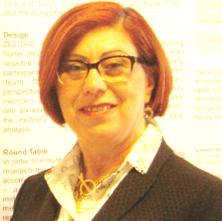
Title: Hospice Care in Israel - via the HMO or Outsourcing?
Authour names : Dr. Yaffa Ein-Gal, Esti Didi, Ayelet Hazan-Tzadik, Dr. Anat Aka Zohar
Affliation : QA Department, Israel Ministry of Health, Jerusalem

National recommendations (2016) for end-of-life care in Israel included palliative care services in the community. The 4 Health Management Organizations (HMO) provide minimal Palliative Care (PC) services in the community, mostly outsourced.
Goals:
1. Determine the quality of care in home-care hospices
2. To define appropriate care procedures in home-care hospices
Methods: A committee of PC experts designed the QA questionnaire which was filled in at 24 hospice units in June - July 2017. The information was collected from: home visits, interviews with staff, patients and their families, and 423 patient records.
Main findings: The general average for compliance to standards was 77.2%. Team Training and Support scored relatively high (82.5%) while scores were lower: Stages of Treatment (79.6%), Quality Control (72.5%) Work Procedures (72.7%) and Care in Unit (66.7%). External Service Providers (ESP) scored an average of 80% compared to 75% for service provided by the HMO.
In admissions to the hospice unit, the patient and his/her family were interviewed in 96% of the cases, but the patient's preferences regarding EOL treatment were documented for just 29.7% of the medical records. Regarding care processes, staff were equipped with immediate-response medication and equipment in just 73.8% of the cases.

Conclusions: EOL treatment procedures should be improved by enabling immediate response to distressing symptoms, and by enhancing continuity of treatment with the patient's previous ward or clinic or with rescue services. The next step is to establish QA of EOL care by the HMOs and clinics in all the districts.

Biography
Dr Yaffa Ein-Gal has worked for over 30 years in the Israel MOH, as a RN, a nursing teacher and as a QA research administrator. Her PhD is on the subject of Advance Directives in EOL care.

Presenting author details
Full name: Dr Yaffa Ein-Gal
Contact number: +972-50-3057431
Twitter account:
Linked In account:
Session name/ number:
Category: Oral presentation
Passport Number: 13717213

