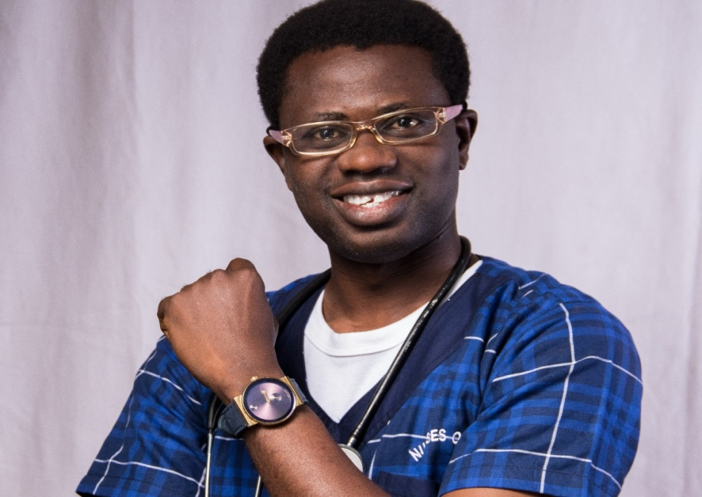
NURSING INNOVATION AND HEALTHCARE: DIGITAL MEDIA INTERVENTION AND STRATEGIES FOR THE 21ST CENTURY NURSE.
By JOSIAH OKESOLA (RN, RPN, BLS, ACLS, DHLM, MNLP)
Director, West African Operations,
Nurses on Air Foundation
Nigeria, West Africa
INTRODUCTION AND ABSTRACT
20 years ago when nursing was being practiced as a 20th century profession, words like E-health, Tele-nursing, scientific research, information technology and digital media wee relatively unknown in some part of the world. Today, we live in the most intriguing times in which digital technology and healthcare innovations are not only changing the pattern of healthcare delivery globally but also influencing the quality of patient centered care and its outcomes.
Nursing is not unaffected by the unprecedented positive changes sweeping through the healthcare systems of nations and impacting healthcare in all practice settings. With the rapidly changing needs of aging populations, increased health burdens of socio economically disadvantaged communities and drug resistant medications; there is currently an urgent need for nurses to become globally recognized as healthcare innovators and solution providers and who can take the lead in transforming the health of families and communities and creating social change.
If nursing must become more indispensably relevant in global healthcare transformation and enhance its brand visibility beyond the clinical settings, the significant role of digital media and technology in changing the narratives for Nurses through media story telling, social media influencing and digital media innovation must begin to get the urgent attention and priority it deserves.
In this presentation, we shall first take a critical self-scrutinizing look at the most recent digitally oriented advancement in nursing and global healthcare. We shall follow up by exploring the phenomenon of digital media technology and the transformational change it can achieve for holistic nursing practice, and then conclude by analyzing the ingenious digital healthcare innovations and media strategies available for raising the status and profile of Nurses across the world as a “Voice to Lead” and a “Force for Change.”
While this submission shall partly focus on the highly innovative inventions being presently utilized by the fastest growing nursing digital media movement in African history; the ultimate purpose of this presentation is to explore highly innovative strategies that can transform Nursing brands across the globe, and empower Nurses to become the most powerful social change agents for families and communities.
This work will excitingly attempt to provide deep insight into the inventive measures, workable tools and innovative strategies available in the digital media world for empowering nurses towards achieving profound impact in communities around the world and advancing Universal Health Coverage and the United Nations Sustainable Development Goals.
The ideology, strategies and processes recommended here for building personal brands for nurses and achieving outstanding impacts as individual, groups and most importantly as national and global brands are universally applicable.
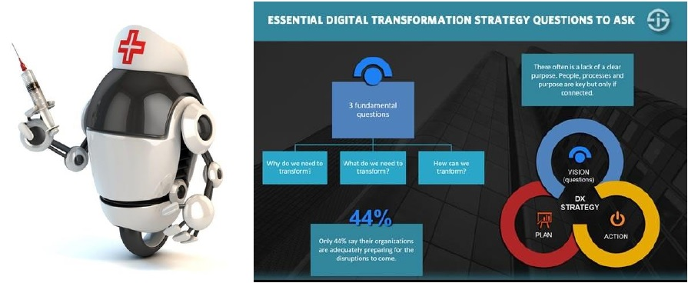
- Paul Flanigan Digital Media in Healthcare Bringing the Patient, the Staff, and the Hospital Together. Vice President – Content Strategy Saddle Ranch Digital 2012 Saddle Ranch Digital
- Vahid Zamanzadeh, Madineh Jasemi, Leila Valizadeh, Brian Keogh, and Fariba Taleghani Effective Factors in Providing Holistic Care: A Qualitative Study May 6, 2015
- Lynn Keegan, RN, PhD, HNC, FAAN Holistic Nursing: A Revolutionary Approach to Improved Patient Care January 1, 2000
- Donnelly, Gloria F. PhD, RN, FAAN, FCPP Media Messages: There's a Pill for Everything! January 2017
- Jackson J, Fraser R, Ash P Social Media and Nurses: Insights for Promoting Health for Individual and Professional Use September 30, 2014

BIO/PROFILE
Josiah Okesola is a licensed professional nurse clinician with specialty in Mental Health.
He holds certifications from the American Heart Association (AHA) in Basic Life Support (BLS) and Advanced Cardiac Life Support (ACLS). He also holds Peer Health Educator from UNICEF; as a Marriage Mentor and Relationship Coach from The Institute of Marriage and Family Affairs (TIMFA, USA); bagged International Award in Delivering Training (IADT) from the London Professional Training Centre; and a Diploma in Leadership in Health & Management from Washington University.
He invented the ‘African Nurses TV’, a first of its kind multilingual, digital media and tele-nursing innovative tool by African nurses. His is currently working with a team of devoted nurses on Nigeria’s first ever news, drama and storytelling project to be anchored by African Nurses – The African Nurses.
He earned an international award from the highest global nursing body, the International Council of Nurses, Geneva, Switzerland in the ICN Wellness Contest.
He was recently awarded a global appointment as the National Coordinator for the Nursing Now Global Campaign in Nigeria, a global campaign powered by the Iinternational Council of Nurses and WHO towards the celebration of the 200th anniversary of Florence Nightingale with the aim of raising the profile and status of nurses around world.
Josiah Okesola currently retired from active Clinical Nursing Practice to focus on Digital Health, Media Branding & Broadcasting, Nursing Career Mentoring & Advocacy, and Family Mental Health Therapy.

Presenting author details
Full name: Josiah Olusegun Okesola
Contact number: +234 908 252 9145
Twitter account: @jayjayprof
Linked In account: Josiah Jackson-Okesola
Session name/number:
Category: (Oral presentation)
Passport Number: A10096677

