The effectiveness of strength training on body composition and physical performances among older people with sarcopenic obesity

Shu-Fang Chang, Professor, National Taipei University of Nursing and Health Sciences, Taiwan.
Shu-Ching Chiu, Instructor, Central Taiwan University of Science and Technology, Taiwan.
Hui Chen Lee, Instructor, National Taipei University of Nursing and Health Sciences, Taiwan.

Abstract
Statement of the Problem: With the coming of aging society, international groups have also developed the name of “sarcopenic obesity” for people with both sarcopenia and obesity. Previous studies showed that, the best method for improving sarcopenic obesity is exercise and nutrition. However, there has not been any study investigating elderly residents in LTC facilities with higher complication.
Purpose: To understand the change in body composition and physical functions of elderly residents with sarcopenic obesity after the implementation of exercise intervention.
Methodology & Theoretical Orientation: This quantitative, interventional study implements exercise intervention in elderly residents. The intervention will be implemented for 3 months. The obesity index and bioelectrical impedance analyzer (BIA) will be used in the pretest to screen the elderly residents with sarcopenic obesity. Afterwards, the elderly residents with sarcopenic obesity are randomized to the experimental group and control group. The study will analysis the variables including body composition index (lean mass, fat percentage and skin fold thickness analysis), the blood analysis (albumin, lipoproteins and cholesterol), body strength and muscular endurance function measurements (grip strength and the arms lift)and a comprehensive daily living activity functions (daily living activities and quality of life).
Findings: Subjects’ attributions and correlation of the body composition index, composed of the body of blood, the performance of muscle strength and muscle endurance and comprehensive daily living functions among the group of sarcopenic obesity were significant.
Conclusion & Significance: The experimental group after the implementation of interventions three months in measurement of body composition and physical function

performance of sarcopenic obesity were improvement. The results could be used as improve the reference plan of intervention in order to improve physical function and quality of life of the elderly people in facilities.

Recent Publications (minimum 5)
- Chang*, S.F. (2017). Frailty as a Predictor of Future Fracture: A Systematic Review and Meta-Analysis. Worldviews on Evidence-Based Nursing (accepted)20160815 (IF:1.762, Rank= 17/116=14.66%，NURSING)
- Chang*, S.F. (2017). Frailty is a major related factor for at risk of malnutrition in community‐dwelling older adults. Journal of Nursing Scholarship, 49(1), 63-72. (IF:2.128, Rank= 7/116=6.03%, NURSING (Nursing (Social Science)); (Nursing (Science)) (Accepted 20160820) DOI: 10.1111/jnu.12258
- Chang*, S.F. & Lin, P.L. (2016). Systematic Literature Review and Meta-analysis of the Association of Sarcopenia with Mortality. Worldviews on Evidence-Based Nursing, 13(2), 153–162. (IF:1.762, Rank= 17/116=14.66%，NURSING). (SCI & SSCI)
- Chang*, S.F. & Wen, G. M. (2016). Association of frail index and quality of life among community-dwelling older adults. Journal of Clinical Nursing, 25(15-16), 2301-2316. (IF:1.384, Rank= 34/116，NURSING) (SCI & SSCI)
- Chang*, S.F. & Lin, P. L. (2016). Prefrailty in community-dwelling older adults is associated with nutrition status. Journal of Clinical Nursing, 25(3-4), 424-433.(IF:1.384, Rank= 34/116=29.31%，NURSING) (SCI & SSCI)

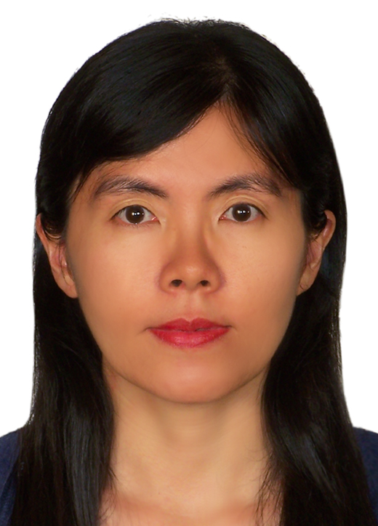Biography (150 word limit)
Shu-Fang Chang Professor, School of Nursing, College of Nursing.National Taipei University of Nursing and Health Sciences. 365 Ming Te Road, Pei-Tou, Taipei, 112, Taiwan, ROC. TEL：886(2)28227101 Ext.3109 E-mail：linda@ntunhs.edu.tw

