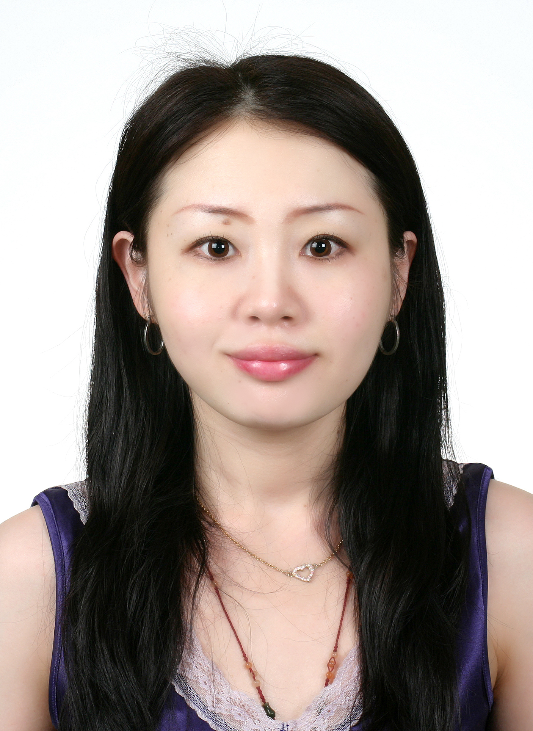

Title:Effects of life album intervention in drug abuse unmarried young woman-a case study

Name: Hui-Ting Tu, Shu-Ming Chen
FooyinUniversity, School of Nursing & Paochien hospital RN, Taiwan
FooyinUniversity, School of Nursing, Kaohsiung, Taiwan

The drug addiction problems care are challenged healthcare provider for decade. The case study described a twenty three year-old drug abuse unmarried woman who suffered from to get rid of drugs and uncetant in future life. The author used the method of life album skills within Ekson's Erikson development stage to take care for patient's psychosocial support. The life album format presented patient's childhood stage and adolescent stage. The life album was used nonverbal skills, time for happiness, favorite person, the most memorable experience. Author also used 5W (Where, When, Who, What, How), method to share the life album after watching the past and now, the future of their own, whether there was a different idea and inspiration is not the same as the new life, willing to play from the heart to get rid of drug addiction, daily review of previous photos, think of family, lead to change the idea, encourage postive life style in the future. The rsults showed that patients described her positive experience about reflection her own life from life ablum. She also look forward to the positive life in the future. The self reflection give her hope and power to face her familes and friends. Finally, she decided to get rid of drugs. In conclusion this study have pointed out the important outcoms that life album skills could help this patient reflection and reset her life.

Biography
Hui-Ting Tu works in nursing department for ten years, hepatobiliary and stomachcare experience for two years, internal, surgical intensive care unit for five years. Currently in the pediatric ward as a nurse teacher. She also study in FooyingUniversity of Nursing for master degree.
Presenting author details
Full name:Hui-Ting Tu
Contact number: 886- 0988239179
Twitter account: j55931199@yahoo.com.tw
Linked In account:None
Session name/ number:None
Category: Poster presentation
Passport Number: None

