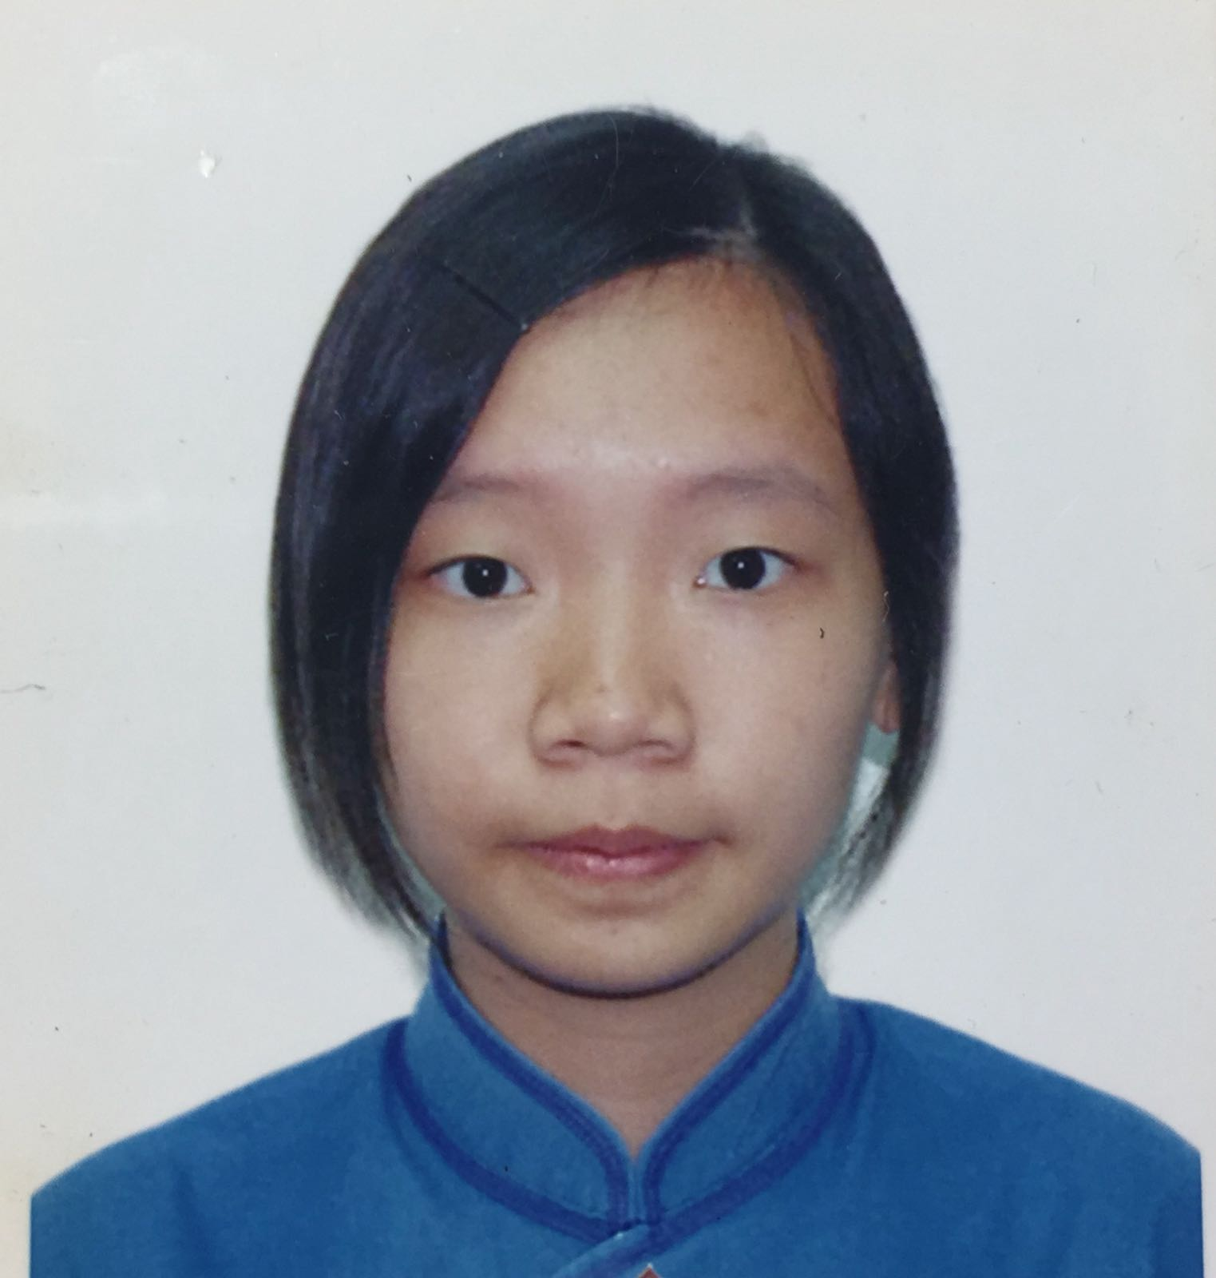
A survey: Knowledge and attitudes towards blood donation between post-secondary students who are taking health-care and non-healthcare related programmes in Hong Kong
Ms.LO Hiu Man, Dr. WONG MF Florence,
Ms. LI Wai Ting, Ms HO Hiu Yan, Ms HO Wing Laam, Ms MOK Ho Yan, Ms POON Chiu Lam Ms.POON Chiu Lam

Tung Wah College, Hong Kong SAR, China

The demand of blood in Hong Kong has been increasing particularly due to ageing and increased prevalence of chronic-illnesses. Hong Kong Red Cross conducted various campaigns to recruit new blood donors and promote blood donation practice for the shortage of blood supply to the needy in hospitals. Knowledge and attitudes towards blood donation practice are crucial and the perception of blood donation can be different between students in healthcare and non-healthcare programmes. This study aimed to examine knowledge and attitudes towards blood donation between healthcare and non-healthcare students. A cross-sectional study was used to achieve the study purpose. The validated questionnaire related to the study topics towards blood donation was used. By March 2017, a total of 45 eligible subjects were recruited including 6 (13.3%) from healthcare programmes and 39 (86.7%) from non-healthcare programmes. The data collection is still in progress. Of 45 subjects, most of them (80%) had no religion. There were 60% of them with no experience of blood donation. The preliminary result showed that the item “fear of seeing blood” was significant difference between healthcare and non-healthcare student groups (t=3.457, p=0.002). The mean (SD) of the item ‘fear of seeing blood” between healthcare and non-healthcare student groups were 4.17 (0.408) and 3.31(1.151) respectively. Based on this preliminary result, strategies to cope with fear of seeing blood may be needed to promote blood donation in this specific age group. Education with psychological support to improve knowledge and attitudes towards blood donation is important to encourage blood donation practice. (250 words)

Biography

Ms. LO Hiu Man is a nursing student studying Bachelor Degree of Health Sciences (Major in Nursing) at Tung Wah College in Hong Kong. Ms. LO Hiu Man is the representative of the group to give the presentation in the conference. Her research interests include blood donation, knowledge and attitudes of undergraduate students.

Presenting author details
Full name: Ms.LO Hiu Man
Contact number: 852-97523102
Twitter account:
Linked In account:
Session name/ number:
Category: Poster presentation

