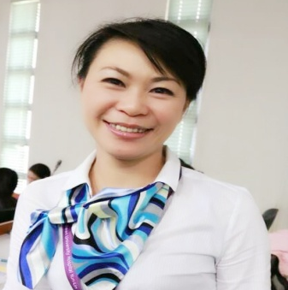
Title:Reducing Rate of Unplanned Extubation of Endotracheal Tube in Intensive Care Unit
Name: Kuo,Ya-Fen
National Taiwan University Hospital Yun-Lin Branch , Taiwan

Reducing Rate of Unplanned Extubation of Endotracheal Tube in Intensive Care Unit: Extubation of endotracheal tube in ICU is one of the dangerous medical accidents.endotracheal tube are the important devices in respirators that sustain the respiration of patients. If endotracheal tubes extubat, patients would immediately under the risk of hypoxia and may extend the inhospitalization time period, which increases medical costs. The incidence rate of extubation of endotracheal tube was 2.3% during January through June in 2016, in order to improve the medical caring quality, programs were designed to collect data and undergo investigations for finding out the reason for the slipping off of the inner tracheal. Team group would be established to stipulate standardized medical caring measures, to edit pocket books, to throw in-service education and training for different units, to audit, and to review and analyze. After implementing measures, effectiveness evaluation was conducted in October and November. The occurance rate for the extubation of endotracheal tube were decreased from 2.3% to 0%. With the setting of standard, educational promotion, and application of management techniques and team resources, colleagues can aggregate consensus for cooperation and notify each other in advance. Discussion after the incidences also promote the communications of the team group.

Biography

Kuo Ya Fen from Taiwan Graduate Institute of Medical Management, China Medical University complete a master's degree, National Taiwan University Hospital Yunlin Branch Medical ICU nurse. She is intensive care unit of a long, rich clinical experience, to care business investment, can encounter problems deep thinking actively seeking solutions, guidance and love of the backward spare no effort in learning benchmark for the nurses, was elected superior nursing head.

Presenting author details
Full name: Kuo Ya Fen
Contact number: +886-9-72655565
Twitter account: P630131@gmail.com
Linked In account: Y00303@ms1.ylh.gov.tw
Session name/ number: 23rd World Nursing & Healthcare conference“Current Challenges and Innovations in Nursing Education and Healthcare”
Category: Poster presentation

