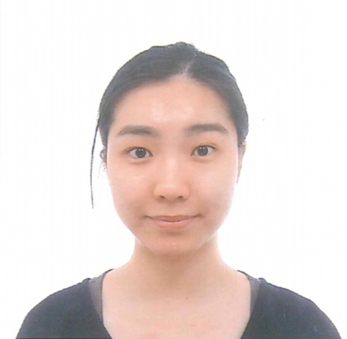
Title: Nurses in street attire: Facilitator of recovery process?
Name: Daniel Bressington, Lok Yan Chu, Tin Wai Chang, Tsz Yuet Dai, Lok Hui, Hei Tung Ip, San Yuet Kwok, Kin Long Ying and Fung Man Chan

School of Nursing, The Hong Kong Polytechnic University, Hong Kong

The Recovery Model has been introduced in Hong Kong since 2010. Recently, the policy of uniform in rehabilitation ward has changed to allow staff wear their own clothes to better fit the Recovery Model. The effects of nursing staff wearing street attire have been under discussion over the past decades in the United States, the United Kingdom and Australia. However, this literature is of limited value to the psychiatric services in Hong Kong, where no related research has been conducted. The aim of the study was to explore Hong Kong mental health nurses’ views about wearing street attire within an in-patient rehabilitation unit in regards to facilitating patients’ recovery process. A qualitative descriptive study method, utilizing individual in-depth semi-structured research interview, was employed in this study. Interview data were content analyzed from the perspective of post-positivism. A total of 11 interviews were conducted with nurse participants. The analysis process initially identified 177 open codes, which were merged into 81 nodes. Finally, 3 main themes and 9 sub-themes were identified. Main themes were ‘building up rapport with patients’, ‘street attire helps deinstitutionalization’ and ‘different approaches to maximize the benefit and to minimize the risk’. A majority of nurse participants positively viewed the policy of wearing street attire in a psychiatric rehabilitation unit, they felt the policy was potentially beneficial to patients’ recovery process. Street attire is not the only key to recovery, nurses are recommended to be aware of their skills in taking care of patients, to further maximize the benefit of the policy.

Biography
Tin Wai was born and raised in Hong Kong. She is a year 5 student of Mental Health Nursing. Last summer, she completed a leadership course and a nutrition course in Alverno College in the US under the student exchange programme offered by the School of Nursing. In 2014, she went to Hui Long Guan Hospital for clinical placement for three weeks in Beijing. In her free times, she likes to have quality chats with her friends, making little improvisation on some songs, reading theological books and playing with her lovely Chinchilla and Scottish Fold.

Presenting author details
Full name: Tin Wai, CHANG
Contact number: +852-60676702
Twitter account: N/A
Linked In account: N/A
Session name/ number: Psychiatric and mental health nursing (Track 4-11)
Category: (Oral presentation/ Poster presentation)

