The effectiveness of different methods for verification of nasogastric/orogastric (NGT/OGT) placement for reducing complications in adult hospitalized patients: a systematic review protocol
Constantin Vintilescu RN, MSN, DNP student
Rutgers, the State University on New Jersey, School of Nursing
By
Constantin Vintilescu
ABSTRACT
Nutritional support is very important for critically ill adult patients. Nasogastric tube (NGT) and Orogastric tube (OGT), are very important for critically ill patients .OGT/NGT can be used for initiation of enteral feeding, medication administration and lavage fluid aspiration. Insertion of the NGT/OGT is done currently as a blind placement at the patient’s bedside. Prior enteral feeding, and medication administration the NGT/OGT placement must be verified. In many health care institutions, placement verification is done through chest x-ray. This method is costly and exposes patients to unnecessary radiological exposure increasing patient’s harm.
There have been many research studies with different methods and technology devices to determine the safest, and less expensive, method for placement verification of nasogastric/ orogastric (NGT/OGT) tube. Insertion of NGT/OGT is a high risk procedure, considering the possible complication of misplacement. The placement of NGT/OGT inserted for enteral feeding require accurate verification for prevention of multiple complications. Even during the insertion, there is a risk of aspiration if patient is vomiting at the time of procedure.
Regardless of the institution, caring for the patients with NGT/OGT, is an important responsibility for nurses, and require many interventions as : carefully insertion of the NGT/OGT, safely removal of it when it is not needed, assessing the correct placement in the stomach, measuring and securing the tubes and, monitoring the patient throughout the process.. Patient outcomes are influenced by nurses’ interventions and management of the nasogastric tube. It is important that nursing care follow the best evidence based practice available. Health care providers are ensuring that all the adult patients with NGT/OGT in critical care are safe, and are receiving evidence based practice care across the country over the course of their illness. However there have been an increased number of incidents and misplacement of NGT/OGT in adult hospitalized patients with serious complications. Registered Nurses around the country value the application of scientific evidence-based practice to guide and improve the quality of healthcare for better outcome.
Recent evidence suggests that official statistics greatly underestimate the occurrence of complications from misplaced nasogastric (NG) tubes, even when detected (Weinberg & Skewes 2006). NGT may be misplaced in the brain, especially in patients with maxillofacial trauma (Pillai et al 2005), or after endoscopic skull base surgery (Hanna et al 2012). Inadvertent placement of a NGT into the brain of a patient with a traumatic defect in the cribriform plate is a problem that has been recognized for decades but reports of this complication still occur (Rahmi et al 2005). Serious complications were associated with the malposition in 14 (28 %) of the patients ; these included eight instances of pneumothorax that required chest tubes and one that required endotracheal tube and intubation, as well as five cases of pneumonia( Taylor, 2014).
There are variety of practices related to the accurate method of verifying the NGT/OGT placement.
The purpose of this systematic review is to conduct a comprehensive research to reconcile the evidence and determine what method for verification of nasogastric/orogastric (NGT/OGT) tube placement reduce complications in adult hospitalized patients.
Inclusion Criteria: This systematic review will incorporate studies related to hospitalized patients who require nasogastric tube for enteral feeding, medication or abdominal decompression. In those patients placement verification of NGT/OGT is very important for patient safety.
Data collection: All project data will be extracted from research studies using a modified Joanna Briggs Institute (JBI) data extraction form
Conclusions & Implications: Cortrak Enteral Access System, is a new electromagnetic tube placement device that could eliminate the need for x-ray placement verification of NGT/OGT. The review of literature research revealed the evidence that support the use of Contrak Enteral Access System (Creel et al, 2007). Cortrak enteral electromagnetic tube feeding is a new practice for NGT/OGT placement verification. The use of an electromagnetic tube placement device, such as Cortrak, is potentially the safest and most efficient practice method in current healthcare practices (Roberts et al, 2007). The Cortrak 2 has FDA clearance to be used in confirming tube tip location in lieu of X-ray.
This, in effect, leads to reduced cost and improved patient safety (Sackett et al, 2007). The research literature suggests that the use of Cortrak enteral electromagnetic tube placement device would be more beneficial than existing practices.
This Cortrak Enteral electromagnetic tube feeding placement device needs to be implemented and standardized in hospital settings. The research shows that twelve aspiration events occurred among 276 patients (prevalence, 4.4%; 95 % confidence interval, 2.2% to 7.6%). In this study the incidence of aspiration as 2.4 % per 1000 tube-feeding days (95% confidence interval, 1.2 to 3.9 per 1000) (Mullan & Roubenoff, 1992). Electromagnetic placement devices have been suggested as a replacement for radiographic confirmation of feeding tube placement at the bedside, although adverse outcomes have been reported, implying that a high level of user expertise may be necessary to obtain consistently positive results (Metheny,2014).

References
Creel, A. M., & Winkler, M. K. (2007). Oral and nasal enteral tube placement errors and complications in a pediatric intensive care unit
Hanna, AS., Grindle, CR., Patel, AA. Rosen, MR., Evans, JJ. (2012). Inadvertent insertion of NGT into the brain stem and spinal cord after endoscopic skull base surgery. American Journal of Otolaryngology; 33(1):178-180

Metheny, N. A., & Meert, K. L. (2014). Effectiveness of an electromagnetic feeding tube placement device in detecting inadvertent respiratory placement. American Journal of Critical Care, 23(3), 240-248. doi:10.4037/ajcc2014954
Mullan, H., Roubenoff, R. A., & Roubenoff, R. (1992). Risk of pulmonary aspiration among patients receiving enteral nutrition support. JPEN.Journal of Parenteral and Enteral Nutrition, 16(2), 160-164.
Pillai, JB., Vegas, A., Brister, S. (2005). Thoracic complications of nasogastric tube: review of the practice. Interactions in Cardiovascular Thoracic Surgery; 4(5):429-433
Rahimi, M., Boroojeny, SB., Moghtaderi, A. et al. (2005). Intracranial placement of a nasogastric tube: a lesson to be re-learnt? Acta Neurochirurgica (Wien); 147:573-574
Roberts, S., Echeverria, P., & Gabriel, S. A. (2007). Devices and techniques for bedside enteral feeding tube placement
Sackett, D. L., Rosenberg, W. M., Gray, J. A., Haynes, R. B., & Richardson, W. S. (2007). Evidence based medicine: What it is and what it isn't. 1996. Clinical Orthopaedics and Related Research, 455, 3-5.
Taylor, SJ. (2014) Cortrak tube placement: Advanced training. Silhouette Publications, UK ISBN: 978-0-9754558-3-2
Weinberg, L., & Skewes, D. (2006). Pneumothorax from intrapleural placement of a nasogastric tube

Biography
Constantin Vintilescu RN, MSN Critical Care nurse in Intensive Care Unit at Veteran Administration Hospital, New Jersey, and Trinitas Regional Medical center .Adjunct faculty instructor in Trinitas Regional Medical Center School of Nursing, Elizabeth, New Jersey. Currently I am a DNP student at Rutgers University School of Nursing Newark, New Jersey. I have published two articles in Nursing Journals.
1. Harold’s Story, in the Student Voice section of Creative Nursing, Volume 19, Issue3, 2013
2. Simulation: A learning Tool for OB Nurses in the Journal of Nursing Practice Applications & Reviews of Research, Vol 3 No 2, July 2013. This was a collaborative study with two of my classmates from Grad School (Monina A. Franco-Tantuico and Luz- Patricia Torres
Author details:
Constantin Vintilescu RN, MSN
Phone: 732-829-7267
Email: costinvintilescu@yahoo.com
Oral and Poster Presentation


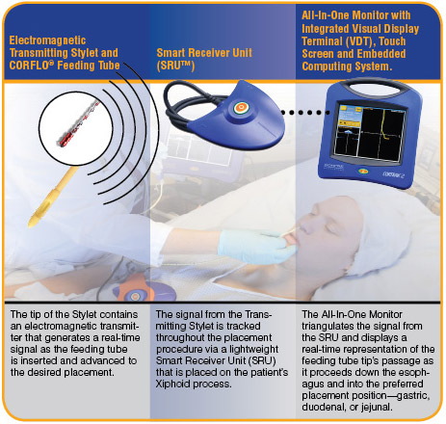
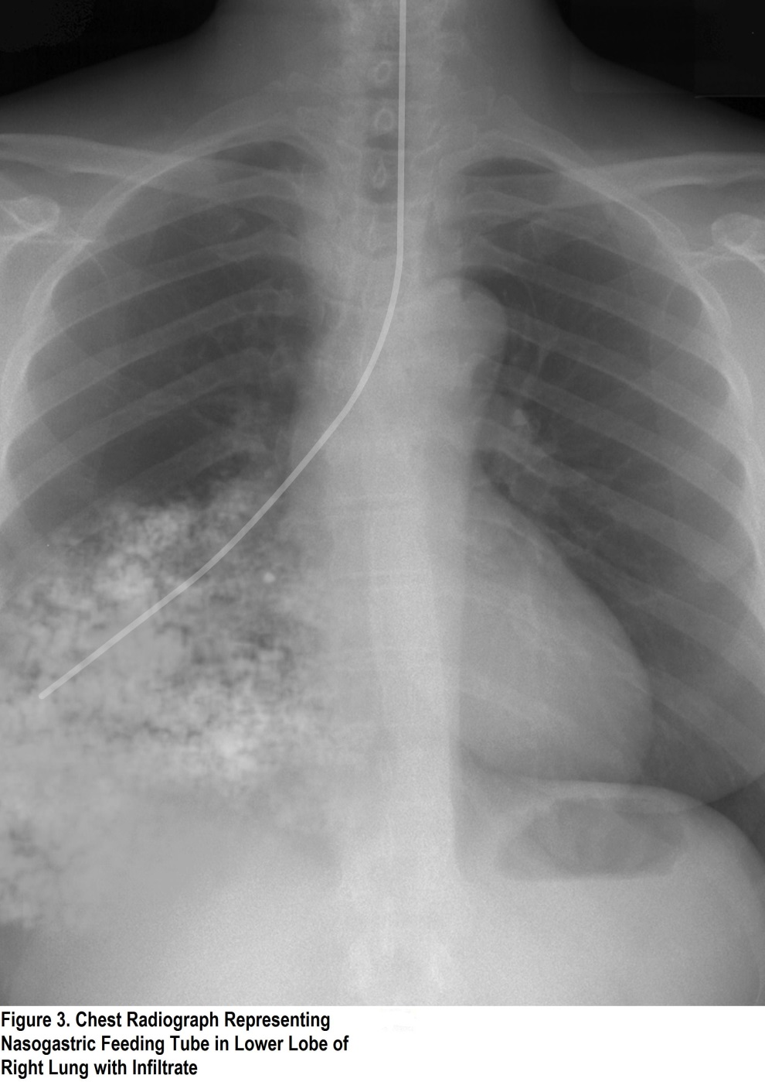
THE EFFECTIVENESS OF DIFFERENT METHODS FOR VERIFICATION OF
NASOGASTRIC/OROGASTRIC (NGT/OGT) PLACEMENT FOR REDUCING
COMPLICATIONS IN ADULT HOSPITALIZED PATIENTS
References
Powers, J., Fischer, MH. Ziemba, Davis, M., Brown, J., & Phillips, DM (2013 November 22). Elimination of radiographic confirmation for small-bowel feeding tubes in critical care. American Journal of Critical Care (6):521-527, doi: 10.4037/ajcc2013755
Roberts, S., Echeverria, P., & Gabriel, S. (2007). Devices and techniques for bedside enteral feeding tube placement .Nutrition in Clinical Practice, 22 (4)
Sparks, DA (2011).Pulmonary complications of 9931 narrow-core nasoenteric tubes during placement; a critical review .JPEN Journal of Parenteral Enteral Nutrition; 35(5):625-629.
Thomson, M. A., Lawson. & Shaw, M. (2007). Best practice with regard to confirmation of nasogastric tube placement. Proceeding of the Nutrition Society 67, doi: 10.1017/S0029665108007490
  - Nasogastric/ Orogastric (NGT/OGT) are commonly used for enteral feeding. The insertion of NGT/OGT is associated with a risk to patient’s safety because is blindly procedure.
  - Complications of NGT/OGT misplacement include malnutrition, pulmonary aspiration, and even death.
  - About 1.9% of feeding tubes are misplaced and commonly lead to pneumothorax (1 in 5) and death (1in 39) (Thomas, Lawson, & Shaw, 2007).
  - Time constraints for nurses
  - Unavailable financial support for new equipment
  - Poor communications
BARRIERS
  - Norma Metheny PhD - The associate dean of research at Saint Louis University School of Nursing was induced in 2014 into the International Nurse Researcher Hall of Fame by the Honor Society of Nursing, Sigma Theta Tau International for her life- saving feeding tube research.
BACKGROUND & HISTORY
Among hospitalized adult patients, which method for verifying NGT/OGT placement reduce complications.
CORTRAK® ENTERAL ACCESS SYSTEM
- The key to maximizing the safety of NGT/OGT feeding is to rule out feeding into the lung and to minimize feeding into the esophagus. A critical step to prevent inadvertent administration of enteral feeding into the broncho-pulmonary tract is reliable confirmation of tube position prior to initiate enteral feeding. There is also the potential for soft tissue trauma caused during incorrect NGT/OGT insertion. A study reports 35(18.7%) incidents of pneumothorax among 187 tube placement with an associated increase in mortality (Sparks, DA et al 2011).
- Technique to improve the accuracy of NGT/OGT feeding tube insertion such as electromagnetic guidance may prevent both pulmonary tree injury and the consequences of NGT/OGT malposition.
Confident Placement without X-Ray
CONCLUSION:

