Title: Predictor Variables of Academic Learning Outcomes among Diploma Nursing Graduates: Towards Program Intervention

Abstract

The research study aimed to identify the degree of learning outcomes of graduated nursing students; learning success is comparatively associated with the passing marks received by the students at the end of the 3 years diploma program. The proponents identified the significant contributions of several employed. Non Academic Factors (Age, Gender, Domicile& Type of Secondary School); leading to the success of the students in terms of their marks obtained in their major nursing courses from year one to three having the Final Comprehensive marks and Overall GPA as outcome predictor.. The Proponents utilized Nursing Students who graduated Batch 2011-2015. Sampling Method will utilized a mixed method approach using Consecutive sampling based on criteria on each batch of Salalah Nursing Institute from 2011-2015 N=161 (Identifying those who passed & tracing their previous academic performance and graduated GNP Program ). For this Correlational prospective design the researcher utilized Retrogressive document analysis. Descriptive statistics was performed. The following are the results and findings of the study demographic profile of the respondents shows that majority of the respondents are of female in gender. In terms of domicile it shows that 72.7 % of the student respondents are residing in rural areas and 27.3 % from urban areas. It can be observed that batch 2015 produced less graduates with 19.9 % a big decline from the previous graduates from 2011-2013. In addition the study showed the frequency distribution and percentage of student dropouts and graduates from year 2011-2015. The result implicates the total number of graduates and dropouts from year 2011-2015 with the exemption of year 2014 which is the pioneering year of the foundation program. The perusal of the study indicates that in this year there were 289 students who joined of the Diploma in Nursing, 161 of which successfully passed with the percentage of 55.7% and a 128 total number of dropouts 44.3% from batch 2011-2015. Batch 2013 yielded the highest percentage of successful completion at 64.70% while Batch 2015 got the highest number of dropouts at 61.5%. It can be observed that there is a notable fluctuation of successful completion from year 2011 to 2015. Thus an observed decline of graduates from batch 2015 shows thirty two (32) 38.5 % which has the largest entry students in the span of five years eighty three (83). Parametric test on correlation of factors age and Overall GPA using Pearson R , the Test results shows significant relation between Age and Overall GPA using the decision criteria on the p value <0.01. The Scrutiny of the statistical result using Pearsons R suggests correlation between type of Secondary School and Overall GPA. Using the decision criteria of a p value <0.01. Results indicate relationship between type of secondary school and overall GPA. The review of the statistical results using Kendall's tau_b and Spearman's rho shows correlation between GPA per year of GNP is significant. Result expresses that year two GPA among any other year predicts and correlates strongly with the Overall GPA, Year 2 performance significantly affects the outcomes of student learning as to the rate and marks they get overall after finishing the General Nursing Program. In conclusion the results of the study shows that majority of the students based the demographic profile are female, single, residing in rural areas and took secondary school in a government run institution. The study showed that the factors such as age, marital status, domicile type of secondary school and year1 to 3 general point averages are factors contributing to the overall learning success. In this study the researcher concludes that the identified large number of dropouts was found among batch 2015.

Image

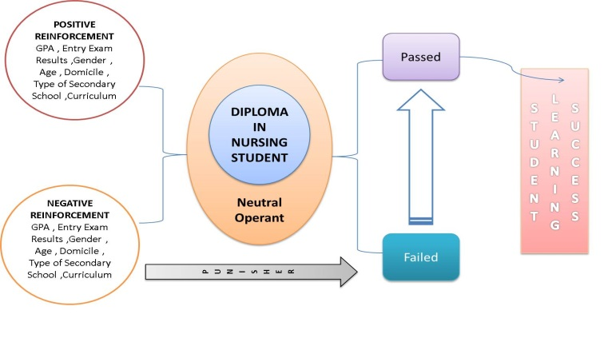
Figure 1.1 Predictor Variables of Academic Learning Outcomes among Diploma Nursing Graduates: Towards Program Intervention

Recent Publications (minimum 5)
1.Valdez G., (2015) , The Filipino Nurses in the Diaspora Contextualizing Workforce Diversity and Cultural Adaptability : A Middle Eastern Perspective .
2.Farhan, M., Valdez.G. (2015) Implications of follow-up nursing care for children with special needs in Dhofar Region : Basis for developing homecare guidelines
3.Valdez G., (2015) The Philippine Registered Nurses in the Diaspora: Contextualizing Educational Preparedness, Competency & Cultural Adaptability a Middle Eastern Perspective. (Dissertation)
4.Valdez G., Farhan M.,Doloolat,Z., Program Intervention Initiatives: Predictor Variables of Dropout and Completion in Salalah Nursing Institute (2014) Ministry of Health , Sultanate of Oman.
5.Valdez G .,Dolloolat Z., Mathews S. (2014) Oman Nursing Training Institutes -Nurse educators’ workplace empowerment, burnout, and job Satisfaction: Testing Kanter’s theory Ministry of Health , Sultanate of Oman

Biography


The author at present is an Assistant Tutor (Assistant Professor) Salalah Nursing Institute,Directorate General for Human Resource Development Ministry of Health Sultanate of Oman. He specializes in Nursing Administration, Leadership and, earned units with his Doctor of Nursing Management from Trinity University of Asia (DNsg.M), and obtained his Doctor of Philosophy in Educational Leadership and Management (PhD.EM)( Meritissimus) from St. Jude College Graduate School, Manila. His research inclination is geared towards Nursing Education, Trans-cultural Nursing ,and Leadership and Management. He has participated in Major Nursing Conferences with Accepted papers as Presenter for Oral /Plenary and Poster in the Philippines, Singapore, Malaysia, Brazil, Oman, South Africa, United Kingdom, United States & Canada. He's experience in the service side includes working as an operating room nurse & field researcher. He held post as Assistant Professor II and chaired various committees and cohort groups in his 10 years of teaching. He received several awards in the academe, practice and teaching. Recently he was recognized as one of the 10 Most Outstanding Filipino Overseas Worker (TOPES) in the Academe awarded by the Philippine embassy in Muscat. Awarded Best Young Researcher at the 6th World Nursing and Healthcare Conference, in London, United Kingdom 2016.

Email:glennfordvaldez@yahoo.com
Website: http://gfdvaldezcarpediem.weebly.com

Notes/Comments:

