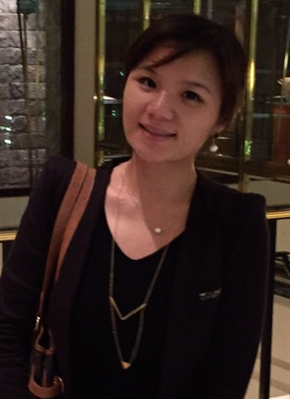
The effectiveness of acupressure for relieving chemotherapy-induced bone marrow suppression
Ya-Wen Shihª, Shun-Fa Yang^{b}, Ming-Hsien Chien^{c}, Ching-Wen Chang^{d}, Hung-Shu Chang^{e}, Hsiu-Ting Tsai^{a,f*}

ªSchool of Nursing, College of Nursing, Taipei Medical University, Taipei, Taiwan.
^{b}Institute of Medicine, Chung Shan Medical University, Taichung, Taiwan
^{c}Graduate Institute of Clinical Medicine, College of Medicine, Taipei Medical University, Taipei, Taiwan
^{d}Department of Obstetrics and Gynecology, Taipei Medical University Hospital, Taipei, Taiwan
^{e}Program for Translational Medicine, College of Medical Science and Technology, Taipei Medical University, Taipei, Taiwan
^{f}Accelerated Bachelor of Science in Nursing, College of Nursing, Taipei Medical University, Taipei, Taiwan

Aim
The purpose of this study was to evaluate the effectiveness of non-invasive acupressure on the prevention and improve of chemotherapy-induced myelosuppression among patients with gynecologic cancer.
Methods
A double-blind, randomised controll trial with total of 28 women underwent chemotherapy were randomly assigned to experimental group (n=10) receiving acupressures on Hegu (LI4), Quchi (LI11); Xuehai (SP10); Sanyin-jiao (SP6), Taixi (K3), Zusanli (ST36), Taichong (LR3); and Baihui (GV20), 5 min each, 3 times a day for 6 weeks; or randomly assigned to control group received usual care (n=18). The blood counts, including WBCs, platelets, and hemoglobin, and the blood levels of SCF and GM-CSF were collected for analysed.
Results
The concentration of blood hemoglobin was significantly decreased from 11.6±2.2mg/dL (Mean±SD) to 10.8 ±1.6mg/dL (P=0.03) in control group after 6 weeks, but there was not a significantly different of hemoglobin concentration before (11.4mg±1.0) and after (10.9mg±1.1) chemotherapy in acupressure group. The levels of SCF were significantly increased before and after chemotherapy in both control group (from1196.10±293.17ng/mL to 1325.05±253.77ng/mL; p=0.01) and acupressure group (from1046.78±469.52ng/mL to 1387.06±310.00ng/mL; p=0.007), and the borderline difference (p=0.05) of increased mean difference of SCF before and after 6 weeks of receiving chemotherapy was found between acupressure group (340.28ng/mL±255.46) and control group (128.94ng/mL±250.64). There was a significantly interaction effect between acupressure and time-dependent manner to increase blood level of SCF when the acupressure was conducted for 6 weeks (β=211.34, p=0.02).
Conclusion
Acupressure is a recommended novel strategy for clinical application to the alleviation of myelosuppression induced by chemotherapy, and the effect was associated with the regulation of expression of stem cell factor (SCF).

Biography
Ya-Wen Shih is a PhD student from Taipei Medical University, Taipei, Taiwan. She completed MSc of Nursing in Queen's University of Belfast, UK. Her professional research focus is on women's health, immunity and cancer.

Presenting author details
Full name: Ya-Wen Shih
Contact number: +886-978-986-938
E-mail: stacy0419@hotmail.com
Category: Poster presentation

