Four stories from yeast: New insights into the toxicities linked with new familial PD mutant forms of alpha-synuclein
Emily Ong, Maiwase Tembo, Paul Jones, Chisomo Mwale, Charles Alvarado, Morgan Marshall, Michael Buabeng, and Shubhik DebBurman
Neuroscience Program and Biology Department,
Lake Forest College, Lake Forest, IL 60045

Abstract
Statement of the Problem: Parkinson’s disease (PD) is associated with the aggregation and misfolding of alpha-synuclein in midbrain dopaminergic neurons. The gene for alpha-synuclein has six known mutations that directly cause familial PD. Three mutations that were discovered first (A30P, E46K, A53T) generate toxicity in ways distinct from each other. Three newer ones (H50Q, G51D, and A53E) are less well studied and are this study’s focus. Methodology & Theoretical Orientation: We expressed H50Q, G51D, and A53E in an unconventional model system, yeast, and hypothesized that each mutant would generate toxicity in distinctive ways, and would be differentially susceptible to two known PD-associated disruptions (nitrative stress and endocytosis). Next, we examined if H50Q, G51D, and A53E are toxic because they lose an original amino acid or gain the mutation, by characterizing substitution mutants for each new mutant that correspond to key functional amino acid classes. Finally, we assessed the loss-of-function impact of other PD-causing/risk genes on these new mutants. Findings: First, H50Q, G51D, and A53E exhibited properties distinct from each other; H50Q and A53E associated with membranes at different rates and were toxic to yeast, while G51D was surprisingly not. Second, G51D dominated over the two new mutants, when combined with them. Third, both the loss of the original amino acid and the gain of the new mutation contributed to each mutant’s toxicity. Finally, defective endocytosis, nitrative stress, and loss of key PD-associated genes each added to the toxicity of the three mutants, but to different extents. Conclusion & Significance: Each new familial PD mutant is toxic in a distinctive way: G51D is unexpectedly protective and shows toxicity only under high nitrative stress. Collectively, this work adds insight into the pathogenicity of different familial PD mutants of alpha-synuclein and further strengthens yeast as a powerful model system for understanding PD.

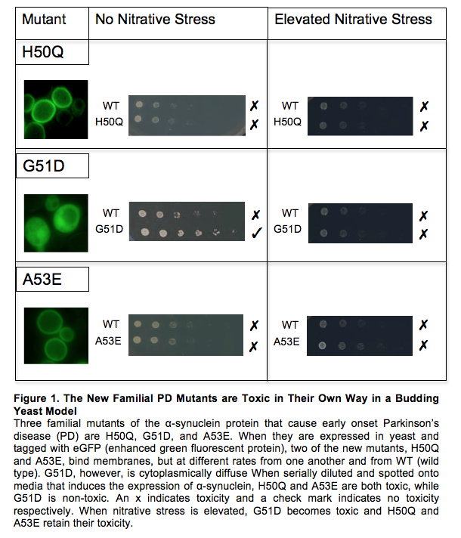
Recent Publications
1. Chi YC, Armstrong GS, Jones, DNM, Eisenmesser EZ, Liu C (2014). Residue histidine 50 plays a key role in protecting a-Synuclein from aggregation at physiological pH. Journal of biological chemistry 289: 15474-15481.
2. Chung CY, Khurana V, Auluck PK, Tardiff DF, Mazzulli JR, Soldner F, Baru V, Lou Y, Freyzon Y, Cho S et al. (2013). Identification and rescue of a-synuclein toxicity in Parkinson patient-derived neurons. Science 342: 983-987.
3. Lesage S, Anheim M, Letournel F, Bousset L, Honoré A, Rozas N, Pieri L, Madiona K, Durr A, Melki R et al. (2013). G51D α-synuclein mutation causes a novel Parkinsonian- pyramidal syndrome. Annals of Neurology 73: 459-471.
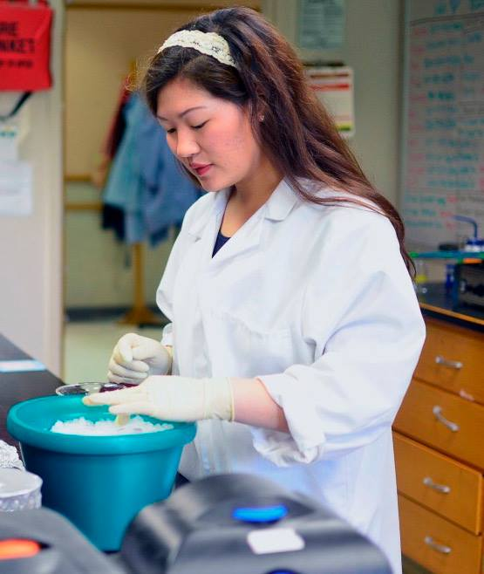
4. Pasanen P, Myllykangas L, Siitonen M, Raunio A, Kaakkola S, Lyytinen, J, Tienari PJ, Poyhonen M, Paetau A (2014). Novel a-synuclein mutation A53E associated with atypical multiple system atrophy and Parkinson’s disease-type pathology. Neurobiology of Aging 35: 2180- 2185.
5. Proukakis C, Houlden H, Schapira AH (2013). Somatic alpha-synuclein mutations in Parkinson's disease: hypothesis and preliminary data. Movement Disorders 28: 705-712.

Biography
Emily Ong started her research on Parkinson’s two years ago in Dr. DebBurman’s lab at Lake Forest College where she recently graduated with a B.A. in neuroscience. In 2016, she was chosen as one of fourteen undergraduate/medical students across the country to receive a grant from the Parkinson’s Disease Foundation and she was the only recipient from a small, liberal arts college. Her research culminated in a senior thesis which earned distinction entitled “Understanding the Nature of Toxicity of Parkinson’s Disease associated Familial Mutants (H50Q, G51D, A53E) with Yeast Models.” She plans to pursue medical school after pursuing more biomedical research.
Email: ongen@mx.lakeforest.edu

