The effects of transcranial LED therapy (TCLT) on cerebral blood flow in the elderly women
Afonso SI Salgado, PhD, Salgado Institute of Integral Health
Renato A Zângaro, PhD, Center for Inovation, Thecnology and Education
Rodolfo B Parreira, MSc, Salgado Institute of Integral Health
Ivo I Kerppers, PhD, Universidade Estadual do Centro-Oeste

Abstract (300 word limit)
Statement of the Problem: During aging processes, there is a range of functional changes, where we can highlight the disease related to the central nervous system, such as Alzheimer disease and others forms of dementia. This This study investigated the effects of transcranial light emitting diode (LED) on cerebral blood flow in healthy elderly women analyzed by transcranial Doppler ultrasound (TCD) of the right and left middle cerebral artery and basilar artery. Methodology & Theoretical Orientation: Twenty-five noninstitutionalized elderly women (mean age 72 years old), with a cognitive status >24, were assessed using transcranial Doppler ultrasound on two separate occasions: pre-irradiation and post-transcranial LED therapy (TCLT). Prior to this, they answered two questionnaires: the perceived stress scale and the general health questionnaire. TCLT (627 nm, 70 mW/cm2, 10 J/cm2) was performed at four points of the frontal and parietal region for 30 s each, totaling 120 s two times per week for 4 weeks. Findings: Paired t-test results showed that there was a significant improvement after TCLT with increase in the systolic and diastolic velocity of the left middle cerebral artery (25 and 30 %, respectively) and basilar artery (up to 17 and 25 %), as well as a decrease in the pulsatility index and resistance index values of the three cerebral arteries analyzed (p<0.05). TCD parameters showed improvement in the blood flow on the arteries analyzed. Conclusion & Significance: TCLT promoted a blood and vasomotor behavior of the basilar and middle cerebral arteries in healthy elderly women.
Image
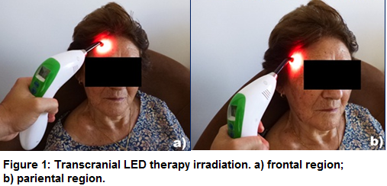
Recent Publications (minimum 5)
- Ball KA, Castello PR, Poyton RO (2011) Low intensity light stimulates nitrite-dependent nitric oxide synthesis but not oxygen consumption by cytochrome c oxidase: implications for phototherapy. J Photochem Photobiol B 102:182–191
- Chen JJ, Rosas HD, Salat DH (2011) Age-associated reductions in
cerebral blood flow are independent from regional atrophy.
- Jagdeo JR, Adams LE, Brody NI, SiegelDM(2012) Transcranial red and near infrared light transmission in a cadaveric model. PLoS One 7:e47460
- Naeser MA, Hamblin MR (2011) Potential for transcranial laser or LED therapy to treat stroke, traumatic brain injury, and neurodegenerative disease. Photomed Laser Surg 29:443–446
- Uozumi Y, Nawashiro H, Sato S, Kawauchi S, Shima K, Kikuchi M (2010) Targeted increase in cerebral blood flow by transcranial nearinfrared laser irradiation. Lasers Surg Med 42:566–576

Biography (150 word limit)
Afonso Salgado is Graduated in Physical therapy. Received his master’s degree Experimental cirgury at UNESP in 2004 and a Ph.D. degree in Biomedical Engineering from de UNICASTELO in 2014. Hi is Head director from Salgado Institute of Integral Health
Email: afonsosisalgado@yahoo.com.br

Notes/Comments:

