Transcranial LED therapy on amyloid-β toxin 25-35 in the hippocampal region of rats
Camila L Eltchechem, PT student
Afonso SI Salgado, PhD, Salgado Institute of Integral Health Renato A Zângaro, PhD, Center for Inovation, Thecnology and Education
Mario CS Pereira, PhD, Universidade Estadual do Centro-Oeste
Ivo I Kerppers, PhD, Universidade Estadual do Centro-Oeste
Rodolfo B Parreira, MSc, Salgado Institute of Integral Health

Abstract (300 word limit)
Statement of the Problem: Excessive Aβ deposition in the brain is associated with the formation of senile plaques, and their diffuse distribution is related to Alzheimer’s disease. The main objective of the present study was to evaluate the effect of PBM treatment on the presence of senile plaques in rats with AD induced by the administration of Aβ25–35 toxin in the hippocampal region and on their spatial memory and behavioral state. Methodology & Theoretical Orientation: Thirty rats (EG) were irradiated with light-emitting diode (photobiomodulation (PBM)) in the frontal region of the skull after being inoculated with the Aβ toxin in the hippocampus; 30 rats were used as the control group (CG). The analysis was conducted at 7, 14, and 21 days after PBM irradiation. PBM (627-nm ; 70 m/W; 7 J/cm2) was stationary positioned in skin contact at the frontal region in the rat’s head. The irradiation was applied once a day for 100 s for 21 days. Findings: We observed a decreased in Aβ deposits in treated animals compared with animals in the CG. The behavioral and motor assessment revealed that the EG group covered a larger ground distance and explored the open field than the CG group on days 14 and 21 (p < 0.05). The EG group was statistically significant in the spatial memory test compared to the CG group on day 14. Conclusion & Significance: The use of PBM significantly reduced the presence of Aβ plaques and improved spatial memory and behavioral and motor skills in treated animals on day 21.
Image
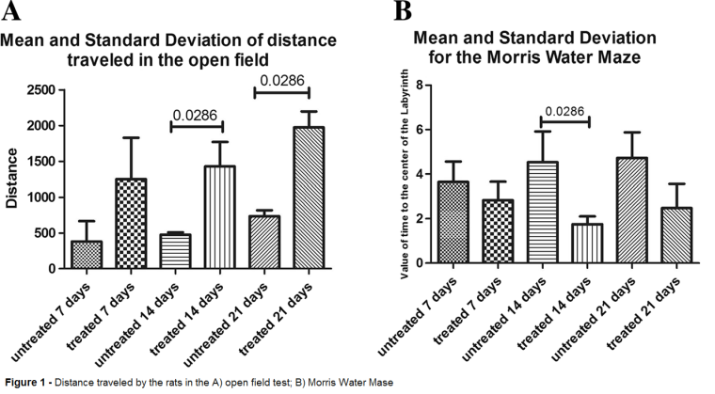
Recent Publications (minimum 5)
- Fisher R, Maier O (2015) Interrelation of oxidative stress and inflammation in neurodegenerative disease: role of TNF. Oxidative Med Cell Longev 2015:610813
- Michalikova S, Ennaceur A, van Rensburg R, et al (2008) Emotional responses and memory performance of middle-aged CD1 mice in a 3D maze: effects of low infrared light. Neurobiol Learn Mem 89:480–488
- Rojas JC, Bruchey AK, Gonzalez-Lima F (2012) Low-level light therapy improves cortical metabolic capacity and memory retention. J Alzheimers Dis 32:741–752
- Sommer AP, Bieschke J, Friedrich RP, et al. (2012) 670 nm laser light and EGCG complementarily reduce amyloid-β aggregates in human neuroblastoma cells: basis for treat
- Zheng H, Koo EH (2011) Biology and pathophysiology of the amyloid precursor protein. Mol Neurodegener 6:27

Biography (150 word limit)
Afonso Salgado is Graduated in Physical therapy. Received his master’s degree Experimental cirgury at UNESP in 2004 and a Ph.D. degree in Biomedical Engineering from de UNICASTELO in 2014. Hi is Head director from Salgado Institute of Integral Health
Email: afonsosisalgado@yahoo.com.br

Notes/Comments:

