Intraventricular neural pathways of the mammalian brain
Thazhumpal Chacko Mathew,
Department of MLS, Faculty of Allied Health Sciences, Kuwait University, Kuwait.

Abstract

Objective: Cerebral ventricles, filled with cerebrospinal fluid, enjoys a unique environment in the mammalian brain. Recent studies indicate that the ventricular surface is another site of neurogenesis in the vertebrate brain. The surface of the third, fourth and lateral cerebral ventricles is covered by supraepndymal cells and an immense net-work of nerve fibers. This study is focused on characterization supraependymal cellular clusters and the nerve fibers present on the ventricular surface of the brain of adult rats.

Methods: Identification and characterization of the intraventricular cellular clusters and nerve fibers in adult rats were carried out using correlative transmission and scanning electron microscopy. Characterization of supraependymal nerve fibers were carried out by immunohistochemical analysis as well as by the intraventricular administration of selective neurotoxins such as 5,7-Dihydroxytryptamine and 6-hydroxy dopamine. Further studies were carried out to understand axotomy induced axonal regeneration of supraependymal nerve fibers of the third ventricular floor.

Results: Electron microscopic studies have shown the presence of catecholaminergic, cholinergic or peptidergic nerve fibers on the ependymal surface of the cerebral ventricles in rat. Studies following the injection of selective neurotoxins into the cerebral ventricles have confirmed the serotonergic, adrenergic and/or dopaminergic nature of these fibers. Immunohistochemical studies revealed the presence of tyrosine hydroxylase positive fibers on the ependymal surface. Labeling studies using the retrograde tracers have suggested that some of these fibers may have originated from the superior cervical ganglia. Profound axonal regeneration of the fibers were observed following axotomy.

Conclusions: The data presented in this study shows the existence of clusters of supraependymal cells and an extensive, novel, intraventricular neural pathway in the vertebrate brain. These fibers are of varied nature and origin. Studies using retrograde neuronal tracers show that at least some of these nerve fibers could be originated from the superior cervical ganglia.
Image

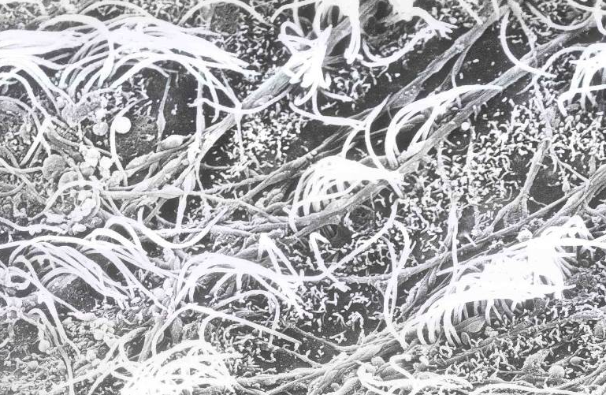

FIG. Scanning electron micrograph showing extensive network of nerve fibers on the ventricular surface of the rat brain.

Recent Publications (minimum 5)
- Mathew TC (2017) Evidences of novel neurogenic niche in the ventricular region of the rat brain. J Cell Sci Ther. 8:1 (Suppl):73.
- Tong et al., (2014) Axonal Control of the Adult Neural Stem Cell Niche. Cell Stem Cell. 3;14(4):500-11.
- Mathew TC (2008) Regional Analysis of the Ependyma of the Third Ventricle of Rat by Light and Electron Microscopy. Anat. Histol. Embryol. 37, 9–18.
- Mathew TC (1999) Regeneration of supraependymal nerve fibers in rat. Journal of Submicroscopic Cytology and Pathology 31 (1): 83-90.
- Mathew TC (1999) Association between supraependymal nerve fibres and the ependymal cilia of the mammalian brain. Anat. Histol. Embryol. 28, 193–197.

Biography
Prof. Mathew completed his PhD from the University of Alberta, Canada in 1992 and obtained FRCPath (UK) in 2003. In 1983, he had undergone a research training at the University of Lund, Sweden. After his postdoctoral studies at the University of Alberta, he worked as Assistant Scientist at NYU, USA. In 1993 he joined the FAHS of Kuwait University. Currently he is Professor and Vice Dean for Research. He was also the Director of the Electron Microscope Unit. He is a member of the international advisory board of the Netter’s atlas of human anatomy. His research is in molecular neurobiology. Prof. Mathew received several awards and published more than 75 papers and attended over 100 conferences.
Email: tcmkwt@gmail.com

Notes/Comments:

