Resting-State Functional Connectivity in Untreated Overt Hyperthyroidism (Graves’ disease) with Mood Disorders

TAHIR MEHMOOD SHAKIR, MA SHAO HUI, MA XUE YING, ZHANG MING

Abstract
Objectives: patients with hyperthyroidism have neuropsychiatric problems such as lack of concentration, depression and anxiety. These symptoms are indication of brain dysfunction. However the process of brain dysfunction is unknown. At the same time, the functional magnetic resonance imaging (fMRI) is important technique to assess the brain function. This study is to understand the functions of brain using fMRI in hyperthyroid patients.
Methods: This study included 15 consecutively referred, newly diagnosed and untreated patients with hyperthyroidism. In addition, 20 healthy age and gender matched control subjects were included. Anxiety was assessed by the Zung SAS, and Zung SDS was used to measure the depression. Image preprocessing was carried out using SPM8 and Metlab. Amplitude of low-frequency fluctuations (ALFF) analyses were performed using REST V1.7 software. For Regions of interest (ROI)-based fear condition (FC) analysis, a seed reference time course was obtained for each ROI by averaging the time series of all voxels in the ROI.
Results: Results of the two-sample t-test showed significant ALFF differences between patients with hyperthyroidism and healthy controls (P < 0.05). Areas showing decreased ALFF values in the patients group included the posterior cingulated gyrus and bilateral inferior parietal gyrus; and increased ALFF values in the right thalamus and bilateral cuneus. Furthermore, correlation analysis demonstrated that there was a significant negative correlation between ALFF values of the left inferior parietal gyrus (P = 0.0021) and the anxiety score in ASA, and a significant negative correlation between ALFF values of the left posterior cingulated gyrus (P = 0.0437). ROI-based FC analysis revealed increased FCs between the left inferior parietal gyrus and left rostral anterior cingulate cortex and bilateral frontal lobe; left posterior cingulated gyrus and bilateral left temporal lobe.
Conclusion: Our study demostrated that brain dyfunction existed in patients with hyperthyroidism and were associated with neuropsychiatric signs and symptoms.
Clinical relevance:
Hyperthyroidism necessitates fMRI imaging to be done. Moreover, fMRI brain should be advised to the hyperthyroid patients with neuromuscular signs and symptoms, and who do not respond to conventional treatment otherwise.
KEY WORDS：Magnetic Resonance Imaging, Resting State Functional MRI, Blood Oxygen Level-dependent (BOLD), Hyperthyroidism, Mood Disorders

Figure

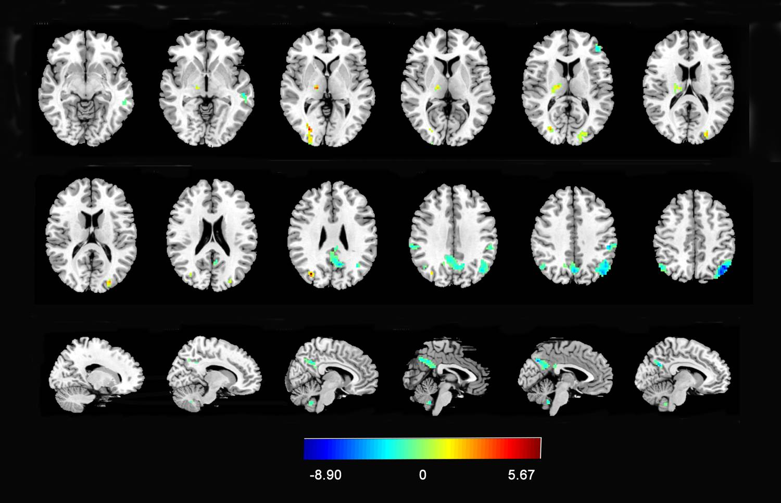
Figure 1：Group differences in ALFF values
References

- Bunevicius, R. & Prange, A., 2010. Thyroid disease and mental disorders: cause and effect or only comorbidity?. July, 23(4), pp. 363-368.
- Lee, I. et al., 2003. Relationship of stressful life events, anxiety and depression to hyperthyroidism in an asian population. Hormone research, 60(5), pp. 247-251.
- Segerstrom, S. C. & Miller, G. E., 2004. Psychological stress and the human immune system: a meta-analytic study of 30 years of inquiry. Psychological bulletin, July, 130(4), pp. 601-630.
- Zhu, D.-F.et al., 2006. fMRI revealed neural substrate for reversible. Brain, pp. 2923-2930.
- Greicius, M. D. et al., 2007. Resting-State Functional Connectivity in Major Depression: Abnormally Increased Contributions from Subgenual Cingulate Cortex and Thalamus. Biological Psychiatry, 1 September, 62(5), pp. 429-437.
- Kim, J.-M.et al., 2010. Thyroid Stimulating Hormone, Cognitive Impairment and Depression in an Older Korean Population. Psychiatry Investigation, December, 7(4), pp. 264-269.

Biography
Tahir Mehmood Shakir is M.D. Resident of Medical Imaging and Nuclear Medicine in The First Affiliated Hospital of Xi’an Jiaotong University, Xi’an, Shaanxi, China. Contact number: +8615029010446 E-mail: dr_tahir81@hotmail.com
Ma Shao Hui is PhD Scholar of Medical Imaging and Nuclear Medicine in The First Affiliated Hospital of Xi’an Jiaotong University, Xi’an, Shaanxi, China.
Ma Xue Ying is PhD Scholar of Medical Imaging and Nuclear Medicine in The First Affiliated Hospital of Xi’an Jiaotong University, Xi’ an, Shaanxi, China.
Zhang Ming is Professor of Medical Imaging and Nuclear Medicine in The First Affiliated Hospital of Xi’an Jiaotong University,Xi’an,Shaanxi,China.

