Delayed-onset MRI findings in acute chorea related to anoxic brain injury
Mehdi Ghasemi, Firas Kaddouh, Anindita Deb, Margaret A. Owegi
Department of Neurology, University of Massachuestts School of Medicine, Worcester, MA 01655, USA.

Abstract
OBJECTIVE. To report a case of acute chorea in anoxic brain injury due to chlordiazepoxide toxicity with delayed MRI findings of bilateral globus pallidus lesions.
BACKGROUND. Anoxic brain injury can manifest with a variety of abnormal movements. Associated damage to basal ganglia can also cause involuntary movements; mostly delayed akinetic-rigid or dystonic syndrome, ballismus and rarely chorea.
METHODS. Case report.
RESULTS. A 32-year-old man with a history of major depression, anxiety, and polysubstance abuse was found unresponsive due to chlordiazepoxide toxicity 5-6 hours after he was last seen normal. He underwent resuscitation for 10 minutes, and required mechanical ventilation for 20 hours before being successfully extubated. Four days later, he was discharged fully recovered. However, 2 hours after discharge, he developed acute-onset of involuntary movements involving both upper and lower extremities and gait instability. A CT head without contrast upon re-admission was unremarkable. MRI brain without contrast 8 days after the unresponsive event was unremarkable. However, repeat MRI brain with and without contrast 15 days after the unresponsiveness event showed T2 hyperintensities and enhancement within the bilateral globus pallidi. He was treated with haloperidol (1 mg 2-3 times daily p.r.n. chorea), sertraline (200 mg/day), and diazepam (5 mg twice a day p.r.n. chorea) while inpatient and discharged home on risperidone (0.5 mg b.i.d). In subsequent follow-up visits over 8 months (with risperidone up-titration to 2 mg b.i.d. and addition of cyclobenzaprine (5 mg b.i.d.), the patient improved significantly with only mild residual chorea and minimal postural tremor.
CONCLUSIONS. Physicians should consider anoxic brain injury in the differential diagnosis of chorea, even several days after the anoxic insult. Radiographic evidence of bilateral basal ganglia lesions may be delayed over a week after the onset of chorea in anoxic brain injury.
Image

Figure 1. Axial DWI (diffusion weighted imaging) brain MRI (A-C) and axial T2 FLAIR MRI sequences (D-F) four days after the onset of chorea (8 days after unresponsiveness event related to chlordiazpoxide toxicity) showing unremarkable results.
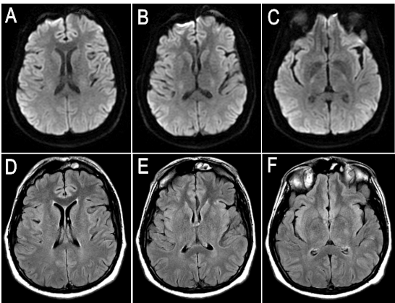

Figure 2. Axial DWI (diffusion weighted imaging) brain MRI (A-C), axial T2 FLAIR MRI (D-F) and T1-postcontrast (G-I) eleven days after onset of chorea (15 days after unresponsiveness event related to chlordiazpoxide toxicity) showing T2 hyperintensities and enhancement within the globus pallidus bilaterally.
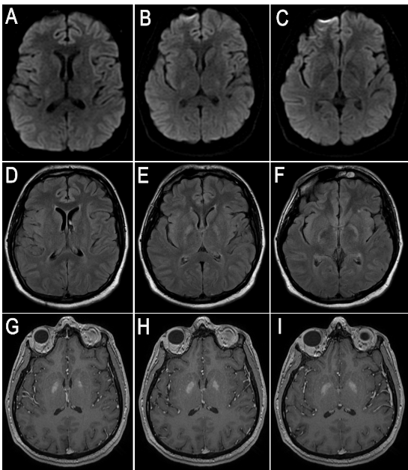
Recent Publications (minimum 5)
- Hawker K, Lang AE. Hypoxic-ischemic damage of the basal ganglia. Case reports and a review of the literature. Movement disorders: official journal of the Movement Disorder Society 1990;5(3):219-24.
- Vila N, Chamorro A. Ballistic movements due to ischemic infarcts after intravenous heroin overdose: report of two cases. Clinical neurology and neurosurgery 1997;99(4):259-62.
- Virmani T, Greene PE, Pearson TS. Delayed onset of progressive chorea after acute basal ganglia injury. Movement disorders : official journal of the Movement Disorder Society 2013;28(5):585-7.
- Pearson J, Baden MB, Richter RW. Neuronal depletion in the globus pallidus of heroin addicts. Drug and alcohol dependence 1976;1(5):349-56.
- Hermann A, Walker RH. Diagnosis and treatment of chorea syndromes. Current neurology and neuroscience reports 2015;15(2):514.

Biography
Dr. Mehdi Ghasemi has completed his M.D. in Tehran University of Medical Sciences (TUMS). After working as a clinical researcher in Dept. of Psychiatry and senior researcher in Dept. of Pharmacology in TUMS, he joined Department of Neurology at Johns Hopkins University School of Medicine as post-doctoral research fellow (2009-2014). He was also the director of Neuroscience Clinical Research Program at Neurology Institute for Brain Health and Fitness between 2012 and 2014. He has published over 60 papers in peer-reviewed journals and 30 abstracts in scientific conferences worldwide. He is currently the chief resident of neurology at University of Massachusetts Medical School. His focus of research is mainly clinical research in general neurology and basic aspects of neurodegenerative disorders.
Email: mehdi.ghasemi@umaessmemorial.org

