Clinical application of magnetic resonance spectroscopy in the diagnosis of atypical meningiomas

P.K. Lamsal, Ma Shao Hui, Ma Xue Ying, Liang F.L., Zhang Ming

Abstract
Statement of the Problem: The main purpose of this study was to evaluate the clinical utility and diagnostic value of Magnetic resonance spectroscopy added to histopathological grades for the diagnosis of atypical meningioma. Methodology & Theoretical Orientation Findings:A retrospective study looking at brain MR spectroscopy examinations done over a period of 2 consecutive years for 29 (male14, female15, age range33-80years) cases of histologically proved meningiomas in the first affilated hospital of xi’an jiaotong university,china.All examination including MR imaging and proton MR spectroscopic imaging were performed on a 3.0-T MR scanner(SignaHDxt;GE Medical Systems,Waukesha,WI,USA). SPSS©v20.0 was used for the analysis.The mean metabolites ratios of (Cho/Cr, Cho/NAA, NAA/Cho and NAA/Cr) were compared between Histopathological grades using Mann-whitney U Test . Wilcoxon signed Rank Test, ANOVA(Tukey Post Hoc Analysis) and Mann-Whitney U Test were used for comparisons of metabolites ratio between intratumoral and peritumoral regions, in grades of edema and various paired groups respectively. statistical significant P<0.05. Conventional MRI is not suitable for histopathological grading of meningiomas,P>0.05. The majority of the cases showed elevated Cho (82.8%),significatly reduced Cr(51.7%) and absent NAA(62.1%) peaks in the intratumoral region. in peritumoral regions NAA ,Cho and Cr peaks were Normal.The Mean of the metabolites of Cho/Cr,Cho/NAA and NAA/Cho were different in intra and peritumoral region,P<0.05 but no significant difference found in NAA/Cr in both regions,P>0.05.There were no significant differences found in Metabolites ratio between WHO Grades of Meningioma,P>0.05.No significant differences found in Metabolites ratio of Grades of edema,P>0.05.No significant differences of metabolites ratio in gender, enhancements patterns of MRI on T1WI with contrast, location of the tumors on the basis of either supratentorial or infratentorial, regular or irregular margin of the tumors, presence or absence of the necrosis , present or absent of the calcification and present or absent of the dural tail sign,P>0.05 . Cho/Cr ratio are higher in meningioma which showed midline shift in cMRI,P<0.05. Cho/NAA ratio are higher in soft meningioma than firm meningioma ,P<0.05. To comparison with the peritumoral region,Mean of the Cho/Cr [5.41±0.99( 5.25)]is higher in the intratumoral region .Conclusion & Significance: MR spectroscopic parameters were unable to distinguish the Histopathological grades of meningioma.Cho/Cr and Cho/NAA ratio were lower and NAA/Cho ratio was higher in the peritumoral region of meningioma .The metabolites ratios were not dependent to degree of edema, gender, locations, regularity of the tumor margins, tumor calcification, necrosis, dural tail sign and enhancement patterns of MRI, however, we found association between Cho/Cr and Cho/NAA ratios in those tumors who had midline shift in cMRI and soft in consistency.
Keywords: Meningioma, Magnetic Resonance Spectroscopy, Choline, N-acetyl aspartate, Creatinine

Figure

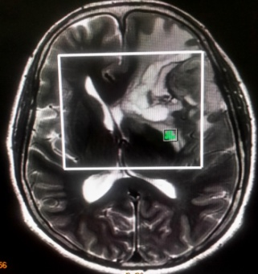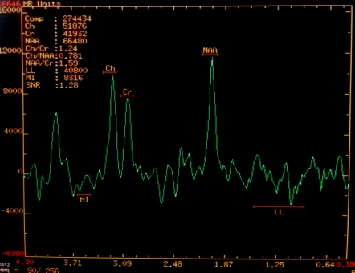
Figure1. The ill-defined mass lesion, seen in the Right-temporal of 49year old female, which shows Hyperintense T2 signal , MRS shows Present of NAA , Choline and Creatine in the edematous region.

Refrences

- Alger J R, Barker P B, Bartha R,et al. Clinical Proton MR Spectroscopy in Central Nervous System[J]. 2014, 270(3).
- García-Figueiras R, Baleato-González S, Padhani A R,et al. Proton magnetic resonance spectroscopy in oncology: The fingerprints of cancer[J]. Diagnostic and Interventional Radiology, 2016, 22(1): 75–89.
- Saito T, Sadoshima J. HHS Public Access[J]. Medical Image Analysis, 2016, 116(8): 1477–1490.
- Bi W L, Zhang M, Wu W W,et al. Meningioma Genomics: Diagnostic, Prognostic, and Therapeutic Applications[J]. Frontiers in Surgery, 2016, 3(6): 1–7.
- Watts J, Box G, Galvin A,et al. Magnetic resonance imaging of meningiomas: A pictorial review[J]. Insights into Imaging, 2014, 5(1): 113–122.
- Oz G, Alger J R J, Barker P B P,et al. Clinical proton MR spectroscopy in central nervous system disorders.[J]. Radiology, 2014, 270(3): 658–79.
- Article O. Magnetic Resonance Spectroscopy and its Usefulness in Brain Tumors[J]. 2013, 9(4): 180–183.

Biography
P.K. Lamsal is M.D. Resident of Medical Imaging and Nuclear Medicine in The First Affiliated Hospital of Xi’an Jiaotong University, Xi’an, Shaanxi, China. Contact number: +8613201577897 e-mail: lamsalpawan@ymail.com
Ma Shao Hui is PhD Scholar of Medical Imaging and Nuclear Medicine in The First Affiliated Hospital of Xi’an Jiaotong University, Xi’an, Shaanxi, China.
Ma Xue Ying is PhD Scholar of Medical Imaging and Nuclear Medicine in The First Affiliated Hospital of Xi’an Jiaotong University, Xi’ an, Shaanxi, China.
Liang F.L. is M.D. Resident of Medical Imaging and Nuclear Medicine in The First Affiliated Hospital of Xi’an Jiaotong University,Xi’an,Shaanxi,China.
Zhang Ming is Professor of Medical Imaging and Nuclear Medicine in The First Affiliated Hospital of Xi’an Jiaotong University,Xi’an,Shaanxi,China.

