The Association of Neutrophil-Lymphocyte Ratio with the 30-day Mortality among Patients with Acute Ischemic Stroke

Euodia P. Guinmapang MD, DPCP
Marietta C. Olaivar MD, FPCP, FPNA
Alexander D. Abe MD, FPCP, FPNA

INTRODUCTION: The role of inflammation in atherosclerosis has been well established over the past years. From a pathological perspective, all stages, ie, initiation, growth, and complication of the atherosclerotic plaque might be considered to be an inflammatory response to injury. The main trend amongst cardiovascular diseases is both primary and secondary prevention. The Neutrophil-Lymphocyte Ratio (NL Ratio) is one of potential early markers that can be correlated to mortality or morbidity with it being a readily available, cost effective a routinely requested laboratory. The primary objective of this study is to determine the association of NL Ratio in the 30-day Mortality among patients with acute hemorrhagic and non-hemorrhagic stroke.

METHODOLOGY: This is a retrospective cohort study which included 228 patients with a first episode Acute Ischemic Stroke (AIS). The demographic and clinical profiles were tabulated including co-morbidities and baseline NIHSS (National Institute Stroke Scale). The baseline NL Ratio was taken from the CBC taken within 24 hours of admission. The diagnosis of Ischemic stroke was based on clinical and imaging studies done. The length of hospital stay, recurrence of stroke and mortality was noted during the course of admission and a period of 30 day follow up records were reviewed.

RESULTS: The group with low NL Ratio (<5.9) had mostly minor to moderate strokes, while those with higher NL Ratio (>5.9) had a similar distribution with a higher proportion for moderate and moderate to severe stroke. The median number of hospital days was longer for the high NL Ratio group. (5 versus 3 days, p = 0.012). There was a greater proportion of mortalities for the high NL Ratio group (31% versus 14%, p = 0.003). On further analysis however, upon comparing the expired and surviving patients, there was insufficient evidence to demonstrate a difference between the two groups. Also, the NIHSS has a more significant correlation to mortality as compared to the NL Ratio.

CONCLUSION: The NL ratio has a direct proportion to patients with non-surviving patients because of its proportion to higher NIHS scale patients. It is cost effective and has the potential to be a short term mortality predictor. Compared to NIHSS however, the association of NL Ratio still lacks the direct correlation to mortality.

The determination of NL ratio invites researchers to further pursue in both acute and chronic cardiovascular diseases which may help in managing our future patients.

Image
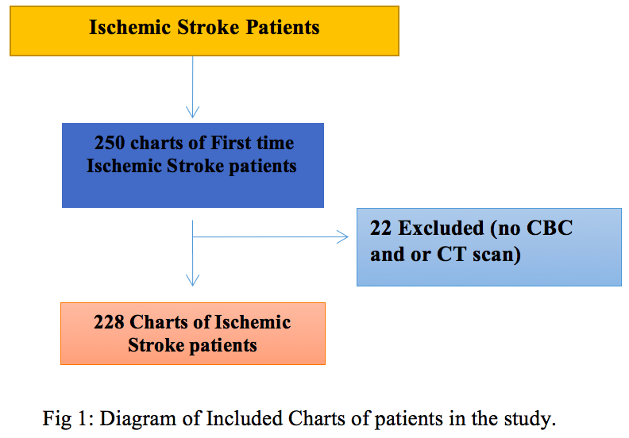
REFERENCES

- S. Gökhan et al; Neutrophil lymphocyte ratios in stroke subtypes and transient ischemic attack. European Review for Medical and Pharmacological Sciences, 2013; 17: 653-657
- Chun Li et al; Predictive value of neutrophil to lymphocyte ratio for mortality in acute cerebral infarction patients Pak. J. Pharm. Sci., Vol.29, No.2(Suppl), March 2016, pp.737-743
Celikbilek et al; Neutrophil to Lymphocyte Ratio Predicts Poor Prognosis in Ischemic Cerebrovascular Disease. Department of Biostatistics and Medical Informatics, Erciyes University, Kayseri, Turkey 27 DEC 2013;DOI: 10.1002/jcla.21639
- Elkind et al, Relative elevation in baseline leukocyte count predicts first cerebral infarction; M.S.V. MS DOI: 10.1212/01.WNL.0000165989.12122.49
- Peng et al, Relationship between white blood cell count at admission and short term outcome in patients with acute cerebral infarction. Clin Inest Med • Vol 34, no 4, August 2011 MS DOI: 10.1212/01.WNL.0000165989.12122.49
- Pearson et al, Markers of Inflammation and Cardiovascular Disease: Application to Clinical and Public Health Practice A Statement for Healthcare Professionals; From the Centers for Disease Control and Prevention and the American Heart Association. Thomas A. American Heart Association, Inc, and the Centers for Disease Control and Prevention. DOI: 10.1161/01.CIR.0000052939.59093.45


Main Author:
Euodia Guinmapang trained in the field of Internal Medicine at Ospital ng Makati located in the Philippines. Her love for medicine drives her passion to pursue her chosen field in the spirit of serving her fellow countrymen. She has also recently passed the Philippine Specialty Board of Internal Medicine (PSBIM) Examination.
Email: docdigui@gmail.com

