Neuroprotection of naringin against cerebral ischemia-reperfusion injury through attenuating reactive nitrogen species-mediated autophagic cell death.

Feng Jinghan, School of Chinese Medicine, LKS Faculty of Medicine, The University of Hong Kong, Hong Kong SAR, China
Shen Jiangang, School of Chinese Medicine, LKS Faculty of Medicine, The University of Hong Kong, Hong Kong SAR, China

Abstract

Aims: Reactive nitrogen species (RNS) largely generate at the reperfusion phase after cerebral ischemia, triggering a series of cascades to exacerbate brain damage. Emerging evidences indicate that RNS are sufficient to induce excessive autophagy under pathological condition. Unlike basal level autophagy, overactivated autophagy can lead to cell death at least partly attributed to energy depletion. In this study, we tested whether naringin, a non-toxic bioflavonoid, could attenuate brain damage by inhibiting RNS-mediated autophagic cell death during cerebral ischemia-reperfusion.

Methods: Middle cerebral artery occlusion (MCAO) for 2 h followed by reperfusion (RP) for 22 h in vivo and oxygen-glucose-deprivation (OGD) for 10 h and reoxygenation (RO) for 14 h in vitro were used to mimic cerebral ischemia-reperfusion injury. The effects of naringin on reducing cell death, decreasing peroxynitrite and autophagy level were investigated.

Results: (1) Naringin reduced SH-SY5Y cell death and decreased superoxide anion, nitric oxide and peroxynitrite level after OGD/RO in vitro. (2) Naringin dose-dependently reduced neurological deficit score, infarct volume and apoptotic cell death compared with vehicle-treated MCAO/RP group in vivo; (3) Naringin decreased nitric oxide level in serum, inhibited NADPH oxidase activity, the expression of p47^{phox} and p67^{phox}, and also reduced inducible nitric oxide synthase and 3-nitrotyrosine level of brains in vivo; (4) Naringin significantly reversed autophagy activation in MCAO/reperfused rat brains, similar to peroxynitrite decomposition catalyst-FeTMPyP.

Conclusion: Naringin might be a promising neuroprotective agent against cerebral ischemia-reperfusion injury and its mechanisms could be at least partially attributed to attenuating RNS-mediated autophagic cell death.

Acknowledgement: This work was supported by Grants of the National Natural Science Foundation of China (31570855).
Image

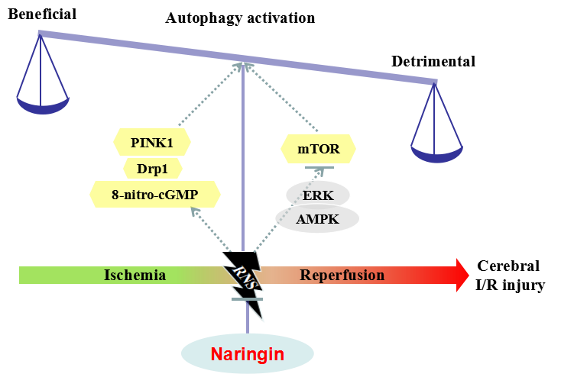

Figure1: The roles of RNS-mediated autophagy activation in ischemic stroke and the potential therapeutic effects of naringin.
Recent Publications
- Feng J, Chen X, Shen J. (2017) Reactive nitrogen species as therapeutic targets for autophagy: implication for ischemic stroke. Expert Opin Ther Targets. 2017 Mar;21(3):305-317.
- Chen H, Chen X, Feng J, Liu K, Qi S, Shen J. Peroxynitrite Decomposition Catalyst Reduces Delayed Thrombolysis-induced Hemorrhagic Transformation in Ischemia-reperfused Rat Brains. CNS Neurosci Ther. 2015 Jul;21(7):585-90.
- Gao L, Chen X, Peng T, Yang D, Wang Q, Lv Z, Shen J. Caveolin-1 protects against hepatic ischemia/reperfusion injury through ameliorating peroxynitrite-mediated cell death. Free Radic Biol Med. 2016 Jun;95:209-15.
- Gao L, Zhou Y, Zhong W, Zhao X, Chen C, Chen X, Gu Y, Chen J, Lv Z, Shen J. Caveolin-1 is essential for protecting against binge drinking-induced liver damage through inhibiting reactive nitrogen species. Hepatology. 2014 Aug;60(2):687-99.
- Gu Y, Chen J, Shen J. Herbal medicines for ischemic stroke: combating inflammation as therapeutic targets. J Neuroimmune Pharmacol. 2014 Jun;9(3):313-39.

 Biography
Feng Jinghan, PhD student from The University of Hong Kong. Her research focuses to explore the roles and in-depth mechanisms of autophagy in ischemic stroke and aims to raise some potential therapeutic targets. Further, she has made a lot efforts to screen some effective natural compounds to regulate autophagic process for better outcomes. She has more than 3 year experiences on establishing rat/mouse middle cerebral artery occlusion model and performing a series of molecular experiments.
Email: jinghanf@hku.hk

