Preventive effects of resveratrol against chemotherapy induced cognitive impairment are associated with the modulation of neuro-inflammation and synaptic plasticity in mice
DD Shi, PhD, School of Chinese Medicine, the University of Hong Kong, Hong Kong, China
CM Dong, Department of Electrical and Electronic Engineering, the University of Hong Kong, Hong Kong, China
LC Ho, Department of Electrical and Electronic Engineering, the University of Hong Kong, Hong Kong, China
EX Wu, Department of Electrical and Electronic Engineering, the University of Hong Kong, Hong Kong, China
Q Li, Department of Psychiatry, the University of Hong Kong, Hong Kong, China
XM Wang, Department of Anesthesiology, the University of Hong Kong, Hong Kong, China
ZJ Zhang, School of Chinese Medicine, the University of Hong Kong, Hong Kong, China

Abstract
Chemotherapy-induced cognitive impairment, often referred to as “chemobrain”, is a potential long-term side effect, clinically manifesting as difficulty in learning and memory, problems with processing speeds and executive function, resulting in reduced quality of life in cancer survivors. Resveratrol is a novel natural agent that may have the potential to improve cognitive performance. In the present study, we first showed that resveratrol has no proliferation effects in the two breast cancer cell lines, MCF-7 and MAD-231 cells. In a separate experiment, female C57 mice were treated with 100 mg/kg resveratrol for 3 weeks. Three injections of chemotherapeutic agents of docetaxel (10 mg/kg), adriamycin (10 mg/kg), and cyclophosphamide (40 mg/kg) (DAC) in combination were given in the middle week at every three days. Following the completion of resveratrol treatment, animals were tested in water maze at Day 1 and with manganese-enhanced magnetic resonance imaging (MEMRI) at Day 8. Resveratrol treatment resulted in significantly longer duration and more number of entry into the target quadrant than DAC-treated animals. Resveratrol also markedly lowered the level of TNF-α and IL-6 in the blood, the whole brain, the prefrontal cortex, and the hippocampus. Resveratrol treatment further increased the intensity of MEMRI in the dentate gyrus, CA1, and CA3 subregions of the hippocampus. The duration and number of entry in water maze were negatively correlated with TNF-α and IL-6 concentration, but positively correlated with MEMRI intensity in several tissues examined. Resveratrol also reversed DAC-induced suppression of the expression of brain derived neurotrophic factor (BDNF), the related receptor tropomyosin receptor kinase B (TrkB) and the N-methyl-D-aspartate receptor (NMDR1) in the prefrontal cortex and the hippocampus. These results indicate that resveratrol can prevent cognitive impairment from chemotherapy probably via regulating neuroinflammation and synaptic plasticity in related brain regions.

Image
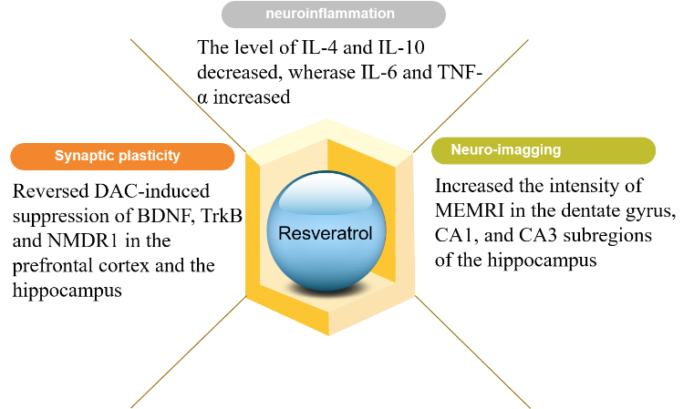
Recent Publications
- Shi DD, Kuang YY, et al（2014）. The mechanism research on lupeol treating on breast cancer cells MCF-7 based on cell metabonomics, Chinese journal of chromatography, 32:278-283.
- Shi DD, Wang GM, et al (2014). Metabonomics study on luteolin intervention of breast cancer MCF-7 cells, Chinese Journal of Analytical Chemistry,42:1088-1093.
- Wang GM, Shi DD, et al. Study on Mechanism of Costunolide-induced Apoptosis in Breast Cancer MCF-7 Cells, Chinese Journal of Analytical Chemistry,43:682-688.
- Peng ZX, Wang Y, Gu X, Shi DD, Yan C. Rapid detection and identification of anti-breast cancer constituents of Dandelion (Taraxacum mongolicum Hand.-Mazz.) using a bioactivity-guided fractionation screening strategy based on serum pharmacology (under review).
- Shi DD, Peng ZX, et al. A bioactivity-guided fractionation screening strategy in the search for anti-breast cancer ingredients from Dandelion based on Urine-pharmacology (under review).

Biography (150 word limit)
Shi Dongdong has experience in analysis and neurobiology. I have many experimental skills. For example, skills about operating analysis instruments: HPLC, UPLC, PCEC. HPLC-ELSD, HPLC-MS, UPLC-MS, etc and statistical analysis; molecular and cellular biology techniques including cell culture, cell viability assay, FACS analysis, PCR, Western blot as well as skills about proteomics and metabonomics; data analysis skills: Data-processing software: SPSS, SigmaPlot, SIMCA-P, Masslynx, Origin.
Email: laural.dong.shi@gmail.com

