ROLE OF PLASMA COPEPTIN LEVELS IN ASSESSING THE FUNCTIONAL OUTCOME OF PATIENTS WITH ACUTE ISCHEMIC STROKE
Kevin T John Keeppallil, MD Resident, Pondicherry Institute of Medical Sciences, Pondicherry, India

Abstract
- Introduction: Copeptin, a 39-aminoacid glycopeptide at the C-terminal part of pre-provasopressin, the precursor of Arginine Vasopressin has a good prognostic accuracy in patients manifesting acute ischemic stroke. It was superior to other commonly measured laboratory parameters, estimates severity of stroke on par with the National Institute of Health Stroke Scale (NIHSS) score and predicts functional outcome of stroke by showing correlation with modified ranking scale.
- Objectives:
To evaluate copeptin as a prognostic marker in patients with acute ischemic stroke & outcome of stroke patients after 90 days from baseline
- Methods: A hospital-based, prospective, cohort study was conducted at Pondicherry Institute of Medical Sciences, Puducherry between 1st December 2014 and 30th April 2016 involving 60 subjects above 18 years of age with acute ischemic stroke.
- Results: The study participants were mostly middle aged people (mean age= 57.58 years.). The favourable outcome group had a lower mean Copeptin level of 6.73 which was significantly (p value=0.003) lower than the poor outcome group (9.75). There was a significant difference (p<0.05) between copeptin levels measured in minor stroke [NIHSS score 1-4] (6.38 ng/ml) and severe stroke [NIHSS score 21-42] (9.65 ng/ml). There was a highly significant correlation between copeptin values and NIHSS scores (Pearson rho = 0.610). The diagnostic efficacy of copeptin in predicting poor outcomes of stroke was assessed using receiver operator characteristic curve analysis which revealed the Area under the ROC curve (AUC) was 0.843. A cut-off copeptin value of 8.3 ng/ml showed a sensitivity of 77.8% and specificity of 78.6% in predicting poor outcomes when analyzed as a function of mRS scores.
- Conclusion: The study proved that copeptin can be used as a reliable biomarker to predict the severity and functional outcomes of stroke including death from any cause within a 90 day follow up period.

Image

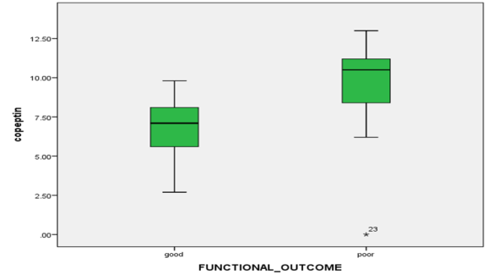

Recent Publications
- J. Emberson, K. R. Lees, P. Lyden et al. Effect of treatment delay, age, and stroke severity on the effects of intravenous thrombolysis with alteplase for acute ischaemic stroke: a metaanalysis of individual patient data from randomised trials. The Lancet.2014; 384 (9958): 1929–35.
- Katan M, Fluri F, Morgenthaler NG, Schuetz P, Zweifel C, Bingisser R, et al. Copeptin: A novel, independent prognostic marker in patients with ischemic stroke. Annals of Neurology. 2009 Dec;66(6):799–808.
- Maas MB, Furie KL. Molecular biomarkers in stroke diagnosis and prognosis. Biomark. 2009. Med. 3(4): 363–383.
- Fassbender K, Schmidt R, Mossner R, et al. Pattern of activation of the hypothalamic-pituitary-adrenal axis in acute stroke. Relation to acute confusional state, extent of brain damage, and clinical outcome. Stroke 1994;25:1105–1108.
- Olsson T, Marklund N, Gustafson Y, Nasman B. Abnormalities at different levels of the hypothalamic-pituitaryadrenocortical axis early after stroke. Stroke 1992;23: 1573–1576.

 Biography
Dr. Kevin T. John Keeppallil , a medical graduate from MOSC Medical College, Kerala, South India moved to Pondicherry in 2014 and joined the Department of General Medicine in Pondicherry institute of Medical Sciences as a resident to pursue his passion in Internal Medicine. Alarmed by the poor outcome of a large number patients with stroke and a keen interest in Neurology led to his post graduate research topic on the role of the novel biomarker “copeptin” in assessing the functional outcome of acute stroke and its utility in improving the rehabilitation of these patients. He aspires to do a fellowship in neurology and pioneer innovative research in this field in future. His interest in his spare time includes travelling, photography and meeting new people.
Email: kevintjohn@gmail.com

