Coexisting or prevalent unknown diseases with chronic renal failure.

Marilena G. Koukou¹, Vassilios E. Smyrniotis², Nikolaos F. Arkadopoulos², Eirini I. Grapsa³.

The affiliation(s) for each author: PhD, Faculty of Medicine at University of Athens¹, 4th Department of Surgery in ATTIKON University Hospital², Nephrology Department in ARETAIEIO Hospital³.

We made an assessment of the situation of Hemodialysis (HD) patients in the period of economic crisis compared to international data through the recording of demographic characteristics. Our sample consists of 2,586 subjects undergoing HD (27% of patients in HD), with the most common cause of end-stage renal disease for patients undergoing HD is the "unknown cause" with 33.02%. Similar is the situation in Spain (30.3%), Italy (30.3%), Hungary (41.7%), Poland (25.8%) and Portugal (28.1%). The mean age was determined at 68.7 ± 14.1 years (63.7% men) and 66.3 ± 13.2 years (49.4% men) for the Czech Republic up to 68.9 ± 15 years (58 , 8% men) for France. We noticed that patients with "unknown cause" are following an ESRD patient in HD. In their dossier, drugs such as,epoetin alfa, IV iron therary, levocarnitine, vitamins, clopidogrel and hydrochloride. At the same time, there is no mention of another co-existing disease, such as fabry disease, which could have led the patient either to hemodialysis or to cause a worsening of the dementia of patients on hemodialysis. This situation should be of worldwide interest as there are several countries within the European Union but possibly outside of the country where there is no examination of the primary cause of renal insufficiency, with the result that the patient does not have the right treatment even though he is in dialysis.

Biography

I has completed my PhD at the age of 34 years from National and Kapodistrian University of Athens in Medicine.
I worked like Medical Science Liaison & Tender Manager
- Acting as bridge (MSL) between the company and members of the healthcare industry, finding efficient ways to manage collaboration with the physicians, as well as to improve interaction with KOLs.
- Working throughout a product’s lifecycle as local regulatory rappresentative, helping to ensure that is utilized effectively.
- Planning, implementation and development of integrated proposals-solutions for both public and private sectors.
- Handling the communication with company suppliers abroad (from all major manufacturing countries such as Switzerland, England, Nederland, Germany, Italy, Austria etc)
- Managing procedures for respective ISO Certification 9001:2008, recycling system and EKAPTY (formerly EKEVYL).
- Representing the company at opening of the tenders in both Public and Private Hospitals.
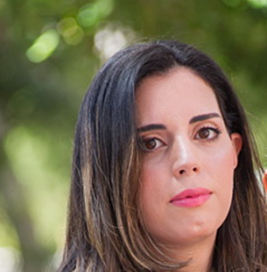
Presenting author details
Full name: Marilena Koukou
Contact number: 6974586653
Category: e-Poster presentation

