De novo proliferative GN with monoclonal IgG deposits (PGNMID):

De novo proliferative GN with monoclonal IgG deposits (PGNMID) is an extremely rare disease [1-6]. PGNMID is a unique type of GN, that was first presented in the literature for the first time in 2004 [7], 5 years later the largest series (37 case) was presented in 2009 [8]. PGNMID is a proteinuria/hematuria syndrome with a reported incidence of only 0.17 %, usually with a normal workup for paraproteinemia [8]. While the recurrent PGNMID presents early (within the 1st two years after renal transplantation), de novo PGNMID appears several years later [1, 2]. A few handful of cases of de novo PGNMID have been reported in the literature (table 1), since Nasr et al (2009) presented his largest series of the native PGNMID [9].

For a period of 30 month follow up of these patients, 38% had complete or partial recovery, 22% developed ESRF, and (38%) of these patients experienced persistent allograft dysfunction. Only 10% of patients expressed low complement level. No M protein bands were detected, which indicates that PGNMID disease should not be considered a precursor for multiple myeloma development [9]. However, Batal et al (2013) reported that 18% of their patient with native PGNMID disease showed an evidence of low grade lymphoma [10]. Moreover, Barbour et al (2011), also reported two patients with native PGNMID kidney disease with an evidence of chronic lymphocytic lymphoma [11].

Case reports of de novo PGNMID in the literature: A detailed summary of the case reports of the de novo PGNMID in the literature, as regard age, gender, time elapsed since kidney transplantation, type of the deposited IgG, presence of C1q, native kidney disease, pattern of glomerular injury as well as the presence of monoclonal gammopathy have been shown in table (1) [2, 11- 14].

Case | Age at diagnosis | Gender | Onset time (month) | Type of IgG deposits | C1q deposition | Native kidney disease | Pattern of glomerular injury | Monoclonal gammopathy | Reference
1 | 24 | M | 43 | IgG3κ | n/a | T1DM | MPGN | none | Albawardi A et al (2011) [2].
2 | 68 | F | 156 | IgG1κ | n/a | PKD | MPGN | none | Albawardi A et al (2011) [2].
3 | 38 | F | 72 | IgG3κ | 1+ | T1DM | MesGN or EC | n/a | Hussain S. M. et al (2017) [11].
4 | 61 | F | 98 | IgG3κ | C1q | MPGN | EC | none | Al-Rabadi L et al (2015) [12].
5 | 40 | F | 132 | IgG3κ | n/a | MPGN | MPGN | none | Al-Rabadi L et al (2015) [12].
6 | 46 | M | 49 | IgG1κ | 1+ | FSGS | MesGN | n/a | Tsuji T et al (2017) [13].
7 | 69 | M | 6 | IgG3κ | 1+ | Obesity  (FSGS?) | MPGN | n/a | Merhi B. et al (2017) [14] .

Table 1. Case reports in the literatures on de novo proliferative GN with monoclonal IgG deposits in renal allografts. EPGN, endocapillary proliferative glomerulonephritis; FSGS, focal segmental glomerulosclerosis; MesGN, mesangioproliferaitve glomerulonephritis; MPGN, membranoproliferative glomerulonephritis; n/a, not available; PGNMID, proliferative glomerulonephritis with monoclonal IgG deposits; PKD, polycystic kidney disease; T1DM, type 1 DM EC, endocapillary proliferative

Clinical presentation: Like recurrent PGNMID, de novo PGNMID usually manifest with an allograft dysfunction associated with a variable degrees of proteinuria with or without hematuria in a white female, the disease generally can be seen in adults above 50 years of age [11,12].

Pathogenesis: PGNMID pathogenesis is not clear. However, the reported recurrence of this disease suggests the presence of a circulating factor in RTR [11]. Other reports suggest deposition of a circulating non-deleted monoclonal IgG in the glomeruli, followed by complement fixation with outburst of inflammatory mediators [15]. A variety of intrinsic and extrinsic antigens would cause glomerular injury through stimulation of B-cell clones with subsequent production of the monoclonal IgG, particularly IgG3 subtype (8% of the total IgG). The latter is rapidly absorbed by the glomeruli so that it cannot be detected by immunofixation. Three criteria have been postulated to increase the avidity of IgG3 to glomerular deposition:
- Positively charged nature.
- The heaviest molecular weight, and
- The greatest complement fixing capacity.
So, these criteria would augment the affinity of IgG3 to the negatively charged glomerular elements, making it highly nephritogenic [1] .

Histopathology: LM usually show mesangioproliferative or endocapillary GN. EM shows prominent granular mesangial and subendothelial electron dense deposits (EDD) (figure 1) [12]. Finally, IF study could ultimately establish the PGNMID diagnosis. A positive staining of one of the monoclonal IgG subtypes, with IgG3 being the most common and either kappa (most common) or the less common lambda subtype, strictly and exclusively in the glomerular constituents. C1q and complement 3 may be positive denoting complement activation (figure 2, 3) [12].

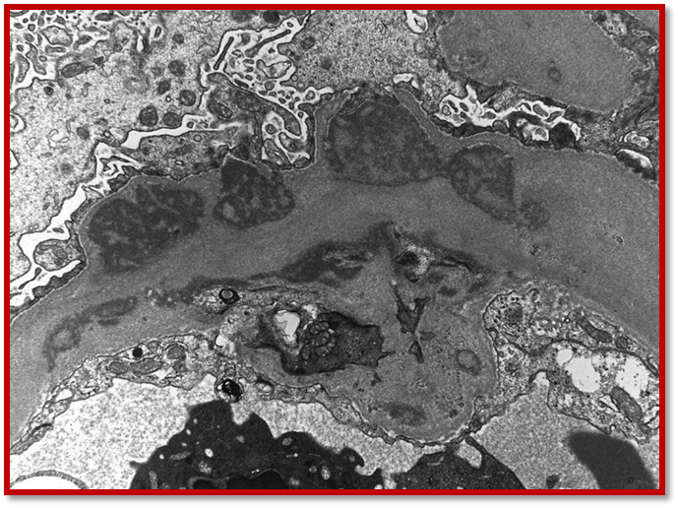

Fig. 1: Glomerular capillaries are greatly distorted and thickened by the presence of numerous, sometimes large and/or confluent subendothelial electron-dense deposits. The electron-dense deposits have a variegated (‘two-toned’) appearance and are finely granular, but they do not show organized substructures. (Adapted from: Al-Rabadi L et al, (2015), (open access) [12] ).

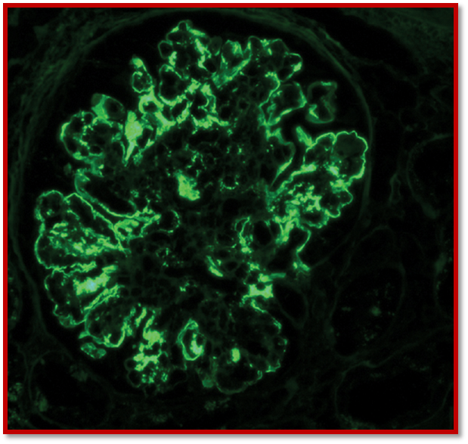

Fig. 2. Diffuse irregular granular and pseudolinear deposition of IgG (3+/4+). No staining is found in Bowman's capsule or the tubular BM (Adapted from: Al-Rabadi L et al (2015), (open access) [12]).

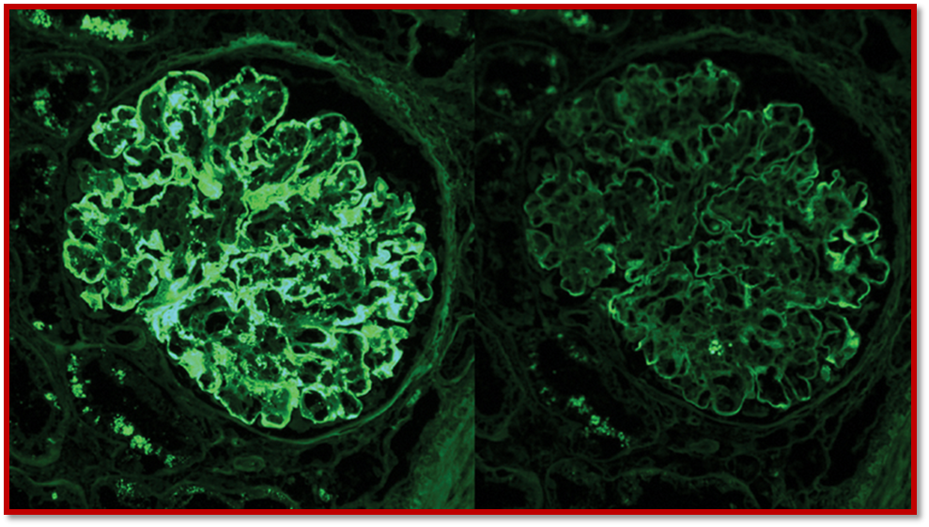

Fig. 3. Kappa light chains stain strongly positive (3+/4+) along the peripheral capillary walls and mesangial areas. Lambda light chains are negative in the deposits (Adapted from: Al-Rabadi L et al (2015), (open access) [12]).

Differential diagnosis: PGNMID should be differentiated from other entities e.g. type I cryoglobulinemic GN, transplant glomerulopathy, primary MPGN, post infectious GN, immunotactoid and fibrillary GN. As regard type I cryoglobulinemic GN, PGNMID lacks the serologic evidence of cryoglobulinemia, and also the annular-tubular as well as the fibrillary substructure by EM are absent. The microtubules of 30-40 nm in EM that characterizing immunotactoid are missed, so did the negative Congo red randomly organized fibrils of 16-24 nm diameter of the fibrillary GN. Lack of IF and EM studies can lead to a suspicion of transplant glomerulopathy, but the absence of monoclonality and the faint staining of the IgG can differentiate it from PGNMID [2]. PGNMID may simulate LHCDD in many aspects, but the pathogenesis is not alike [12]. While the heavy and the light chains deposition involve the glomerular as well as the tubular basement membrane in LHCDD, deposition of the intact monoclonal Ig is usually confined to the glomerular constituents in PGNMID. Also, the electron dense deposits (EDD) are of granular nature in PGNMID as opposed to the powdery nature of LCDD deposits [12] .

Conclusion: In the last few years, PGNMID disease attained a particular entity. Given the lack of monoclonal bands either in urine or serum, with normal appearance of bone marrow biopsy, this entity should be differentiated from other diseases with similar presentation, a challenging insight during RTR preparation [12]. Once the features of MPGN have been shown in the LM of allograft kidney biopsy, considering PGNMID disease should not be overlooked in the differential diagnosis. For better understanding of the basis of the PGNMID pathogenesis and the advent of the best therapeutic approach, further studies on a wider randomized base should be accomplished. Long term monitoring of PGNMID is recommended to guard against a hidden hematological malignancy [11].
References
[1] Nasr SH, Sethi S, Cornell LD, Fidler ME, Boelkins M, Fervenza FC, et al. Proliferative glomerulonephritis with monoclonal IgG deposits recurs in the allograft. Clin J Am Soc Nephrol. 2011;6 (1):122-312. doi: 10.2215/CJN.05750710.

[2] Albawardi A, Satoskar A, Von Visger J, Brodsky S, Nadasdy G, Nadasdy T. Proliferative glomerulonephritis with monoclonal IgG deposits recurs or may develop de novo in kidney allograft. Am J Kidney Dis. 2011; 58 (2):276-81. doi: 10.1053/j.ajkd.2011.05.003.

[3] Sumida K, Ubara Y, Marui Y, Nakamura M, Takaichi K, Tomikawa S, etal. Recurrent proliferative glomerulonephritis with monoclonal IgG deposits of IgG2λ subtype in a transplanted kidney: a case report. Am J Kidney Dis. 2013; 62(3):587-90. doi: 10.1053/j. ajkd.2013.01.013.

[4] Ranghino A, Tamagnone M, Messina M, Barreca A, Biancone L, Basolo B, et al. A case of recurrent
Proliferative glomerulonephritis with monoclonal IgG deposits after kidney transplant treated with plasmapheresis. Case Rep Nephrol Urol. 2012;2(1):46-52. doi: 10.1159/000339405.

[5] Wu D, Chen JS, Cheng DR, Chen H, Li X, Ji SM, et al. Recurrent proliferative glomerulonephritis with
Monoclonal IgG deposits after a renal transplant which was insensitive to pulse therapy remitted by double
filtration plasmapheresis. Exp Clin Transplant. 2015; 13(5):467-70. doi: 10.6002/ect.2014.0107.

[6] Batal I, Bijol V, Schlossman RL, Renke HG. Proliferative glomerulonephritis with monoclonal immunoglobulin deposits in a kidney allograft. Am J Kidney Dis. 2014;63(2):318-23. doi: 10.1053/j.ajkd.2013.07.015.

[7] Nasr SH, Markowitz GS, Stokes MB et al. Proliferative glomerulonephritis with monoclonal IgG deposits: a distinct entity mimicking immune-complex glomerulonephritis. Kidney Int 2004; 65: 85–96

[8] Nasr SH, Satoskar A, Markowitz GS et al. Proliferative glomerulonephritis with monoclonal IgG deposits. J Am Soc Nephrol 2009; 20: 2055–2064

[9] Nasr SH, Satoskar A, Markowitz GS, Valeri AM, Appel GB, Stokes MB, et al. Proliferative glomerulonephritis with monoclonal IgG deposits. J Am Soc Nephrol. 2009; 20 (9):2055-64. Doi: 10.1681/ASN.2009010110.

[10] Barbour SJ, Beaulieu MC, Zalunardo NY, Magil AB. Proliferative glomerulonephritis with monoclonal IgG deposits secondary to chronic lymphocytic leukemia. Report of two cases. Nephrol Dial Transplant. 2011;26 (8):2712-4. doi: 10.1093/ndt/gfr251.

[11] Hussain S. M, Sureshkumar KK. Proliferative glomerulonephritis with monoclonal IgG deposits; an unusual cause of de novo disease in kidney allograft www.nephropathol.com DOI: 10.15171/jnp.2017.36 J Nephropathol. 2017; 6(3):220-224 Journal of Nephropathology
[12] Rabadi L. A., Francis J. M., Henderson J., Ghai S. Proliferative glomerulonephritis with monoclonal immunoglobulin in renal allografts. Clin Kidney J (2015) 8 (6): 722-728. DOI: https://doi.org/10.1093/ckj/ sfv105
[13] Tsuji T, Miura M, Yanai M, Itami H, Ishii Y, Akimoto M, Fukasawa Y. De Novo Proliferative Glomerulonephritis with Monoclonal IgG Deposits of the IgG1κ Subtype in a Kidney Allograft: Protocol Biopsy Findings Am J Transplant. 2016; 16 (suppl 3). http://atcmeetingabstracts.com/abstract/de-novo-proliferative-glomerulonephritis-with-monoclonal-igg-deposits-of-the-igg1-subtype-in-a-kidney-allograft-protocol- biopsy- findings/. Accessed May 28, 2017.
[14] Merhi B., Patel N., Bayliss G., Henriksen K. J., Gohh R. Proliferative glomerulonephritis with monoclonal IgG deposits in two kidney allografts successfully treated with rituximab Clin Kidney J sfx001. DOI: https://doi.org/10.1093/ckj/sfx001, Published: 22 March 2017
[15] Nasr SH, Markowitz GS, Stokes MB, Seshan SV, Valderrama E, Appel GB, et al. Proliferative glomerulonephritis with monoclonal IgG deposits: a distinct entity mimicking immune complex glomerulonephritis. Kidney Int. 2004; 65(1):85-96.
&&&&&&&&&&&&&&&&&&&&&&&&&&&&&&&&&&&&&&&&&&&&&&

