Et₂Cit improved vascular calcification by Wnt/β-catenin pathway
Xiaotao Ma, The second affiliated hospital of Xi 'an jiaotong university , China

Abstract (300 word limit)
Vascular calcification is a risk factor for causing cardiovascular events and has a high prevalence among chronic kidney disease (CKD) patients. However, the effective method of treatment is still lack. Et₂Cit is expected to become one of the effective for treatment of vascular calcification. Vascular smooth muscle cells (VSMCs) were induced by a concentration of phosphorus (Pi) of 3.0 mmol/L and different concentrations of Et₂Cit, and were subjected to cell calcification analyses, such as Alizarin red staining, Calcium Deposition , Alkaline phosphatase (ALP) Activity. Lithium chloride(LiCl) and dickkop1(DKK1) were used to activate or inhibit Wnt/β-catenin pathways. The effect of Et₂Cit on the Wnt/β-catenin pathway was measured using RT-PCR and Western blotting. Et₂Cit improved VSMC calcification that is induced by high Pi, upregulated expression levels of VSMC markers, and downregulated levels of osteogenic markers. Et₂Cit decreased the Wnt/β-catenin pathway and β-catenin activity. These results suggest that Et2Cit improved vascular calcification by the Wnt/β-catenin pathway in high phosphorus level-induced aortic calcification in CKD.

Image
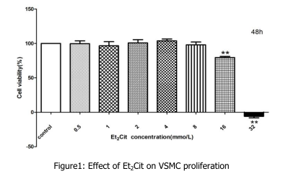
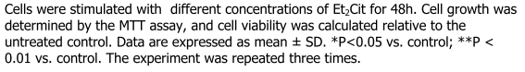
Recent Publications (minimum 5)
- Jia L-N, Ma X-T, Gui B-S(2015). Sorafenib Ameliorates Renal Fibrosis through Inhibition of TGF-β-Induced Epithelial-Mesenchymal Transition. PLoS One. 13;10(2).

Biography (150 word limit)
Xiao-tao Ma graduated from xi 'an jiaotong university, dedicated to the treatment of chronic kidney disease, especially in the prevention and therapy of vascular calcification. This is part of the preliminary experiment results.

Email: maxiaotao365@163.com

