Childhood hypertension and 24hours blood pressure monitoring Ala. A Habaibeh, MD, Dubai Hospital, UAE

Abstract
High blood pressure is the leading risk factor-related cause of death throughout the world: 12.8% of all deaths ,51% of stroke deaths and 45% of coronary heart disease deaths are related to hypertension.
In USA, 33% of adult more than 20 years old are hypertensive and after age of 55years 90% will go on to develop hypertension in their lifetime.
2011 to 2012 in the United States, the prevalence of high blood pressure in pediatrics was 1.6 %
it was found that the distribution of childhood BP has shifted upward in the United States by 1.4 mm Hg for systolic BP and 3.3 mm Hg for diastolic BP.
BMI has the most substantial effect on age related increase in BP as the obese adolescents had 7.6mmhg higher SBP than normal weight adolescents.
It is fundamental to recognize and manage hypertension during childhood, more over classifying this group of population using ambulatory blood pressure monitoring caries the same importance if not more.
24 hours blood pressure monitoring using ambulatory recorder will categories the hypertensive child to be prehypertensive, hypertensive or severely hypertensive.
A new blood pressure parameters should be considered when managing a hypertensive patient beside of the systolic and diastolic blood pressure; this includes the systolic and diastolic blood pressure load, the mean arterial blood pressure during sleep and awake period and the dipping
The presentation will focus on our work as a single center experience in managing pediatric hypertension with aid of a 24 hours blood pressure monitoring with further discussion on the Indications for routine performance of ABPM, Usefulness of ABPM to Classify BP, Approach for ABPM and its role in diagnosis of Prehypertension in and the risk of Progression to Sustained(Ambulatory) Hypertension.
Publications
- The effect of timing of initial bathing on neonatal temperature; The Middle East journal for nursing December/November 2010, volume 4 issue 3
- Vipoma: a case report of uncommon cause of chronic diarrhea JRMS March 2014; 21(1): 79-82 / DOI: 10.12816/0002584
- Our experience in Management of skin hemangiomas in children, third medical conference of Jordanian medical association 2012
- Voiding disorders in children, UNMIL (United Nation Mission in Liberia) Medical conference , Conducted at BANMED7 Hospital at Gbarnga, Liberia on January 2011
- Pediatric CVVHD for Severe Hyper osmolality and AKI – 2017, the third Latifa Hospital International pediatric and neonatology conference
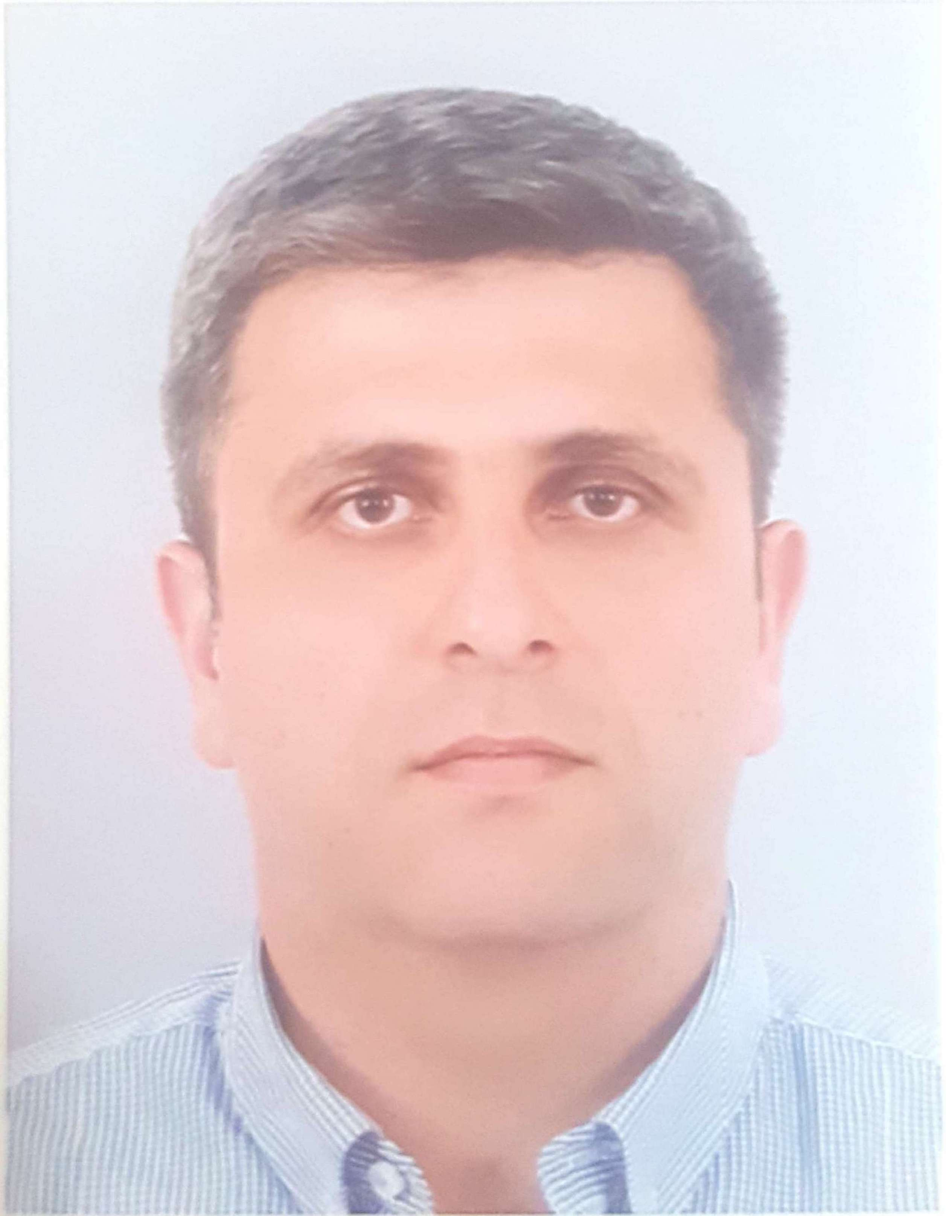 Biography
I Studied medicine at Jordan university of science and technology, I finished my clinical fellowship in paediatric nephrology at queen Rania Childrens hospital – Jordanian Royal Medical Services 2012, Joined Dubai Hospital 2012 ,Tutor at Dubai Medical college, member of the International pediatric hypertension association(IPHA) International pediatric nephrology association (IPNA) and the European society of pediatric nephrology(ESPN),Awarded The united Nation Medal -2010 As a Military member and paediatrician at the united nation mission in Liberia (UNMIL).

