Clinico-pathologic Correlation of Renal Biopsy Findings -An update report from a tertiary kidney center
Hadia Bagherzadegan, M.D, Shahrzad Ossareh, M.D, Mojgan Asgari, M.D
Iran University of Medical sciences – Hasheminejad Kidney Center

Introduction
Several registries have reported the results of renal biopsies from different registries and isolated centers. In most series focal and segmental glomerulosclerosis (FSGS ), IgA nephropathy (IgAN), membranous glomerulpathy (MG) and lupus nephritis (LN) have been reported as the most common primary or secondary glomerulonephritis (GN) with various orders. This study was conducted to update the reports of our center, as the main referral kidney center of the country, on the epidemiology of renal biopsies.
Methods
Data from 3669 patients, who had undergone renal biopsy between Sept-1999 to Feb-2016 were extracted from the GN data registry of our center. Demographic data, renal syndrome at presentation and laboratory findings were studied. Almost all kidney specimens had been studied with light and immunofluoroscent microscopes and in selected cases with electron microscope. Nephrotic syndrome (NS) was defined as proteinuria >3g/day. Nephritic syndrome was defined as proteinuria >500 mg/day and hematuria, with or without hypertension and/or serum Cr (SCr) ≥1.4 mg/dl. Subnephrotic (SN) proteinuria was defined as proteinuria of 200-3000 mg/day.

Results
In 3669 patients, 2050 were male (55.8%). The mean age at the time of biopsy was 39.1±16.1 years (10-88). The most frequent type of renal pathology was MGN (24.7%) followed by FSGS (13.1%), IgAN (12%), LN (9.6%), minimal change disease (MCD) (7.6%), Crescentic GN (6.2%) and paraprotein associated GN (4.6%) . The most common clinical presentation was NS (57.4%), followed by SN proteinuria (14.4%), nephritic syndrome (11.9%), AKI (6.9%) and azotemia (3.7%).

Conclusions
In our series the most common types of GN were MG, FSGS and IgAN, which are the most frequent glomerulonephritids in other biopsy series with various orders. Most of our patients have presented with NS, followed by SN proteinuria. The clinical course and outcomes of the patients are presented in other studies according to GN type.

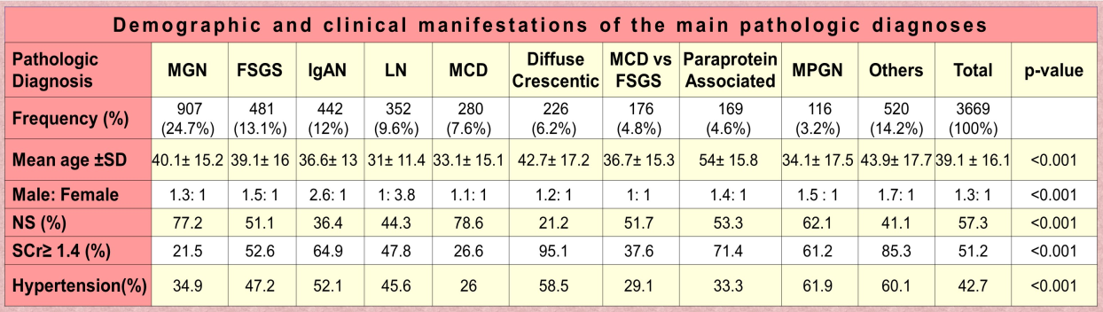

Hadia Bagherzadegan , M.D, Assistant Professor of Nephrology, Iran University of Medical Sciences, Iran, Tehran.
Shahrzad Ossareh, M.D, Professor of Nephrology, Iran University of Medical Sciences, Iran, Tehran.
Mojgan Asgari, M.D, Associate Professor of pathology, Iran University of Medical Sciences, Iran, Tehran.
Email:dr.h.bagherzadegan@gmail.com

