An unusual cause of Myoglobinuria
Abhishek Dixit, MD DM Nephrology, Bombay Hospital.

Abstract (300 word limit)
Rhabdomyolysis is characterized by the acute breakdown of skeletal muscle, which can lead to AKI in severe cases. Number of etiologies have been identified in rhabdomyolysis with drugs and trauma account for the majority of cases.[1]Rhabdomyolysis following a massage session is rare. We report a uniquecase of rhabdomyolysis with AKI following an aggressive massage session.
57 year old gentleman, with history of Diabetes and Hypertension presented with fever, breathlessness and decreased urine output. On investigations it was found that his serum creatinine was 5.7mg%.Further investigations revealed a Hb of 12.7gm% and the TLC was 21400/cumm.His other blood tests showed: LDH 1095 U/l, CPK 58928 U/l with 100% of CPK-MM form, potassium 6.7 mEq/l, creatinine 6.3 mg/dl and BUN 76 mg/dl. In view of the hyperkalemia & fluid overload he was dialyzed once and the potassium was corrected. The qualitative test of urine for myoglobin was positive. The time–concentration curve of CPK and LDH was similar to that of WBC & CRP level.Downward trend of creatinine also associated with fall in CPK, LDH, CRP and WBC levels. After 2 weeks, patient was discharged with a stable creatinine.
To determine the etiology of raised CPK a detailed history was taken & he confessed that he regularly received body massage for 1 hour. However a day prior, he received prolonged body massage session for 2 h served by two masseurs simultaneously with higher intensity.
Compression-induced rhabdomyolysis has been reported in coma or immobilized patients, but it has rarely been associated with body massage.[2]Myoglobinuria is a key player in the complex pathogenesis of AKI only in presence of hypovolemia, hypotension, and aciduria.[3]Sinert et al. reported that AKI is not observed when nephrotoxic cofactors are absent.[4] The people receiving body massage should drink adequate amount of water to prevent rhabdomyolysis-associated AKI, which is exacerbated by volume depletion. [5]

Image
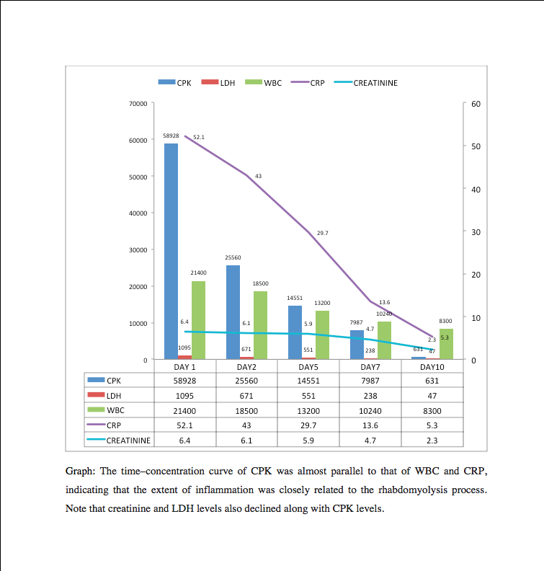
Recent Publications (minimum 5)
- Petejova N, Martinek A. Acute kidney injury due to rhabdomyolysis and renal replacement therapy: a crtical review. Crit Care. 2014 May 28;18(3):224.
- Vanholder R, Sever MS, Erek E, Lameire N. Rhabdomyolysis. J Am Soc Nephrol 2000; 11: 1553–1561.
- Bosch X, Poch E, Grau JM. Rhabdomyolysis and acute kidney injury. N Engl J Med. 2009;361:62–72.
- Sinert R, Kohl L, Rainone T, Scalea T. Exercise-induced rhabdomyolysis. Ann Emerg Med. 1994;23:1301–6.
- Hojs R, Sinkovic A, Hojs-Fabjan T. Rhabdomyolysis and acute renal failure following cardioversion and cardiopulmonary resuscitation. Renal Failure 1995; 17: 765–768.

Biography (150 word limit)
Abhishek Dixit, currently specializing in Nephrology. Always looking to learn and know more.
Email: dnephrologist@gmail.com

