Introduction

Chronic kidney disease (CKD) is increasingly recognized as a global public health problem. The declaration of World Kidney Day to be observed annually beginning in March 2006 sends a clear message to the public, government health officials, physicians, allied health professionals, patients, and families that ‘CKD is common, harmful, and treatable.(1)
Chronic kidney disease (CKD) is receiving increased public attention, with early prevalence estimates at 11% (2) and more recent estimates showing that 13% of the US population has some evidence of kidney damage.(3). More than 20 million Americans aged 20 and older may have CKD, based on a decreased glomerular filtration rate (GFR), a measure of kidney function (Levey, et al.,
2009). Although CKD is common, many Americans with the key risk factors—diabetes and high blood pressure—do not know they are at risk. In addition, the rising rates of diabetes and obesity will continue to fuel its growth, as both conditions increase the risk of developing CKD and speed its progression. In addition to kidney failure, other serious complications— particularly cardiovascular disease (CVD)—are associated with CKD. Other complications include anemia, malnutrition, bone disease, and depression The exact prevalence of chronic kidney disease in Pakistan is not clear in the absence of regular national registry data and provided only by small observation series or rely on reports from personal experience, and the quality of data is quiet uneven. CKD is defined as presence of kidney damage or glomerular filtration rate less than 60ml/min/1.73msq for 3 or longer, irrespective of cause.(4-6)CKD and ESRD impose a tremendous public health burden, costing the U.S. health care system billions of dollars. In 2006, costs for Medicare patients with CKD exceeded $49 billion, accounting for nearly one-quarter of general Medicare costs (USRDS, 2008). Medicare spending for ESRD reached $22.7 billion during the same year (USRDS, 2008). By 2020, Medicare ESRD costs are expected to reach $55.6 billion (USRDS, 2007). Survival, Mortality and Causes of Death in ESRD Patients Despite advances in dialysis and transplantation, the prognosis of kidney failure remains bleak. The USRDS reported more than 60000 deaths of patients with ESRD, and an annual mortality rate of dialysis patients in excess of 20%13. Expected remaining lifetimes of patients treated by dialysis were shorter than the age matched general population, varying (depending on race and gender) from 7.1 to 11.5 years for patients aged 40 to 44 years, and from 2.7 to 3.9 years for patients aged 60 to 64 years.

METHODS

STUDY DESIGN:
This is an Crossectional observational study done at Nephrology department, Pakistan Institute of medical science from january 2014 to january 2015.All relatives of incident dialysis patient will be taken for the study.Documentation of existing standards of care for chronic diseases associated with renal disease and institution of disease management program m that facilitate the systematic management of patient with chronic diseases that lead to end stage renal disease.Randomized non-biased sampling of patients admitted or consulted the nephrology department of Pakistan Institute of Medical Sciences, Islamabad.
INCLUSION CRITERIAS:
Age: All ages
Personal History
- Diabetes
- Hyper tension
- Family History
- Chronic Kidney diseases
- Chronic pyelonephritis
- Autoimmune disease
EXCLUSION CRITERIA
- Renal replacement therapy
- Kidney transplantation
- HBsAg and HCV
- Chronic heart failure
- Chronic liver failure
- Chronic infection disease
- Repeated septicemia
- Other chronic infection
Immuno-compromised states
- HIV-AIDS
- Malignancy
- Chemotherapeutic agents
DATA COLLETION PROCEDURE
Permission will be taken from hospital ethics committee. A standardized data collection instrument will be used to record the number of siblings and children of each incident dialysis patient, the names, vital status, and addresses of relatives with ESRD, and the name, address, and phone number of a relative without ESRD to serve as a family contact. Participants will be informed about the purpose, and importance of the study. Written consent will be taken form each participant / close relatives. Patients who fulfill the inclusion criteria will enroll in the study. .Each participant/ relative will be interviewed and the Questionnaire filled accordingly. Investigations that include urine routine examination, complete blood count, renal functions and ultrasonography will be performed by pathologist and radiology respectively. Estimated GFR to be calculated by nephrology resident.
Required data from each case will be collected and stored on a specially designed Performa along with separately.
DATA ANALYSIS PROCEDURE:
Statistical package for social sciences (SPSS version 13) will to enter and analyze the gathered data. Descriptive statistic and frequencies will be calculated using the background variable.
Results:
In this study total 200 family members of the patients on maintenance dialysis for ESRD were included after taking the consent and fulfilling the inclusion and exclusion criteria. Out of these 200 participant 144(72%) were male and 56 (28%)were female (Figure 1) . Minimum age of the study population was 18 years and maximum age was 66 years. Mean age is 35.5 years with standard deviation of ± 9.93. (Table 2)
As for as relation of the participants with the patients is concerned, it was shown that 112 (56%) were sons, followed by 36(18%) daughters than 24(12%) brothers. (Figure 2). Frequency of risk factors in study population has shown that out of 200 participants 30(15%) has hypertension, 12 (6%) had diabetes, 5(2.5%) has renal stone disease and 148(74%) participants did not have any risk factor at all. (Figure 3). Blood pressure was normal in 166(83%) participants whereas it was increased in 34(17%) participants (Figure 4). Minimum blood glucose was 54mg/dl maximum was 234 mg/dl and mean was 106mg/dl with standard deviation of about 31.48. (Table 2). And this blood glucose was found to be normal in 185 (92.5%) patients and increased in 15 (7.5%) participants. (Figure 5).
When urine sample of these participants were analyzed, it was found that 171(85.5%) participants did not have any urinary protein, 21(10.5%) had 1+ protein, 6(3%) had 2+ protein, and 2 (1%) participants had 3+ urinary glucose (Figure 6) .Similarly 178 (89%) participants did not have urinary glucose, 10(5%) had 1+ glucose, 7(3.5%) had 2+ glucose, 4(2%) had 3+ glucose and one (0.5%) had 4+ urinary glucose.(Figure 7). Same is the case with blood in urine, it was found that 174 participants did not have any blood in urine where as 20 participants had 1+ urinary blood, 5 had 2+ blood and 1 had 3+ blood in urine. (Figure 8). And it is found to be normal in 184(92%) patients and increased in 16(8%) participants. (Figure 9). In our study population lipid profile was normal in 147(73.5%) participants and was abnormal in 53(26%). (Figure 10).
As for as hemoglobin is concerned , it was found that minimum Hb was 8, maximum was 18, mean was 12.12 with standard deviation of about ±2.09. (Table 2). On other hand minimum serum calcium in our study population was 7, maximum was 9.5 and mean was 8.84 with standard deviation of about 0.3991.On ultrasound kidney sizes were normal in 158(79%) participants whereas were decreased in 42 (21%) participants.( Figure 11)

DESCRIPTIVE STATISTICS

VARIABLES | N | Range | Minimum | Maximum | Mean | Std. Deviation
Age of the patients | 200 | 48 | 18 | 66 | 35.95 | 9.931
Weight of the patients | 200 | 67 KG | 42KG | 109KG | 72.67 | 15.343
Blood glucose | 200 | 232 mg/dl | 54 | 234 | 106.21 | 31.418
pH Of Urine | 200 | 3.0 | 5.0 | 8.0 | 6.007 | .7933
RBC in Urine | 200 | 62 | 0 | 62 | 2.37 | 6.937
WBC in Urine | 200 | 43 | 0 | 43 | 1.88 | 4.440
Serum Creatinine  Mg/dl | 200 | 6.68 | .32 | 3.20 | .8176 | .4342
Hemoglobin | 200 | 97.0 | 8.0 | 18.0 | 12.12 | 2.090
Serum Phosphorus | 200 | 2.18 | 3.00 | 5.18 | 3.7380 | .38809
Serum Calcium | 200 | 8.9 | 7 | 9.5 | 8.44 | .3991

Table 2: showing the descriptive statistics of the study population
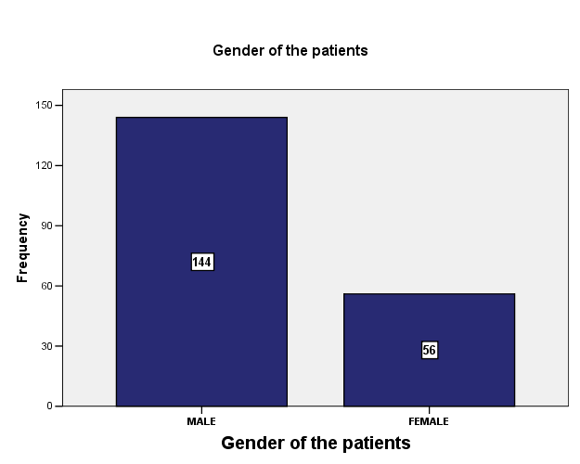

Figure : 1 Gender Of The Participants.

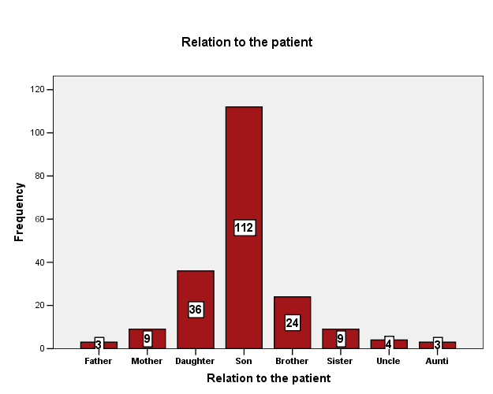

Figure 2 . Frequency Of Relation Of Study Population With The Patients

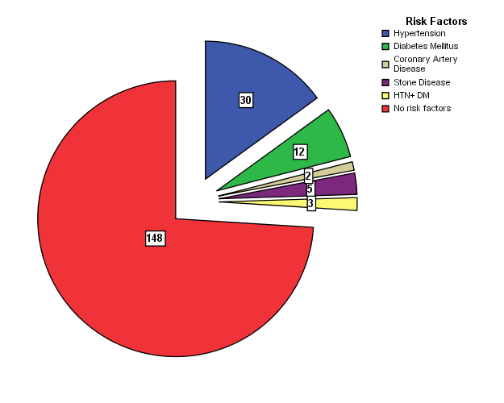
Figure 3. Frequency Of Risk Factors Among The Study Population

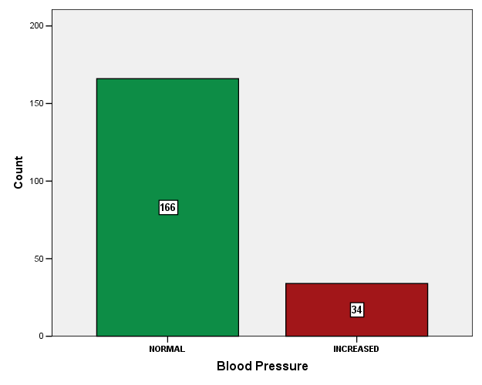

Figure 4: Blood Pressure Of Study Population

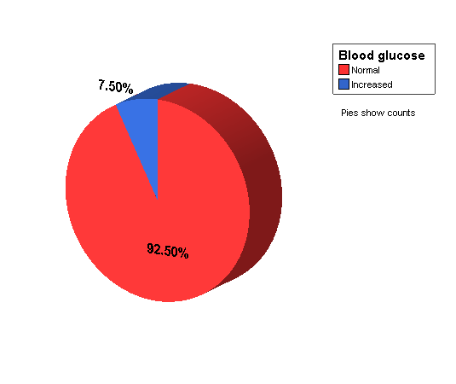
Figure 5: Trend Of Blood Glucose In Study Population

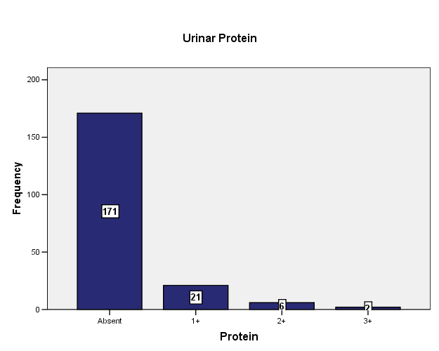

Figure 6: Frequency Of Urinary Protein In study Population

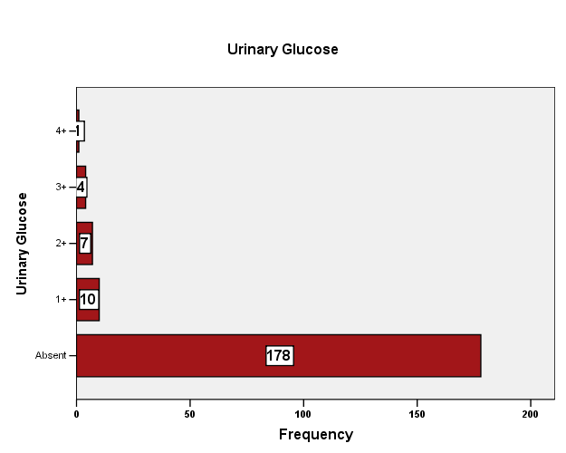

Figure 7: Frequency Of Urinary Glucose In Study Population

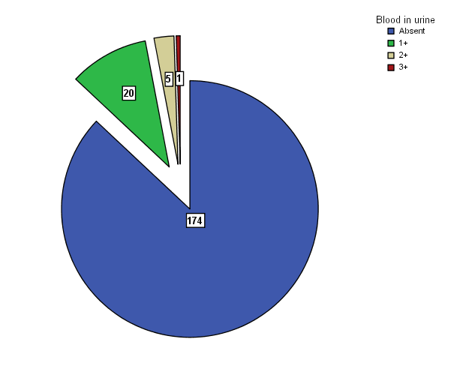

Figure 8. Frequency Of Blood In Urine

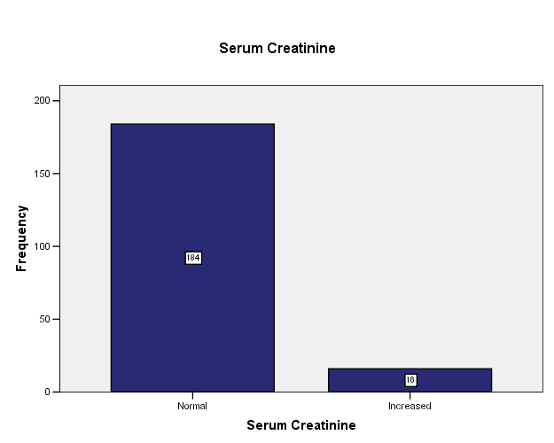

Figure 9: Serum Creatinine In Study Population

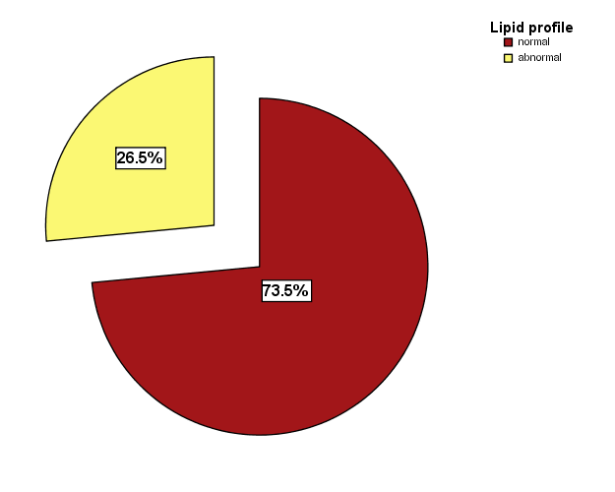

Figure 10: Analysis Of Lipid Profile In Study Population

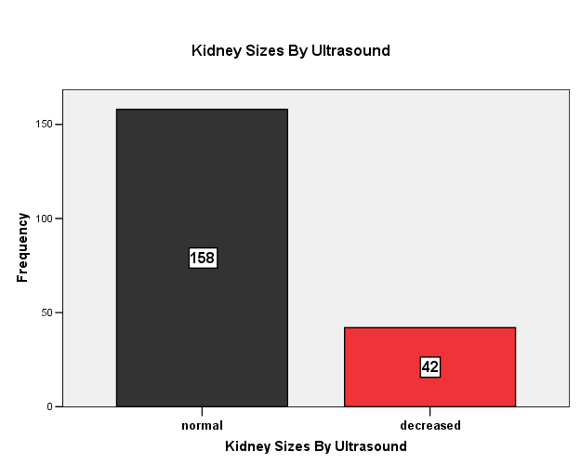

Figure 11: Kidney Sizes By Ultrasound In Study Population

Discussion:

Chronic kidney disease (CKD) is increasingly recognized as a global public health problem. The declaration of World Kidney Day to be observed annually beginning in March 2006 sends a clear message to the public, government health officials, physicians, allied health professionals, patients, and families that ‘CKD is common, harmful, and treatable¹²
The exact prevalence of chronic kidney disease in Pakistan is not clear in the absence of regular national registry data and provided only by small observation series or rely on reports from personal experience, and the quality of data is quiet uneven.
CKD is defined as presence of kidney damage or glomerular filtration rate less than 60ml/min per 1.73 msq. For 3 or more months, irrespective of cause¹³
We have included 200 relatives of the patients with ESRD and on dialysis. Though this number is not much large as compared to international screening analysis, but still gives us direction toward the future strategies. Same cross-sectional survey of screening to identify CKD among family members of ESRD patients was conducted at10 community dialysis centers in Georgia ¹⁴ Family members of ESRD patients were recruited for CKD screening. A medical history, measurements of BP, serum glucose, hemoglobin (Hb), serum creatinine, and urinalysis were obtained at community screening sites. Of 221 family members screened between 1999 and 2001 in Georgia, 13.9% had an estimated creatinine clearance (Ccr) _60 ml/min. Proteinuria of 1+ or more was found on urinalysis in 9.9%. In our analysis proteinuria was significantly present and was 1+ in 10% of the patients, and 3% had 2+ protein in urine. However in another screening survey, out of 84 participants, 26% of these had proteinuria ¹⁵
On other hands, hypertension was present in 15% of our study population, where as it was present with much higher frequency in a crossectional survey in Georgia¹⁴ where 58% of the study participants were hypertensive, some of which were getting treatment for hypertension and some of which were unaware of their disease. Where as in other surveys, 21.9% of the family members of the ESRD patients had hypertension, and these results were comparable with our study results.
Similarly as for as impaired blood glucose is concerned, in our study, 7.5 % of the participants had impaired blood glucose and 92.5% of the participants had normal blood glucose. When we compare these results with international data, it was found that in Georgia survey, 18.6% of the study population had increased blood glucose ⁸. Where as in other survey 18.1 % of the participants had impaired blood glucose

Some of the studies used proteinuria and serum creatinine as a marker of chronic kidney disease like A trial in Urmia by Ghafari et al. The study by Iseki in the Okinawa region of Japan also demonstrated that proteinuria and high serum creatinine level are two valuable prognostic factors for end-stage renal disease⁸⁸. As for as serum creatinine level in our survey are concerned , it was found that out of 200 participants , only 8% of the participants had increased serum creatinine level .though this percentages is not mush high as compared to another trial in Asia but still this is significant as for as screening is concerned.
Conclusion:
In short we can say that screening of the family members of ESRD patients is important for the prevention of kidney disease in other family members. In our study 13 % of the patients had proteinuria, 15 % of the patients had increased blood pressure, , 7.5 % of the participants had impaired blood glucose and 92.5% of the participants had normal blood glucose.

References:

- United States Renal Data System 2008 Annual Data Report Atlas of Chronic Kidney Disease and End-Stage Renal Disease in the United States. Am J Kidney Dis 2009; 1(Suppl 1):S1.
- Levey AS, Eckardt KU, Tsukamoto Y, Levin A, Coresh J, Rossert J. Definition and classification of chronic kidney disease: A position statement from Kidney Disease: Improving Global Outcomes (KDIGO). Kidney Int 2005 Jun;67(6):2089-100.
- Peralta CA, Shlipak MG, Fan D, Ordonez J, Lash JP, Chertow GM et al . Risks for end-stage renal disease, cardiovascular events, and death in Hispanic versus non-Hispanic white adults with chronic kidney disease. J Am Soc Nephrol. 2006 Oct;17(10):2892-9. Epub 2006 Sep 7.
- Feehally, J. Ethnicity and renal disease. Kidney Int 2005; 68:414.
- Tareen N, Zadshir A, Martins D, Pan D, Nicholas S, Norris K. Chronic kidney disease in African American and Mexican American populations. Kidney Int Suppl 2005 Aug;(97):S137-40.
- Rodriguez RA, Hernandez GT, O'Hare AM, Glidden DV, Perez-Stable EJ. Creatinine levels among Mexican Americans, Puerto Ricans, and Cuban Americans in the Hispanic Health and Nutrition Examination Survey. Kidney Int 2004 Dec;66(6):2368-73.
- Scavini M, Shah VO, Stidley CA, Tentori F, Paine SS, Harford AM . Kidney disease among the Zuni Indians: the Zuni Kidney Project. Kidney Int Suppl 2005 Aug;(97):S126-31.
- Choi HS; Sung KC; Lee KBThe prevalence and risk factors of microalbuminuria in normoglycemic, normotensive adults. Clin Nephrol. 2006 Apr;65(4):256-61.
- Viktorsdottir O; Palsson R; Andresdottir MB; Aspelund T; Gudnason V; Indridason OS Prevalence of chronic kidney disease based on estimated glomerular filtration rate and proteinuria in Icelandic adultsNephrol Dial Transplant. 2005 Sep;20(9):1799-807.
- Hsu CC; Hwang SJ; Wen CP; Chang HY; Chen T; Shiu RS et al. High prevalence and low awareness of CKD in Taiwan: a study on the relationship between serum creatinine and awareness from a nationally representative survey. Am J Kidney Dis. 2006 Nov;48(5):727-38.
- Hallan SI; Coresh J; Astor BC; Asberg A; Powe NR; Romundstad S;et al. International comparison of the relationship of chronic kidney disease prevalence and ESRD risk. J Am Soc Nephrol. 2006 Aug;17(8):2275-84.
12.Levey AS, Andreoli SP, DuBose T et al. Chronic kidney disease: common harmful and treatable –World Kidney Day 2007. Am J Kidney Dis 2007; 49: 175–179.2

13.Mital S, Kher V, Gulati S, Agarwal LK, Arora P, Chronic renal failure in India. Renal failure 1997;19(6):763-70.

14.Satko SG, Freedman BI: The importance of family history on the development of renal disease. Curr Opin Nephrol Hypertens.2004. 13:337-341.

15.Iseki K. The Okinawa screening program. J Am Soc Nephrol. 2003;14:S127-30.

