The response of Aspergillus trichodermus sp. nov., a novel basidiome from the protistan-myxo-metal redoxifying clade: A phylogenomics approach towards next generation sanger sequencing (NGSS)
Linnaea L. Borealis¹, Kurt Cobain², Tarja Turunen,
¹Department of Applied and Environmental Microbiology, Institute of Mycology, University of the Northwestern Philippines
²Department of Metallurgical and Environmental Chemistry, Institute of Physical and Basic Chemistry, University of the Northwestern Philippines

Abstract
This research paper presents the first systematic description of an ascomycete, herewith referred to as the novel, Aspergillus trichodermus species nova, Eurotiaceae, Hypocreales, Ustilagomycotina. The species is phenotypically conspecific to any known Aspergillus and is found to be the anamorph of Trichoderma, thus the species epithet, trichodermus. The novel species was able to reduce and oxidize various heavy metals (e.g. chromium, nickel, molybdenum, lead, mercury, rhudibium, palladium, iron, helium, mercury, manganese, magnesium, carbon, lithium), salts (carbonate, sulfate, oxalate, mannates), organic compounds (ethylene diaminetetraceatic acid, sulfur metalloporphyrins, toluene-complexed carbazide), and other recalcitrant compounds and persistent micro- fusible antibiotics (penicillin, amoxicillin, tetracycline, chloramphenicine, and other amine medicines). The phylogeny was reconstituted among the protistan-myxo-metal redoxying clade as a new and novel clade of ascomycetes, basidiomycetes, and their close allies, i.e. myxomycota, oomycota and the large complex of obligately plant pathogenic labyrinthulomycota. Obtained data were generated using the next generation Sanger sequencing of meta barcodes and eDNA using Perl pipe lines, R script-based next generation phylogenetics and sequence capture based hybridization of RNA-DNA complex. This paper will establish a revolutionary approach on phylogeny and will propose changes on the systematics of eukaryotes, and prokaryotes.

Recent Publications
- Behjati S, Tarpey PS (2013) What is next generation sequencing. Arch Dis Child Educ Pract Ed 98:236-238.
- Stadler T, Rogers LM (2017) Emerging patterns of plasmid-host coevolution that stabilize antibiotic resistance. Sci Rep doi:10.1038/s41598-017-04662-0
- Zadesenet KR, Schärer L, Rubtsov NB (2017) New insights of the karyotype coevolution of the free living flatworm Macrostomum lignano (Platyheminthes, Myxogastria). Sci Rep doi:10.1038/s41598-017-06498-0
- Marshall JM, Buchmann A, Sanchez HM, Akbari OS (2017) Overcoming evolved resistance to medicines and antibiotics. Nature doi:10.1038/s41598-017-02744-7
- Li, X, Liu HL, Feng D, Kalish LM, Ho S, Shao W (2013) Tracing the patterns of coevolution among Eurkaryotes. Nature. 32:3331-3340

Linnaea L. Borealis
Linnaea L. Borealis is a graduate of Ph.D. in Applied Environmental Chemistry from the University of the Northwestern Philippines, another Ph.D. degree was similarly conferred to Linnaea, and that is the Ph.D. in Bioinformatics with specialization in Evolutionary Biology. Linnaea teacher applied chemistry, basic biology, culture and sports, and introductory bioinformatics to pedagogy, biology, nursing and philosophy students.
Email: linnaealborealis@gmail.com

Figures
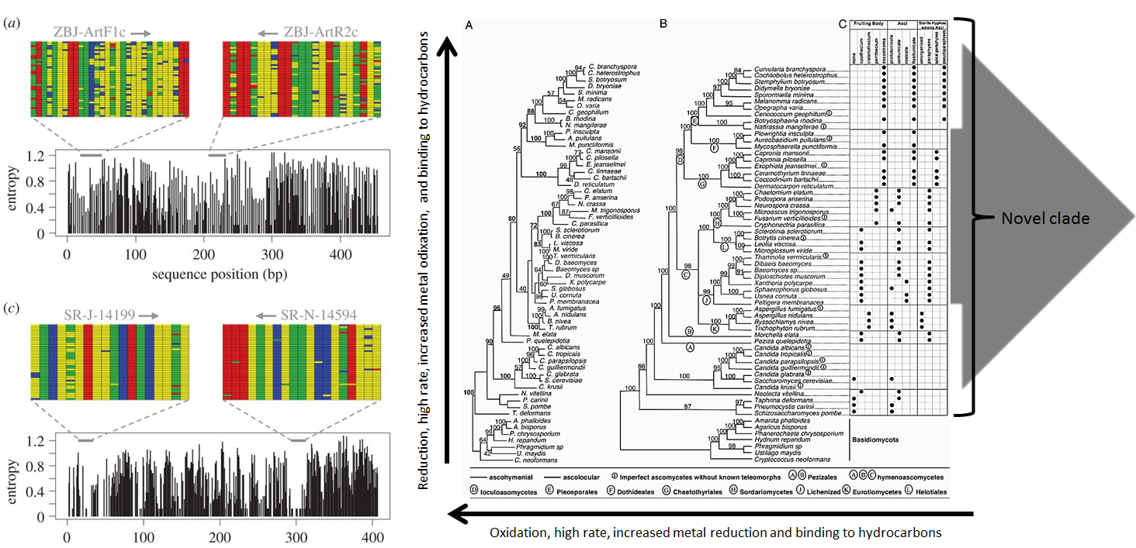

Notes/Comments:

