Poster Balon 2019

Initial experience with intragastric balloon LEXBAL ® in the treatment of patients with mild to moderate obesity (type I-II)
FD . Robledo.
MD PH - Buenos Aires (Argentina).

Background
Evaluate the effectiveness and response Gastric balloon ( Lexbal ) in the treatment of mild to moderate obesity
Observational and retrospective

Introduction
Descriptive observational study in which the sample is made up of the 14 patients treated with balloon LEXBAL
The variables studied were age , sex, weight , BMI, percentage of weight lost , fill volume , tolerance, satisfaction

Objectives
Evaluate the effectiveness and response balloon ( Lexbal ) in the treatment of mild to moderate obesity
Observational and retrospective : Experimental design

Methods
We conducted in Hospital Paroissien an observational, retrospective study .
We have compiled the results of 14 follow intragastric balloons (Balon Lexbal ) in obese patients with mild to moderate type I- II (BMI between 28 and 34.9 kg/m2 ) placed in 2012 and 2018 losses have been achieved . over 70 % of excess weight .
Furthermore, it has been observed satisfaction of our patients
The variables studied were age sex, weight BMI,% of weight lost ,fill volume,tolerance, satisfaction and dietary monitoring
Measurements : Descriptive observational study in which the sample is made up of the 14 patient treated with balloon LEXBAL in our midst. The variables studied were age , sex, weight , BMI percentage of weight lost , fill volume , tolerance, satisfaction and dietary monitoring by patients Results: . Over 80 % degree of patient satisfaction 70 % decrease in weight above the average ( over 12 kilos ) better response in those presenting adherence to nutritional treatment and no difference were observed in the volume of filling the balloon.

Results
Over 80 % degree of patient satisfaction , 70 % decrease in weight above the average ( over 12 kilos ) better response in those presenting adherence to nutritional treatment and no differences were observed in the volume of filling the balloon

Conclusion

Conclusions: Treatment with intragastric balloon, along with a nutritional monitoring allows us to re-educate the patient, and change their eating habits. • Just for gradual diet, and to adapt each phase as tolerated by the patient, helps us to improve dietary behavior and facilitates greater weight loss The intragastric balloon is a safe, well tolerated, with few adverse effects and relatively simple in the hands accustomed to endoscopic practice. We believe it can be considered an effective adjunctive therapy in selected cases of mild / moderate obesity (type I-II).

|||||||||||||||||||||||||||||||||||||||||||||||||||||||||||||||||||||||||||||||||||

Graphics / Tables
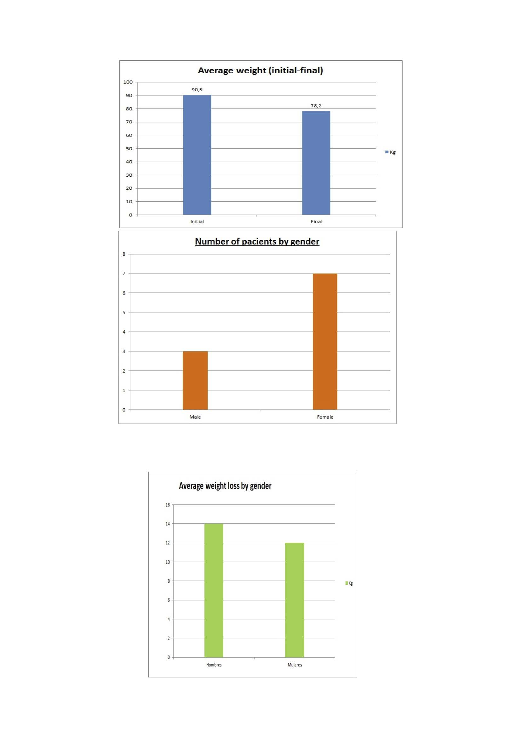

Biography

Mathus, V. (Septiembre 2007). May Gastric Balloon revisited. Proceeding of the"Digestive Disease Week. World Journal Gastroenterology. Volumen 13. (N° 34).
Sallet, J & Marchesini, J (Agosto 2004). Brazilian Multicenter Study of the Intragastric Balloon. Obesity Surgery. Volume 14. N° 7. pp 991-998.
Mathus, V & Tytgat, G. (Enero-Febrero 2009). Intragastric balloon for treatment-resistant obesity. Nutrición Hospitalaria. Volumen 24. (N°1).
.Pi-Sunyer X. The medical risks of obesity. Postgrad Med. 2009;121:21–33
Buchwald H, Oien DM. Metabolic/bariatric surgery worldwide 2011. Obes Surg. 2013;23:427–436. [PubMed]
Look AHEAD Research Group. Eight-year weight losses with an intensive lifestyle intervention: the look AHEAD study. Obesity (Silver Spring) 2014;22:5–13. [PMC free article] [PubMed]
Mathus-Vliegen EM. Endoscopic treatment: the past, the present and the future. Best Pract Res Clin Gastroenterol. 2014;28:685–702.
Gleysteen JJ. A history of intragastric balloons. Surg Obes Relat Dis. 2016;12:430–435. [PubMed]
De Castro ML, Morales MJ, Del Campo V, Pineda JR, Pena E, Sierra JM, Arbones MJ, Prada IR. Efficacy, safety, and tolerance of two types of intragastric balloons placed in obese subjects: a double-blind comparative study. Obes Surg. 2010;20:1642–1646.
Giardiello C, Borrelli A, Silvestri E, Antognozzi V, Iodice G, Lorenzo M. Air-filled vs water-filled intragastric balloon: a prospective randomized study. Obes Surg. 2012;22:1916–1919

|||||||||||||||||||||||||||||||||||||||||||||||||||||||||||||||||||||||||||||||||||

