Acute toxicity and cytotoxicity evaluation of ethyl acetate fraction of Garcinia mangostana Linn. on mice liver, kidney, and intestine histopathology as an alternative therapy for colorectal cancer
Mohammad Idzhar Arrizal, Faculty of Medicine, Universitas Indonesia
Andika Trya, Faculty of Medicine, Universitas Indonesia
Kamarza Mulia, Department of Chemical Engineering, Faculty of Engineering, Universitas Indonesia
Erni H Purwaningsih, Department of Medical Pharmacy, Faculty of Medicine, Universitas Indonesia
Siti Farida, Department of Medical Pharmacy, Faculty of Medicine, Universitas Indonesia

Abstract
Statement of the Problem: Colorectal cancer currently ranks third on the most common cancer worldwide. As treatments available for it still have many side effects to deal with, researchers have been trying to develop a new anticancer therapy with fewer side effect. Mangosteen (Garcinia mangostana Linn.), which contains α-mangostin, is known for having anticancer activity. Ethyl acetate fraction is used to obtain the highest level of α-mangostin from mangosteen. Nevertheless, its acute toxicity and cytotoxicity on liver and kidney tissues as organs involved in drug metabolism and excretion also intestines tissues as target organ have never been evaluated. The aim of this study is to evaluate the acute toxicity of ethyl acetate fraction of mangosteen extract and its cytotoxic effect on mice liver, kidney, and intestine. Methodology & Theoretical Orientation: This study used 6-to-8-week-old BALB/c mice which were distributed to five groups: control group, solvent group receiving emulsifier agent, three treatment groups receiving the extract orally at a single dose of 2, 4, and 6 g/kg.BW, consecutively, each of five per group. Mice then were observed for 14 days. Afterwards, the organs were taken and examined to see any pathological changes. Findings: The study revealed that the administration of extract at 4 and 6 g/kg.BW produced toxicity signs and acute toxicity showed an approximate LD₅₀ value at >6 g/kg.BW. Meanwhile, there were no significant differences among these groups on the organs. However, the histopathology of liver indicated that the mice treated with 6 g/kg extract had significant alteration than the other groups except the solvent group. Conclusion & Significance: Ethyl acetate fraction of mangosteen causes acute toxicity at 4 and 6 g/kg.BW and has cytotoxic effect on liver tissues at 6 g/kg.BW. Further studies are needed for its future development as anti-colorectal cancer therapy.
Image
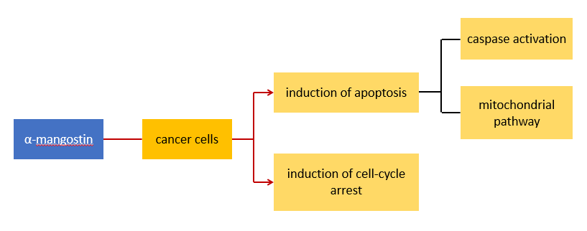
Anticancer mechanism of α-mangostin

References
- Brenner H, Kloor M, Pax CP. Colorectal cancer. Lancet. 2014 Apr;383:1490-502.
- Pratiwi L, Fudholi A, Martien R, Pramono S. Development of TLC and HPTLC method for determination α-mangostin in mangosteen peels (Garcinia mangostana L.,). Int J Pharmacognosy and Phytochem Res. 2017 Mar;9(3):291-302.
- Ibrahim My, Hashim NM, Mariod AA, Mohan S, Abdulla MA, Abdelwahab SI, et al. α-mangostin from Garcinia mangostana Linn: an updated review of its pharmacological properties. 2016;9:317-29.
- Gutierrez-Orozco F, Failla ML. Biological activities and bioavailability of mangosteen xanthones: a critical review of the current evidence. Nutrients. 2013 Aug;3:3163-83.
- Wang MH, Zhang KJ, Gu QL, Bi XL, Wang JX. Pharmacology of mangostins and their derivatives: a comprehensive review. Chin J Nat Med. 2017 Feb;15(2):81-93.

 Biography
Mohammad Idzhar Arrizal is an undergraduate, 4th year medical student at Universitas Indonesia. Having a keen eye on the development of new drugs, this paper marks his contribution in the field of pharmacy. He loves to write in his spare time and is actively involved in journalism organization that publishes newspaper specializing on the topics of health and medicine to the rurals of Indonesia. A graphic design aficionado, he also loves to marry his artistic touch with his knowledge in medicine, as proven by several projects he has been on in which he designs local medical textbooks.
Email: ardzhr@gmail.com

