Treatment of Fatty Pancreas: Acalypha indica Linn. Extract as An Alternative to Simvastatin
Aisyah Aminy Maulidina, Faculty of Medicine, University of Indonesia
Siti Farida, Department of Medical Pharmacy, Faculty of Medicine, University of Indonesia

Abstract
High-fructose and cholesterol diet nowadays has increased the incidence of obesity, dyslipidemia, insulin resistance, and metabolic syndrome which are the main risk factors of non-fatty pancreas disease (NAFPD), a pancreatic disease that may lead to pancreatic cancer. The pathogenesis and treatment of NAFPD is currently not well understood yet, but studies show that NAFPD is a reversible state which can be treated by modifying its underlying risk factors mentioned before. The use of simvastatin in managing pancreatic disease, although was shown to reduce cancer risk and increase survival of patients with pancreatic cancer, raises concerns as simvastatin was recently found to induce diabetes and worsen hyperglycemia and A1c levels in pre-existing diabetes. A. indica Linn. is known to have flavonoids and polifenols which may decrease serum LDL level and increase serum HDL level. A. indica Linn may also, in contrast to simvastatin, control post-prandial hyperglycemia. A study on mice induced with high fructose and a high cholesterol diet shows that A. indica Linn., with or without combination of simvastatin, helped reverse fatty formation in the pancreas. This article reviews the potential use of Acalypha indica Linn. extract as an alternative approach to modify the risk factors underlying NAFPD.

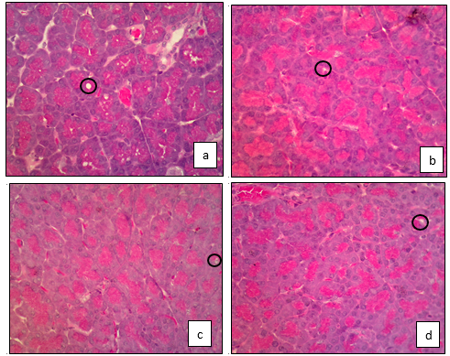
Image

Figure 1. Histopatological image of mice post-induction of high fructose and high cholesterol diet, (a) negative control, (b) treated with simvastatin, (c) treated with A. indica Linn extract, and (d) treated with simvastatin – A. indica Linn. extract. Black circles show fatty formation in the pancreas.

References
- Wu WC, Wang CY (2013) Association between non-alcoholic fatty pancreatic disease (nafpd) and the metabolic syndrome: case–control retrospective study. Cardiovascular Diabetology: 12:1-6.
- Catanzaro R, Cuffari B, Italia A, Marotta F (2016) Exploring the metabolic syndrome: Nonalcoholic fatty pancreas disease. World J Gastroenterol 22: 7660–7675
- Ganda, O. P. (2016). Statin-induced diabetes: incidence, mechanisms, and implications. F1000Research, 5, F1000 Faculty Rev–1499. http://doi.org/10.12688/f1000research.8629.1
- Rajasekaran S, Anandan R, Nishad KM (2013) Antihyperlipidemic Activity of Acalypha Indica Linn. on Atherogenic Diet Induced Hyperlipidemia. International Journal of Pharmacy & Pharmaceutical Sciences 5: Supp 4. 699
- Maulidina AA, Krisnamurti DGB, Purwaningsih EH, Farida S (2018) The improvement effect of simvastatin-Acalypha indica Linn. combination on rats fatty pancreas induced high-fructose and cholesterol diets. Manuscript submitted for publication.
- Masih M, Banerjee T, Banerjee B, Pal A (2011) ANTIDIABETIC ACTIVITY OF ACALYPHA INDICA LINN. ON NORMAL AND ALLOXAN INDUCED DIABETIC RATS. Int J Pharm Pharm Sci 3: 51¬54




Biography
Aisyah Aminy Maulidina is currently pursuing a general practitioner degree in Faculty of Medicine, University of Indonesia. Her interest in research is cultivated through a research module that connected her with her lecturer and mentor, Dr. dr. Siti Farida, PhD from Department of Medical Pharmacy, Faculty of Medicine, University of Indonesia.
Email: aamaisyaham@gmail.com

Notes/Comments

