″A systematic review and meta-analysis of the impact of collaborative practice between community pharmacist and general practitioner on asthma management ″
Naeem Mubarak, PhD (Candidate), Department of Pharmacy Practice, International Islamic University, Malaysia.
Che Suraya Haji Mohd Zin, Postdoctoral, Kulliyyah of Pharmacy, Department of Pharmacy Practice, International Islamic University, Malaysia.

Abstract
Objective: To evaluate the impact of collaborative practice between community pharmacist (CP) and general physician (GP) in asthma management. Methods: An extensive search was carried out in 10 databases (PubMed, Medline/Ovid, CINAHL, Scopus, Web of Science, Cochran central register of controlled trials, PsycARTICLES®, Science Direct, Education Resource Information Centre, PRO-Quest), and grey literature using selected MeSH and key words, such as '' community pharmacist'', ''general physician'' ''medicine use review''. After screening, 23 studies were used for evidence synthesis. The risk of bias was assessed by Cochrane risk of bias tool (EPOC). Studies were included only if there was a definite evidence of collaborative practice between CPs and GPs in management of asthma, such as CPs conducting medications reviews, or providing education and counselling. The studies need to report at least one of the outcomes which include clinical, humanistic, and economical. Results: A total of 23 studies (6 RCTs, 4 C-RCT, 3 controlled trials, 3 case control, and 7 pre-post) were included for meta-analysis. The collaboration between CP and GP has shown consistently improvements in: medication use, inhalation techniques, diseases knowledge, control of asthma, and quality of life However, clinical finding on lungs functions were not significantly improved. The collaboration was shown to be value for money, but the economic outcomes lacked RCT s designs and thus the evidence may not be considered as strong as it was for clinical and humanistic outcomes. Conclusion: The findings from this review established a strong evidence in approval of the positive impact of collaborative practice between CP and GP in the management of asthma.
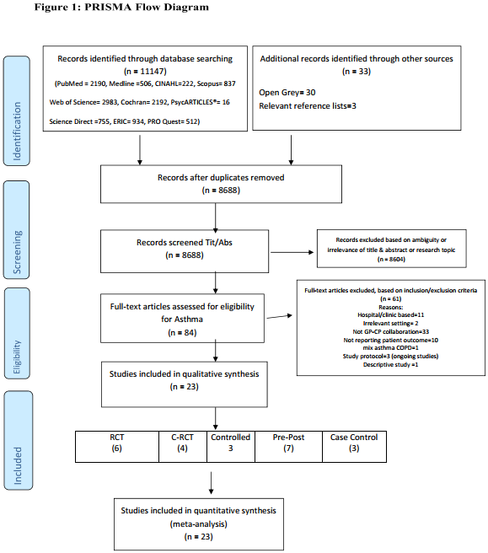

Biography
Naeem Mubarak is a PhD candidate passionate about pharmaceutical policy and practice. Research areas include: Qualitative research, Systematic reviews, Evidence-based research, Pharmacoeconomics and Clinical trials.

Email: naeem.mubarak@lmdc.edu.pk

