Chicory may be a promising anti-hyperuricemia agent both from renal-pathway and intestinal-pathway of urate Excretion
Bing Z, BUCM, China.

Abstract (300 word limit)

Hyperuricemia is characterized by high levels of serum uric acid which is related with impairments of urate excretion closely. It is commonly accepted that the kidney is an important organ which is responsible for two-thirds of urate excretion. At the same time, the gut is also an essential excretive pathway for hyperuricemia which take charge of the remaining third urate excretion. Thus, the drug which could promote renal-pathway and extra-renal/intestinal-pathway of urate excretion may be valued for urate-lowering treatment. Chicory is a traditional Chinese medicine. Functions of it are diuresis and detumescence, and it is also could be applied to treat spleen insufficiency. Our previous studies found chicory was excellent in uric acid-lowering. Currently, we observed whether the uricosuric effect of chicory is benefited by renal and/or intestinal pathways. We chose two kinds of animal model in present research, quails and rats. Quail, an ideal animal for hyperuricemia due to its similar metabolism pathway with human, was fed with 15% yeast. Rats were administrated with 10% fructose-drinking. All of model animals in our studies showed the sustained high level of serum urate level during experimental days. Meanwhile, results showed that chicory extract decreased the serum urate levels of these two kinds of animal models significantly, and increased urate levels of in excreta of hyperuricemia quails obviously, as well as promoted the urate excretion in the urine and feces of hyperuricemia rats. As of now, we thought chicory may be a promising anti-hyperuricemia agent both from renal-pathway and intestinal-pathway of urate Excretion. Next, we will further explore the possible mechanism of the uricosuric effect of chicory underlying the urate transporter responsible for renal-pathway and intestinal-pathway separately.

Image
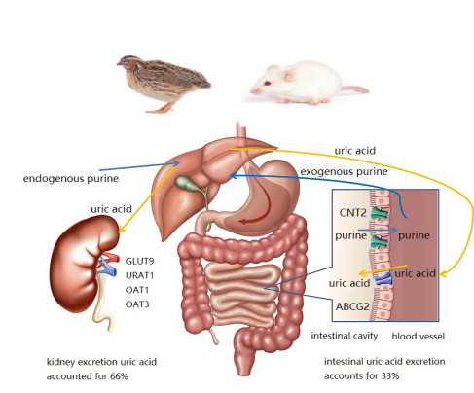
Figure The metabolic process of uric acid in the body
References
- Abramson RG, Levitt MF. Use of pyrazinamide to assess renal uric acid transport in the rat: a micropuncture study. Am J Physiol.1976; 230:1276-83.
- Hu QH, Wang C, Li JM, Zhang DM, Kong LD. Allopurinol, rutin, and quercetin attenuate hyperuricemia and renal dysfunction in rats induced by fructose intake: renal organic ion transporter involvement. Am J Physiol Renal Physiol.2009; 297: F1080-91.
- C. S. Zhu, B. Zhang, Z. J. Lin, X. J. Wang, Y. Zhou, et al. Relationship between High-Performance Liquid Chromatography Fingerprints and Uric Acid-Lowering Activities of Cichorium intybus L, Molecules, 2015, 20, 9455-9567.
- Rozpądek P, Wężowicz K, Stojakowska A, Malarz J, Surówka E, Sobczyk Ł, et al. Mycorrhizal fungi modulate phytochemical production and antioxidant activity of Cichorium intybus L. (Asteraceae) under metal toxicity. Chemosphere.2014; 112: 217-224.
- Nishimura H, Kondo Y, Nagasaka T, Satoh A. Allelochemicals in Chicory and Utilization in Processed Foods. J Chem Ecol.2000; 26: 2233-41.


Biography (150 word limit)

Prof. Bing Zhang, Chief of Clinical Chinese Pharmacy in Beijing University of Chinese Medicine, and Chief of Center for Chinese Pharmacovigilance and rational use of herbs, has research on the prevention and treatment of metabolic diseases. She had published more than 300 papers by first or correspondence author.

Notes/Comments

