Phytochemical and Pharmacological Evaluation of Methanolic Extract of Fruits of Annona muricata (Linn)
Sharmin Jahan, Abhijit Das, Mohammad Anwarul Basher, A. F. M. Shahid Ud Daula, Mohammad Safiqul Islam, Md. Hasanuzzaman*
Department of Pharmacy, Noakhali Science and Technology University, Sonapur, Noakhali 3814, Bangladesh.

Abstract

The present study was aimed to evaluate the phytochemical and biological investigations of fruits of Annona muricata, a plant belonging to the family of Annonaceae. The dry fruits was crushed and made powdered by a mechanical grinder, and were treated with methanol using cold extraction. The crude methanolic extracts of fruits of Annona muricata was evaluated for its possible chemical group identification, antioxidant, analgesic and neuoropharmacological activities. Phytochemical screening revealed the presence of phytoconstituents such as alkaloids, carbohydrates, tannins, saponins, phenols, flavonoids, and diterpines in methanolic crude extracts. The total phenolic content and total flavonoid was found to be 43.6 mg/gm in gallic acid equivalent (GAE) and 36.05 mg/gm in quercetin equivalent (QE), respectively. At the evaluation of analgesic activity, crude methanolic extract of fruits of Annona muricata showed dose dependent analgesia in Swiss albino mice model. In acetic acid induced writhing test, at a dose of 200 and 400 mg/kg body weight, the extractives showed 27.78% and 42.73% inhibition of writhing, whereas aspirin as a standard yield 66.45 % inhibition of writhing. In formalin induced hind paw licking test, methanolic extract showed significant amount of % inhibition of licking (p<0.001) in both of early phase and late phase at a dose of 200 and 400 mg/kg body weight. The crude methanol extracts of fruits was also used to evaluate anxiolytic activities such as open field, hole cross, hole board, elevated plus maze, dark light house test, forced swimming test, and tail suspension test. The result from all above experiment showed that the methanolic fruit extracts of Annona muricata possesses potential anxiolytic, sedative and antidepressant activity. Further study is warranted to elucidate the exact mechanism of these pharmacological activities and to identify the active ingredients for the drug development process.

Image
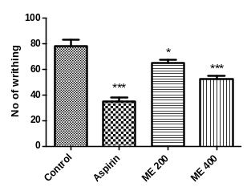
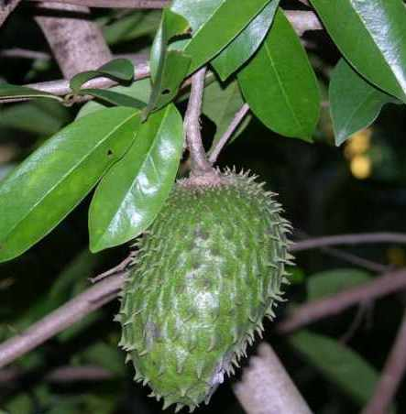

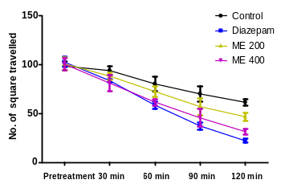
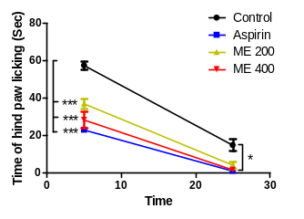

References
- Newman DJ CG, Snader KM. (2003) Natural products as sources of new drugs over the period 1981-2002. J Nat Prod 66:1022-1037.
- Dannerman PJ. Kohn DK SK, Wixson B, White WJ, John G, editors. (1977) In: Monitoring of analgesia in anesthesia and analgesia in laboratory animals. USA: Academic Press: 83-99.
- Pellow S. CP, File S. E., Briley M. (1985) Validation of open: closed arm entries in an elevated plus-maze as a measure of anxiety in the rat. . Journal of Neuroscience Methods 14:149-167.
- Panthong A NP, Kanjanapothi D, Taesotikul T, Anantachoke N, Reutrakul V. (2007) Anti-inflammatory, analgesic and antipyretic activities of the extract of gamboge from Garcinia hanburyi Hook f. J Ethnopharmacol 111:335-340.

.

Biography
Dr. Md. Hasanuzzaman is an Associate Professor of the Department of Pharmacy at Noakhali Science and Technology University, Bangladesh. He received his PhD degree under the mentorship of Professor Jae-Gook Shin from the Department of Pharmacology, Inje University College of Medicine, Busan, Korea. He has expertise in multidrug resistance cancer, multidrug resistance tuberculosis, and drug transporter research. He is also involved in phytochemical research of different medicinal plants in Bangladesh from his academic carrier since 2010. He has strong interest in pharmacogenomics and personalized medicine research in Bangladesh.

Email: hasanprdu@gmail.com

Email: hasanprdu@gmail.com

