Cichorium intybus L. Decreases the Serum Uric Acid Level in Fructose-induced Hyperuricemia by Inhibiting the Reabsorption of Renal Transporters
Yu W, Zhijian L, Bing Z, BUCM, China.

Abstract (300 word limit)
Hyperuricemia is a chronic metabolic disease which caused by excessive production or impediment excretion of uric acid. The kidney plays an important role in uric acid excretion which contains the handling process of reabsorption and secretion. A series of renal uric acid transporters is responsible for the two processes, mainly including reabsorption transporters URAT1 and Glut9 as well as secretion transporters OAT1 and OAT3. Excessive intake of fructose may result in elevated serum uric acid levels. Cichorium intybus L., commonly known as chicory, has been used as an edible vegetable and a traditional remedy which function as diuresis, detumescence and cholagogue. Our previous studies found chicory had an effect on treating hyperuricemia which correlate with decreased production and increased intestinal excretion. Currently, we evaluated the mechanism of its uricosuric effect via renal pathway. Hyperuricemia rats induced by 10% fructose solution were treated with chicory at three doses and benzbromarone respectively. Chicorydecreased the serum levels of uric acid and creatinine, and promoted the clearance rates of creatinine and uric acid, as well as improved renal pathological changes in hyperuricemia rats. Further examination illustrated that chicory inhibited the mRNA and protein expressions of URAT1 and GLUT9 markedly in a dose-dependent manner whereas showed no influence in the mRNA and protein expressions of OAT1 and OAT3. Taken together, chicory might be a promising anti-hyperuricemia agent to promote uric acid excretion in the kidney via inhibiting renal reabsorption which may relate with down-regulation of mRNA and protein expression levels of URAT1 and Glut9.

Image
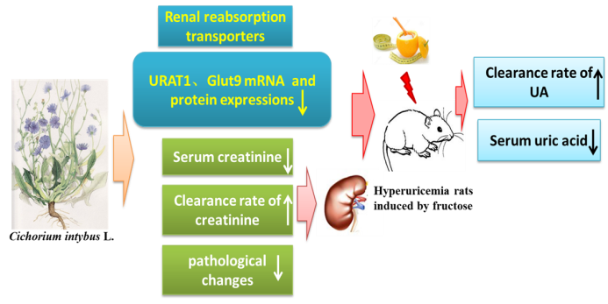
References
- C. Zoccali, F. Mallamaci, Uric acid, hypertension, and cardiovascular and renal complications, Curr Hypertens Rep, 2013, 15, 531–537.
- L. McLean, N. Dalbeth, Etiolgoy and pathogenesis of gout. Rheum, 2015, 2, 1555-1568.
- F. Perezruiz, N. Dalbeth, T. BardinA, Review of Uric Acid, Crystal Deposition Disease, and Gout, Adv Ther, 2015, 32, 31-41.
- C. S. Zhu, B. Zhang, Z. J. Lin, X. J. Wang, Y. Zhou, et al. Relationship between High-Performance Liquid Chromatography Fingerprints and Uric Acid-Lowering Activities of Cichorium intybus L, Molecules, 2015, 20, 9455-9567.
- Y. Wang, Z. J. Lin, Z. Bing, A. Z. Nie, B. Meng, Cichorium intybus L. promotes intestinal uric acid excretion by modulating ABCG2 in experimental hyperuricemia, Nutr Metab, 2017, 14, 38.
- R. M. Pelis, S. H. Wright, SLC22, SLC44, and SLC47 transporters—organic anion and cation transporters: molecular and cellular properties, Curr Top Membr, 2014, 73, 233–261.

 Biography (150 word limit)
Yu W has her expertise in evaluation and passion in improving metabolic disorders by traditional chinses medicine. Her studies focus on the excretion pathway of hyperuricemia and assess the pharmacodynamics of Cichorium intybus L, a dietetic herb frequently used in Chinese medicine and nutrition, in lowering serum uric acid levels. She found Cichorium intybus L. has the uricosuric effect by regulating URAT1 and Glut9 in the kidney to inhibit uric acid resorption.
Email: wangyuxh@163.com

Notes/Comments

