Treatment of genito-pelvic pain/penetration disorder: From cognitive-behavioral sex therapist view
Sung-Chen Tung, M.D., Sung-Ful Sexual Health Center; Taiwan

Abstract (300 word limit)
Background: Genito-pelvic pain/penetration disorder (GPPPD) is one of the leading causes of female sexual dysfunction but not well defined or understood and affects women’s sexual health and satisfaction. The purpose of this study were described the patients’ sexual behaviors before treatment and clinical experience of help-seeking for GPPPD, and compared effectiveness of intensive and weekly cognitive-behavioral therapy (CBT) on GPPPD. Method and material：27 patients meeting DSM-5 criteria for GPPPD were enrolled. 14 patients from China undertook intensive CBT (iCBT, 3 1.5-hr sessions over 3 days) used a comparison group of 13 patients from Taiwan undertook weekly CBT (wCBT, 4 2-hr sessions over 4 wks). All participants responded to sex history, Female Sexual Function Index (FSFI) and Sexual Anxiety Scale (SAS) before the first session and 3-month follow-up after intervention. Result: The subjects were 31.2 years of age on average, 4.6 years of GPPPD duration, 74.1% were severe and 96.3% were lifelong GPPPD, 60.9% had non-penetrative sex and 29.6% seek for otherwise treated before for CBT intervention. At 3-mo follow-up, significant improvements in lubrication (Z=-2.314, p=.021), sexual satisfaction (Z=-2.694, p=.007), and sexual pain (-3.606, p<.001). 25.9% had been defined normal female sexual function (FSFI>26.55) and 92.6% had intercourse in the last 1 month. iCBT had no significant reduce in SAS (p=.374~.953), and wCBT had(p=.005~.196). Conclusions: More than half of female with GPPPD had non-penetrative sexual behaviors. iCBT and wCBT program had signiﬁcantly effectiveness on reduce sexual pain and improve sexual function in GPPPD. But iCBT can’t offer cognitive restructure enough to reduce sexual anxiety.
Image
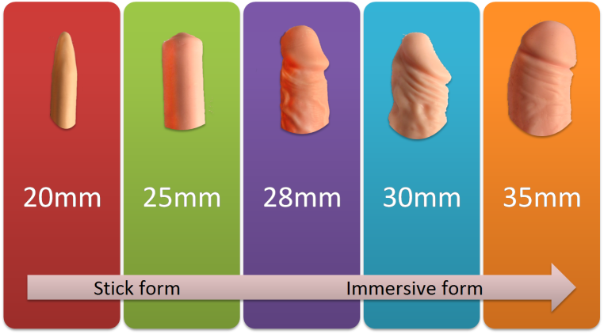
Figure 1. Treatment tools for reality systematic desensitization

Table 1. Effectiveness of cognitive-behavioral therapy on genito-pelvic pain/penetration disorder
 | Pre-test | Post-test | p value
Desire | 3.0 ± 1.4 (1.2-6) | 3.6 ± 1.1 (1.2-5.4) | .151
Arousal | 2.7 ± 1.9 (0-6) | 3.5 ± 1.5 (0-6) | .106
Lubrication | 2.8 ± 2.3 (0-6) | 4.2 ± 1.8 (0-6) | .021
Orgasm | 2.4 ± 2.3 (0-6) | 3.0 ± 1.8 (0-6) | .398
Overall satisfaction | 1.9 ± 1.9 (0-5.2) | 3.6 ± 1.8 (0-6) | .007
Pain | 0.6 ± 1.0 (0-3.6) | 3.1 ± 2.1 (0-6) | <.001
Total | 13.3 ± 9.3 (1.2-29.2) | 21.0 ± 8.4 (1.2-34.8) | .005

References
- American Psychiatric Association.(2013) Diagnostic and Statistical Manual of Mental Disorders(5th ed.) Washington, DC.
- Pereira et al. (2013) Sex therapy for female sexual dysfunction. International Archives of Medicine 6:37.
- Weinberger JM, Houman J, Caron AT, Anger J. (2018) Female Sexual Dysfunction: A Systematic Review of Outcomes Across Various Treatment Modalities. Sex Med Rev DOI:10.1016/j.sxmr.2017.12.004
- Rosen R. et al. (2000) The Female Sexual Function Index (FSFI): a multidimensional self-report instrument for the assessment of female sexual function. J Sex Marital Ther 26(2):191-208.

Biography (150 word limit)
Sung-Chen Tung is a cognitive-behavioral sex therapist and a writer for intimate relationships. As a president of Chung-Hua Sexual Health Promotion Association, she is aim at promoting couple’s sexual wellbeing and training sex therapists. She has expertise in treatment of psychogenic sexual dysfunction by CBT approach, especially on premature ejaculation, erectile dysfunction and female dyspareunia. The techniques of CBT focus on identifying and changing the distorted cognition, and provides strategies/skills to modify sexual behaviors.

Email: sungful168@gmail.com
Notes/Comments

