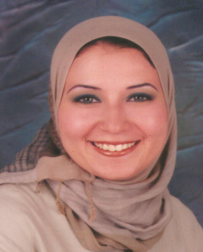
Evaluation of the potential of interleukin-9 expression as a prognostic factor for chronic lymphocytic leukemia in a cohort of Egyptian patients
Hadeer A Abbassy*, Reham A Aboelwafa*, Omar M Ghallab**
* Clinical and Chemical Pathology Department **Internal Medicine,
Faculty of Medicine, Alexandria University, Egypt.
Chronic lymphocytic leukemia (CLL) is a common lymphoid malignancy that has a highly variable clinical course. Genomic features as zeta-chain-associated protein kinase 70 (ZAP70) expression and CD38 expression provide further differentiation of disease prognosis. Extensive studies have confirmed the oncogenic activities of IL-9 in lymphoma. The aim of the current study was to investigate the contribution of IL-9 expression to the pathogenesis of CLL and its correlation to other prognostic parameters. This study was conducted on 80 patients at diagnosis with CLL and 80 healthy controls. Using real time polymerase chain reaction and enzyme linked immunosorbant assay, IL-9 mRNA expression and its serum level were compared between patients and controls. They were both correlated with other prognostic factors. Results: There was an overexpression of IL-9 in CLL patients that correlated with modified Rai staging, ZAP70, CD38 and all hallmarks of an active and aggressive disease. The correlation between IL-9 upregulation and patient characteristics provided direct clinical evidence for its contribution to the pathogenesis of CLL. In conclusion, significantly higher expression of IL -9 measured at both the mRNA and the protein levels in patients with CLL that correlates with more complex course of the disease and worse prognosis may allow one to speculate its importance in the pathogenesis of the disease and its possible impact on prognosis.

Biography:
Doctor Reham Abdel Haleem Aboelwafa, is a Lecturer of Clinical Pathology, Faculty of Medicine, Alexandria University, Egypt. She completed her MD at the age of 33. She has expertise in research, teaching and administration both in hospital and education institution. She is expert in Molecular Techniques: PCR (conventional, and Real time PCR), microarray, Pyrosequencing and NGS in addition to FISH techniques including Prenatal Genetic Diagnosis (PGD) and Flow cytometric mmunophenotyping of different types of hematologic malignancies. She has several international publications in the field of molecular biology, genetics and epigenetics.
Presenting author details
Full name: Reham Abdel Haleem Aboelwafa
Contact number:00201002413832
Twitter account: reham halem
Linked In account: Reham Aboelwafa
Session name: Molecular diagnostics
Category: Poster presentation

