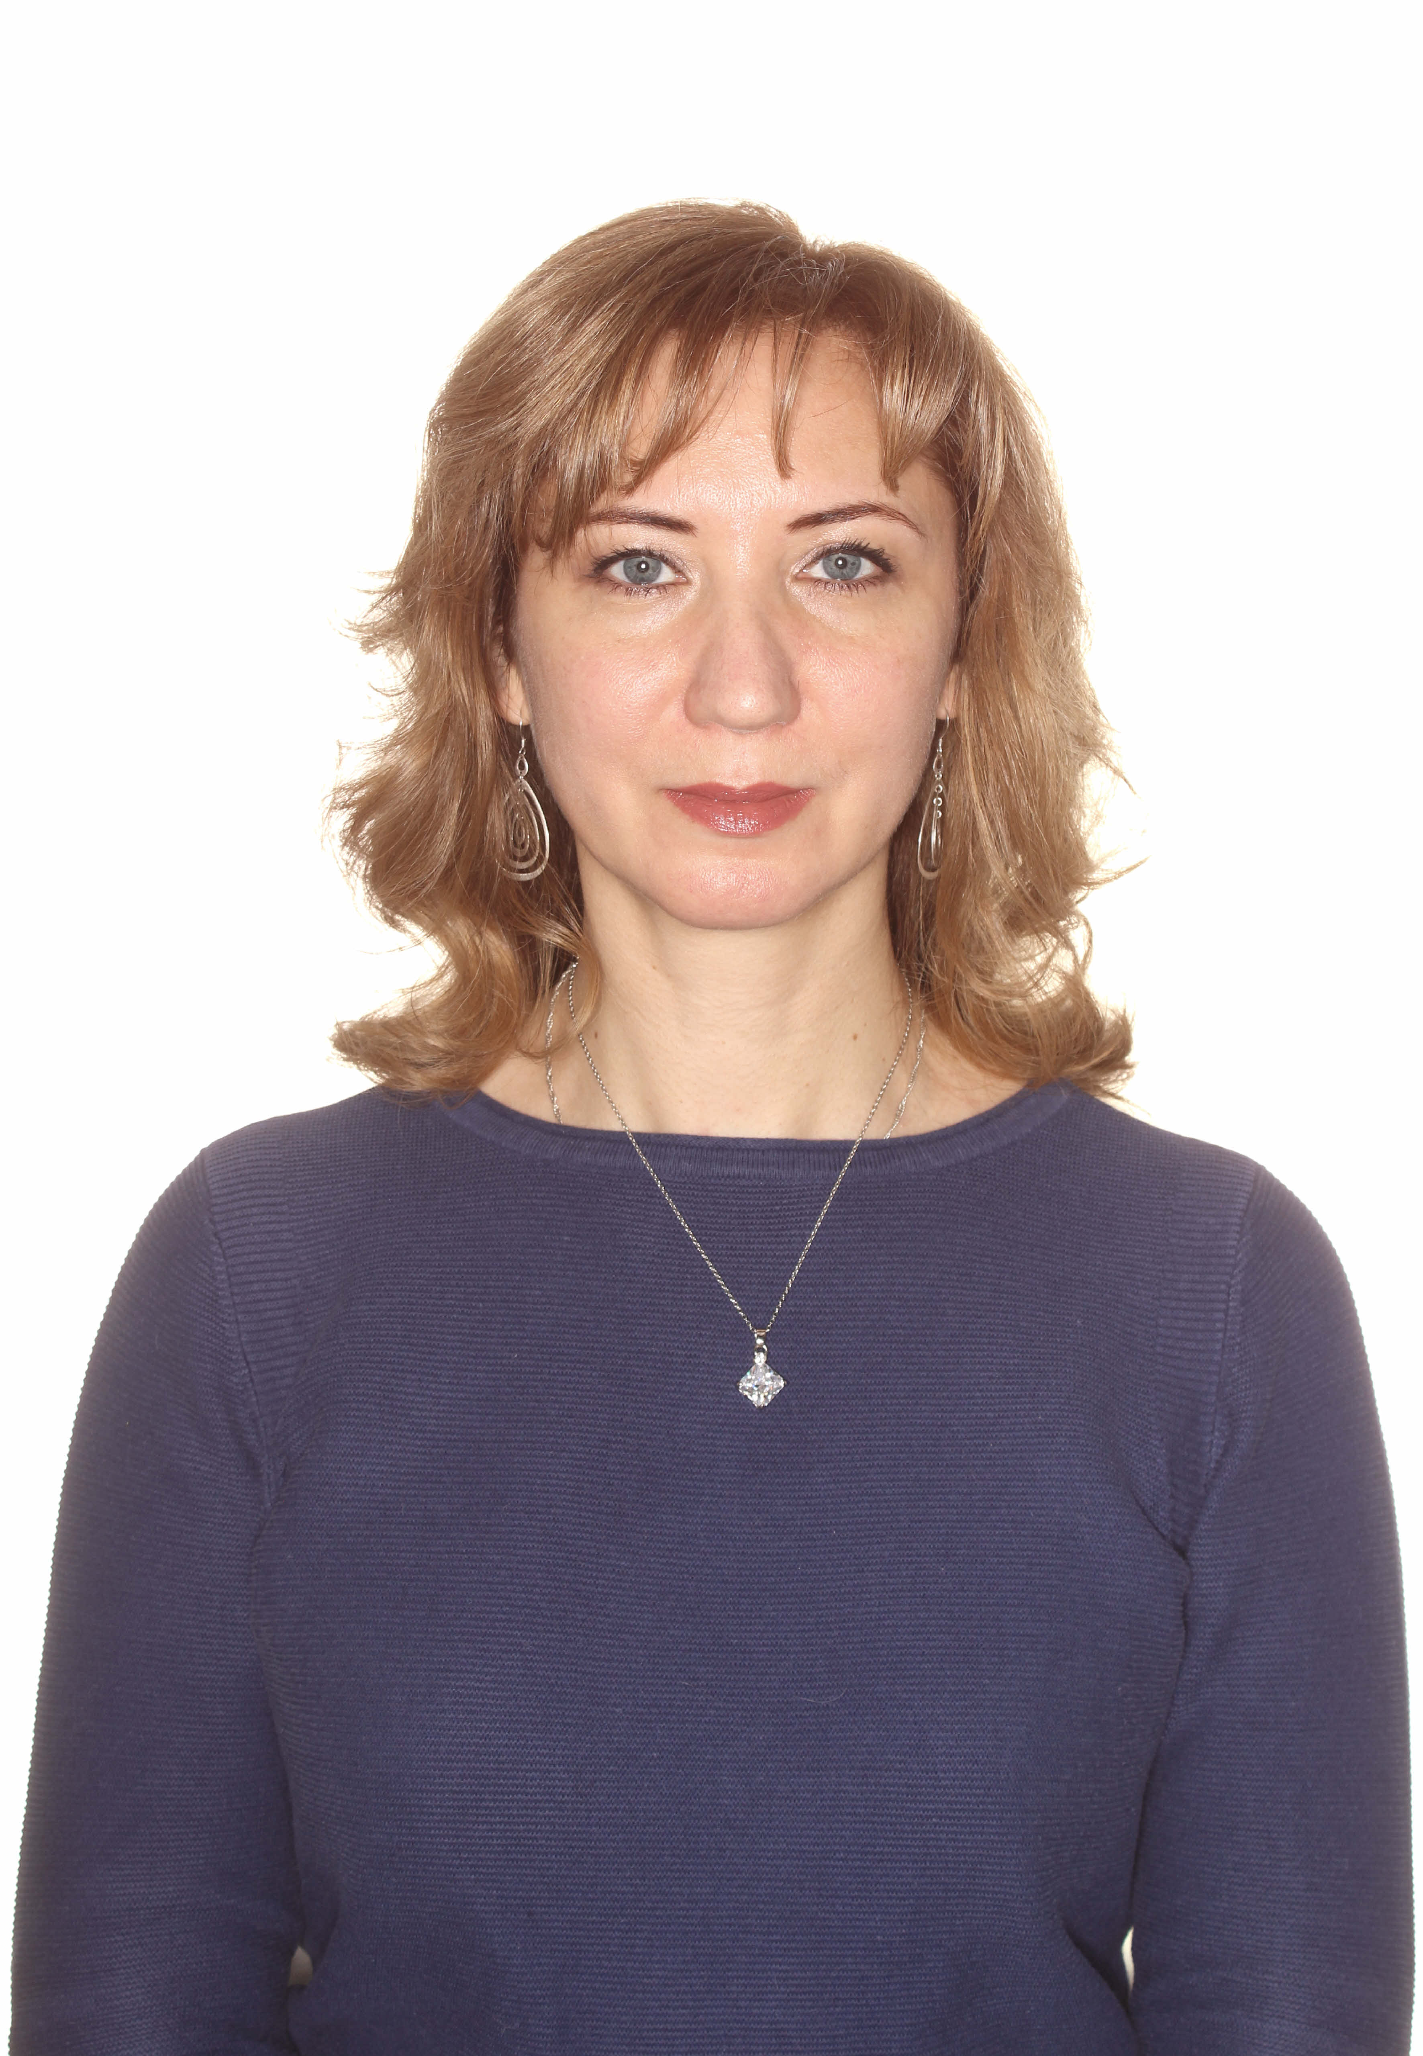
Title: Immunoactive polysaccharide compositions enhancing the effectiveness of anti-infective drugs
Name: Konopleva M.V., Fediakina I.T., Tsyrulnikov S.A., Kirillov I.M., Kiseleva I.V., Davtian S.A., Suslov A.P., Nesterenko V.G.
N.F. Gamaleya National Research Centre for Epidemiology and Microbiology, Moscow 123098, Russia

Macromolecular immunoactive polysaccharides, glucans, are now available for the prophylaxis of viral, bacterial or fungal infection. They can gently induct or modify of immunity without hyperstimulation. A successful example of using glucans for anti-viral treatment is the pharmaceutical called Kagocel. It is based on highly standardized chemically modified both natural polyphenol and immunoactive cellulose beta-glucan. The commercial success of this drug in the Russian pharmaceutical market is due to its excellent safety and efficacy record over fifteen years. The antiviral efficacy of Kagocel against influenza infection has been confirmed in vitro and in vivo in relation of different strains H3N2 and H1N1 influenza viruses, including H1N1pdm09. In vitro, the antiviral activity of Kagocel has been demonstrated by its effect on the infectious titer of influenza virus, and on the level of expression of viral antigens. Clinical studies have shown that the combined use of Kagocel and Tamiflu significantly reduces the number of complications of influenza infection and reduces the time of recovery. Research and development of this concept, has led to other experimental compositions of immunoactive beta-glucan cellulose and polyphenols with antimicrobial activity. Immunoactive beta-glucan cellulose macromolecules with oseltamivir phosphate, the active pharmaceutical ingredient of Tamiflu, significantly increased the biological activity of oseltamivir phosphate. Chemically modified immunoactive beta-glucans may be very promising objects for the development of new pharmaceuticals. (Up to 250 words)

Biography

Konopleva M.V. obtained her PhD and continued her postdoctoral studies at N.F. Gamaleya Institute for Microbiology and Immunology. She is the Senior Scientist in Laboratory of Mediators and Effectors of Immunity. She has published more than 27 papers in scientific journals and also she has been included as an inventor in 2 patents. (Up to 100 words)
Presenting author details
Full name: Mariia Konopleva
Contact number: +7 (916) 313-84-76
Twitter account: none
Linked In account: is not used

Orcid: http://orcid.org/0000-0002-9724-695X

Session name/ number:
Category: (Oral presentation/ Poster presentation)

