Antiviral activity and possible mechanisms of action of Acacia nilotica against influenza A virus

Mona Timan Idriss¹;Malik SulimanMohamed²;Sarawut Khongwichit³;Natthida Tongluan³; Duncan R. smith³;N. H. Abdurahman ⁴; N.H. Azhari ⁵,Alamin Ibrahim Elnima²

¹Department of Pharmaceutical Microbiology, Faculty of Pharmacy,Sudan International University,ObaidKhatim Street, Arkawait, P.O. Box 12769
²Department of Pharmaceutical Microbilogy and Biotechnology, Faculty of Pharmacy, Khartoum University, 11111 Qasr Street,P.O.Box 1996, Sudan
³ Institutes of Molecular Biosciences, Mahidol University, Bangkok, Thailand
⁴Facultyof Chemical and Natural Resource Engineering, University Malaysia Pahang
⁵Facultyof Industrial Sciences and Technology, University Malaysia Pahang
Correspondence should be addressed to Mona Timan Idriss; monatabo40@yahoo.com, or Malik Suliman Mohamed; msmohammed@uofk.edu

Abstract
We investigated the anti-influenza virus activity of Acacia nilotica and possible mechanism(s) of action in vitro. We found that Acacia nilotica has anti-influenza-virus activity, and both pre-incubation of virus prior to infection and post-exposure of infected cells with Acacia nilotica extract significantly inhibited virus yields. Influenza-virus-induced hemagglutination of chicken red blood cells was inhibited by Acacia extract treatment, suggesting that Acacia can inhibit influenza A virus infection by interacting with the viral hemagglutinin. Furthermore, Acacia extract significantly affect nuclear transport of viral nucleoprotein (NP). To best of our knowledge, this study revealed for the first time that Acacia nilotica extract can inhibit both viral attachment and replication and offers new insights into its underlying mechanisms of antiviral action.
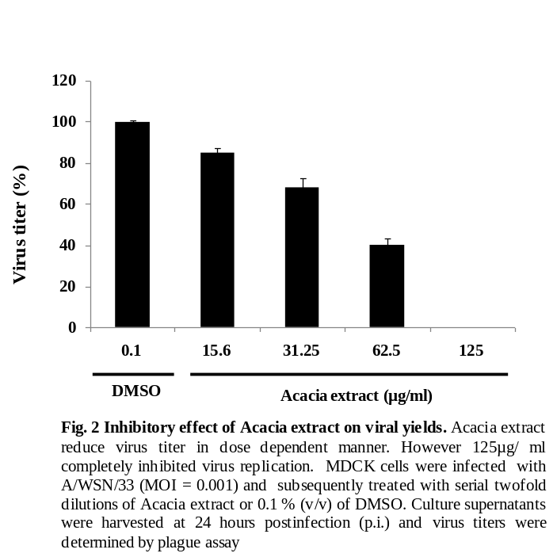
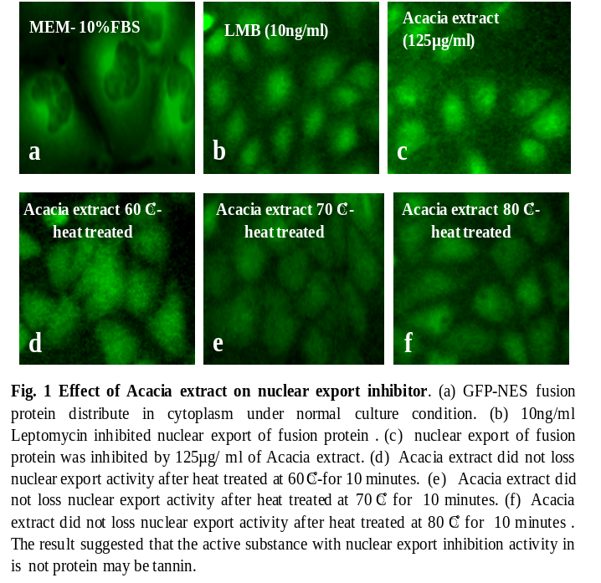
The fruit husk ofAcacia nilotica collected from Sudan and Extracted with70% methanol. The crude extract was screened for its cytotoxicity against MDCK cell line by alamar Blue assay and WST-1 assay. Antiviral properties of the plant extract was determined bycytopathic effect inhibition assay and virus yield reduction assay(plaque assay). Time of addition assay, and nuclear export mechanism were also performed.

