Title: HPLC, “A boon for routine and advance chromatographic separations”.
Bhumika G. Rathod, PhD, Gandhinagar Gujarat, India

Abstract
Chromatography was first discovered in 1903 by Twsett for isolation of chlorophyll. In 1960s HPLC was developed as an analytical tool. Liquid chromatographic approaches cover a wide range of applications today. It is closely relevant in scientific studies, which provides a powerful identification of certain components that will be effective for curing specific diseases. Especially important, LC methods can assist us for isolation and purification of therapeutic drugs that benefit for the development of medical industry. As the development of liquid chromatography, the single effective component within a drug can be separated and purified under extreme purity requirements from a biological system with great complexity and abundance. However, improvement of LC methods is still urgently needed for better application of this method to benefit our lives. It has also been widely used in separation of herbal drug molecules. Routine analysis of herbal drug substances and formulations has also become possible to meet the regulatory requirements. The current study shows review literature of certain advances in chromatographic techniques.
Image
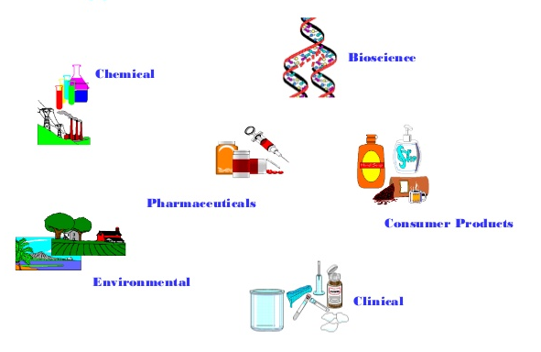
Publications
- Bhumika G. Rathod (2014) Development of RP-HPLC method for simultaneous estimation of berberine Hcl and glycyrrhetenic acid in polyherbal formulation. IJPRD 06(03):001-006.
- Rathod B (2013) Development of validated RP-HPLC method for the estimation of Withaferin – A in Withania Somnifera, its extract and polyherbal formulation. Pharma Science Monitor 04(03):01-09.
- Bhumika G. Rathod (2014) Development of validated RP-HPLC method for the estimation of L-Dopa from Mucuna pruriens, its extracts and in Aphrodisiac formulation. IJPSR 05(08):508-513.
- Rathod B G. (2012) Simultaneous estimation of Sildenafil citrate and Dapoxetine hydrochloride in bulk and pharmaceutical formulations. Inventi Rapid: Pharm Analysis & Quality Assurance ID- " Inventi:ppaqa/510/12.
5. Rathod B G. (2012) Development and Validation of Spectroscopic Methods for Simultaneous Estimation of Avanafil and Dapoxetine Hydrochloride in Combined Dosage Form Inventi Rapid: Pharm Analysis & Quality Assurance: 4: 1-6


Bhumika Rathod is a PhD graduate in Pharmaceutical Science. She is a professional in pharmaceutical field since last eight years; she has a good exposure in Quality control, Quality assurance, Analytical development in Research and development, Analytical development in Formulation and development departments. She has an expertise in HPLC, UPLC operation, troubleshooting and maintenance. Currently she is employed by Piramal Enterprise Ltd, a reputed pharma company in research and development.
Email:bhumi.pharma@gmail.com
- Full Name: Bhumika Gopalbhai Rathod
- Personal Email: bhumi.pharma@gmail.com
- Mobile Number: +91-9427744604
- Linked In: bhumi.pharma@gmail.com
- Facebook: NA
- Session Name/ number:
- Category: (Oral presentation/ Poster presentation)
- Date of Birth: 03 October 1985
- Postal Address: Block No 15/2 sector 4A, Gandhinagar-382006, India

Notes or Comments:

