Characterization and distinction of species the genera Gnaphalium and Achyrocline using chromatographic profiles (HPLC-DAD) and pattern recognition techniques.

Sergio Cuervo-Escobar PhD, Lizeth López-Carrillo, Fabián Ladino-Torres. Facultad de Ciencias, Universidad de Ciencias Aplicadas y Ambientales, Bogotá, Colombia

Abstract
Plants of the genera Gnaphalium and Achyrocline, belonging to the family Asteraceae are used in various parts of the world as medicinal plants due to their recognized applications in the therapeutic treatment of various pathological conditions. Additionally, it has been found that its extracts have activities such as antioxidants, anti-inflammatory, antimicrobial and even anti-tumor. Several species belonging to these genera have similar morphological characteristics which leads to sometimes confused between these genera, there are, however, significant differences in the class and quantity of flavonoids and other molecules with biological potential present in them.
In this work a chromatographic study was performed by HPLC-DAD, for the leaf and flower ketone extracts in the species Gnaphalium elegans, Achyrocline satureioides and Achyrocline bogotensis, through which it was possible to establish signal patterns, specific for each one of them, thus allowing to have a tool for its rapid identification and that it can be used to evaluate the biological potential of other species the family Asteraceae. By pattern recognition techniques, it was established that these profiles show significant differences between them, which allows a quick and unambiguous characterization of these species. The methodology developed for the establishment of chromatographic profiles, which includes a gradient with 2% acetic acid and methanol, on a RP-18 column, It also allows the identification and quantification of at least 10 flavonoids that may be present in these species.
These results contribute to the optimization of time and resources around the investigations that will lead to the establishment of therapeutic treatments from extracts of these plants.

Image

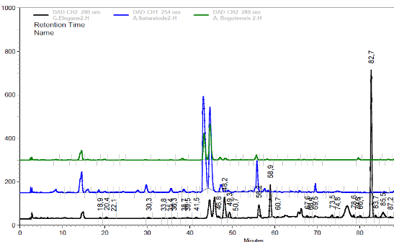

Figure 1. Superposition of chromatograms representative of leaf extracts of A. satureioides, A bogotensis and G. elegans. HPLC-DAD, column RP-18, mobile phase: gradient of acetic acid 2% and methanol.

Recent Publications

- Li, J., X. He, M. Li, W. Zhao, L. Liu, and X. Kong, 2015. Chemical fingerprint and quantitative analysis for quality control of polyphenols extracted from pomegranate peel by HPLC. Food Chem., 176(1): 7-11

- Bezerra, I.C.F., R. T. de M. Ramos, M. R. A. Ferreira, and L. A. L. Soares, 2018. Chromatographic profiles of extractives from leaves of Eugenia uniflora. Rev. bras. Farmacogn., 28(1): 99-101

- Thomas C. M., R. C. III Wood, J. E. Wyatt, M. H. Pendleton, R. D. Torrenegra, O. E. Rodriguez, S. Harirforoosh, M. Ballester, J. Lightner, K. Krishnan, and V. P. Ramsauer, 2012. Anti-Neoplastic Activity of Two Flavone Isomers Derived from Gnaphalium elegans and Achyrocline bogotensis. PLOS ONE, 7(6)

- Ding, Y., D. Dou, Y. Guo, and Q. Li, 2014. Simultaneous quantification of eleven bioactive components of male flowers of Eucommia ulmoides oliver by HPLC and their quality evaluation by chemical fingerprint analysis with hierarchical clustering analysis. Pharmacogn. Mag., 10(40): 435–440

- Rodríguez-Ramos, F., V. H. Sánchez-Estrada, A. Alfaro-Romero, G.R. Tapia-Alvarez, A. Navarrete, 2011. Development and validation of a column high-performance liquid chromatography method for quantification of ganaphaliin A and B in inflorescences of Gnaphalium liebmannii Sch. Bp ex Klatt. J. AOAC Int., 94(4): 1076-1081

- Wang, L., X. Wang and L. Kong, 2012. Automatic authentication and distinction of Epimedium koreanum and Epimedium wushanense with HPLC fingerprint analysis assisted by pattern recognition techniques. Biochem. syst. ecol., 40: 138-145

Biography



Sergio Cuervo-Escobar is Chemist and PhD from Universidad Nacional de Colombia. Experience as a professor at the undergraduate, master's and doctoral levels in the areas of general chemistry, biochemistry, analytical chemistry and quality control. Extensive experience in HPLC, instrumental analysis, development and validation of analytical methodologies. Experience as a researcher in the area of Biochemistry, Analytical Chemistry and Phytochemistry. Has published several articles in recognized journals and has been editor of the journal of Scinces Faculty of the U.D.C.A.

Email: scuervo@udca.edu.co
- Full Name: Sergio Andrei Cuervo Escobar
- Personal Email: scuervo@udca.edu.co
- Mobile Number: 573102067124
- Linked In:
- Facebook:
- Session Name/ number: Method Development and Validation/ 12
- Category: Oral presentation
- Date of Birth: 15-09-1975
- Postal Addre

