Are Oral Arginine Supplements Effective in Attenuating Hypertension?
Sarah Martin, University of Saskatchewan, Canada

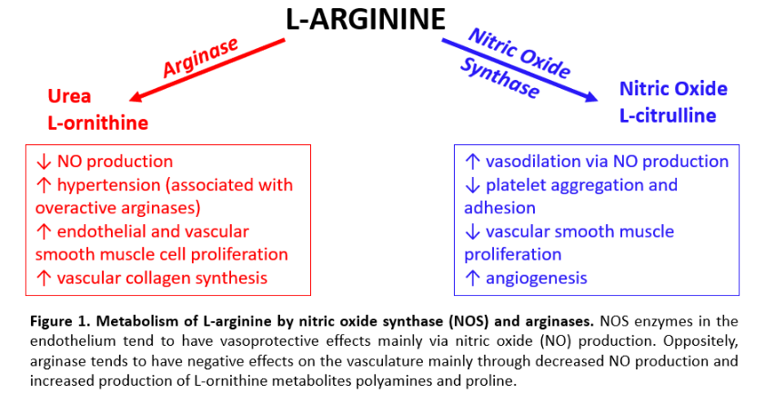
Abstract (300 word limit)

Oral L-arginine supplements have been tried to lower blood pressure with conflicting results, with one of the factors affecting the outcome is whether the subject is healthy or has hypertension. Arginine is a substrate for at least four enzymes including nitric oxide synthase and arginase, but the impact of oral supplements on its different metabolic pathways is not clear. We examined the effect of L-arginine and D-arginine, at two different doses of 500 mg/kg/d (500) or 1000 mg/kg/d (1000) in drinking water administered for 4, 12 or 16 weeks to separate groups of 9 week old male Sprague-Dawley (SD) rats or 5 week old male Zucker Diabetic Fatty (ZDF) rats. We report the effects on the endothelial nitric oxide synthase (eNOS)/nitric oxide (NO) and the arginase/urea metabolic pathways. L-arginine (500) increased eNOS expression in the aorta and the kidney and plasma nitrite levels, but did not affect the mean arterial pressure (MAP) in the SD rats. L-arginine (500) also decreased arginase II in the ileum. D-arginine also unexpectedly increased eNOS expression in the kidney and decreased arginase in the liver and the ileum. Arginine (1000) also did not affect the MAP in the SD rats. On the other hand, L-arginine (1000) attenuated the increase in MAP in the ZDF rats without affecting eNOS expression or nitrite levels. However, it did not attenuate the increased arginase expression or urea levels in the ZDF rats as compared to Zucker lean rats. In conclusion, two different doses and durations of oral arginine treatment did not affect the MAP in Sprague-Dawley rats, but attenuated it in the ZDF rats. Thus, the blood pressure lowering effect of oral L-arginine should not be taken for granted and their effects on the arginase and other metabolic pathways (results not shown) should be considered to avoid adverse effects.
Image

Recent Publications (minimum 5)

 Biography (150 word limit)
Sarah Martin completed her BSc. in Physiology and Pharmacology at the University of Saskatchewan. During this time, she researched which phospholipase C isoform was involved in the cell signaling pathway responsible for osmoregulation via magnocellular neurons. Having a greater interest in pharmacology Sarah switched her focus from neuroscience to begin her MSc. in pharmacology. Her project aimed to study the effects of oral arginine supplements on male Sprague-Dawley and Zucker Diabetic Fatty rats. She will be completing her MSc. this summer and is excited to start the Post Degree Nursing program next spring with the final goal of becoming a nurse practitioner.
Email: sarah.martin@usask.ca
Phone: +1-306-850-8567

Notes/Comments:

