Case report
First case report of gall bladder agenesis and absences of extrahepatic biliary system
Elssayed Osman Elssayed α, Mohanned Omer Abass σ & Abdelrahman Babekir Mhammed ρ
Author α σ ρ: MBBS, MD, Assistant Professor of General Surgery, Faculty of Medicine, Shendi University. E-mail: elssayedosman@gmail.com Author

ABSTRACT++
Gallbladder agenesis and other biliary anomalies were a rare but well-documented anatomical variations. Pre-operative diagnosis may be difficult as patients can present with typical symptoms of biliary colic and imaging may be misleading. We report a first case of agenesis of the gallbladder and absences of extrahepatic biliary system.

INTRODUCTION
Anomalies of the biliary system are not uncommon; theses may involve the biliary ducts or the gall bladder. Gall bladder anomalies may be in the form of abnormalities in the shape, position, or cystic duct. They are usually discovered during surgery for gall stone disease or other surgeries involving the biliary system of the liver. [1]
Agenesis of the gallbladder, an extremely rare condition with incidence of 0.01%–0.02%, is characterized by the absence of the gallbladder without atresia of the extrahepatic biliary system (2)
In 1543, Vesalius identified the anatomical insertion of the common bile duct into the duodenum [(3). In the 500 years since then, the anatomical deviation of the duct into a double common bile duct has been an increasingly rare incidence with Telium (4)
Nakamura K1, Mitsubuchi H, and his colleague report case of Complete absence of bile and pancreatic ducts in a newborn: a new entity of congenital anomaly in hepato-pancreatic development and she died shortly after birth.(5)
First case of Gallbladder agenesis was described in 1701 by Lemery.(6)(7). Since then, there have been described about 500 similar clinical cases in the medical literature, most of them are presented with single clinical cases (6)(8).
The disease is rare and congenital, with an incidence of 10–65 per 100,000(9)(10).
In 50% of the patients with gallbladder agenesis, who complained of the similar symptoms to biliary colic, correct diagnosis: gallbladder agenesis is diagnosed intraoperatively (6)(8),(11),(12),(13),(14). Preoperative diagnosis is often complicated. The main reason of diagnostic difficulties is a “constricted, shrunken gallbladder” and sometimes hyperechogenic shadows seen by radiologist under ultrasonography. Those shadows are considered as gallbladder stones and patient is mistakenly diagnosed with cholelithiasis and later is operated too (6)(12), (14), (15), (16), (17).

LITERATURE SEARCH
PubMed and Google Scholar were used to perform a systematic review of the available literature. Searches using the following keywords “ common bile duct anomalies”, “extrabilary system anomalies”, ”, “absence of extrabilary system”, ”, “gall bladder agenesis”, no case reported in the literature of gall bladder agenesis combined with complete absences of extrahepatic biliary system.

CASE REPORT
A 40-year-old lady presented with frequent attacks of right hypochondrial pain for the last 3 months, the pain was dull , radiate to shoulder was associated with nausea, no vomiting, and no fever or jaundice.
The patient admitted to casualty many time with similar condition. The patient had no history of any medical diseases, and the past surgical history was negative. Ultrasound of the abdomen showed distended gall bladder with thick wall no stone.
After the initial management, laparoscopic cholecystectomy was considered but the patient insist to do it open. During surgery gallbladder could not be found and there was no extrahepatic biliary system and the duodenum completely attach to the liver. Initially we think of contracted gall bladder and the duodenum adherent to it, but the picture is clear after introduce of small sized nasogastric tube, which enter directly to the liver, so this case of gall bladder agenesis and absence of extrahepatic biliary system. Surgical operation was completed without complications. Postoperative treatment included analgesics and antispasmodics. Pre-operative symptoms disappeared. later magnetic resonance cholangiopancreatography (MRCP) confirmed the introperative picture Figure 1. Health condition of the patient is satisfactory.
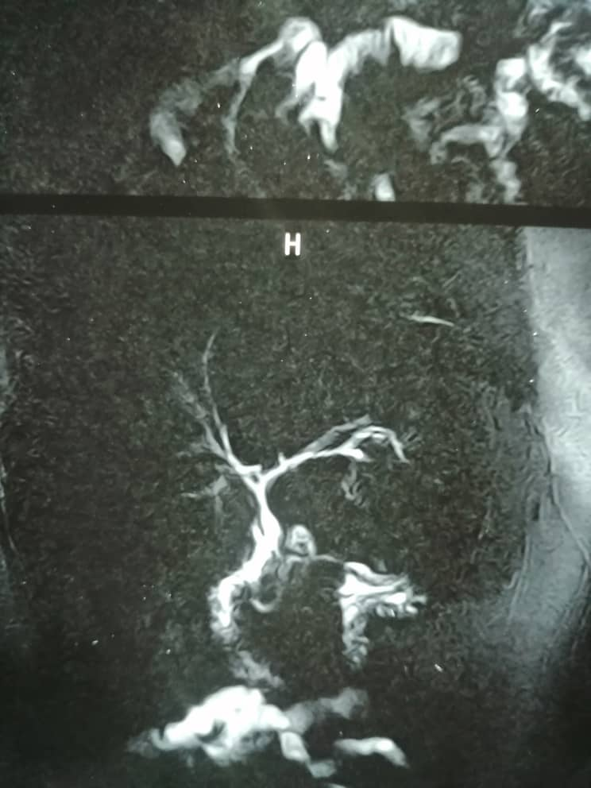
Figure 1: MRCP show intrahepatic biliary sytem with very short part between confluence and dilated area(duodenum)
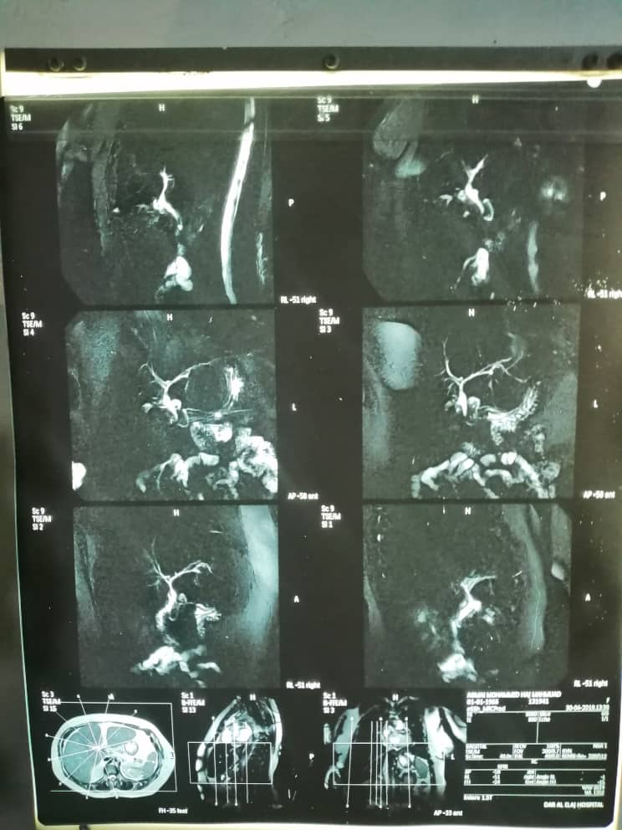
Figure 2 MRCP
.

DISCUSSION
The pathogenesis of agenesis of the gallbladder is known to be related to embryonic development. During the fifth week of intrauterine life, the gallbladder and cystic duct start to develop as a bud from the CBD. Agenesis of the gallbladder occurs because of failure of the bud to proliferate or canalize. In earlier studies of the literature, although the male/female ratio has been equal in postmortem studies, most clinical reports are of female patients [18]. Some reports suggest that gallbladder agenesis is familial [2–19]. Kobacker [20] reported agenesis of the gallbladder in two sisters. Investigation of that family revealed three more sisters with nonfunctioning oral cholecystograms. Sugrue et al. [18] reported ectopia and agenesis of the gallbladder in two sets of twins. These literatures suggested that occurrence of agenesis of the gallbladder might have a genetic connection. Most cases are sporadic (around 70%), and there is very little literature on any familial links [21]. The pathogenesis of this abnormality of embryological development is as of yet unknown. This is the first case of gall bladder agenesis combined with absences of extrahepatic biliary system.
Most cases remain asymptomatic and are discovered at autopsy; however, approximately 50% of these present with biliary colic mimicking a clinical picture of acute cholecystitis or choledocholithiasis [21,22]. During Gallbladder agenesis the mechanism of biliary colic is unknown, but greater part of authors consider that it is determined by dysfunction of sphincter oddi and biliary dyskinesia. The fact that pain is relieved after antispasmodic treatment strengthens this theory [9,10,11]. our case was present with feature not away from which was already mentioned in the literature, not just typical presentation but also the correct diagnosis is established intra-operatively. The rarity of these case reports shows that there is a lack of awareness of gallbladder agenesis when thinking of differential diagnoses. There has also been no conclusive gold standard investigation decided, upon which results are satisfactory enough to avoid surgery.
Generally Ultrasound is the first choice for reliable investigation of the gallbladder and hepatobiliary disease, this may come true for normal presentation of biliary system, but in cases of biliary anomalies, things are totally different.
MacDonald FR and his colleagues state that, Standard imaging modalities like ultrasound and nuclear studies cannot accurately diagnose this condition [23,24]; hence, patients are subjected to unnecessary surgical interventions [25]. With advances in imaging technology, a preoperative diagnosis of GA can be made when the gall bladder is not visualized by standard diagnostic tests, avoiding the need for surgery [26].
There exists one more debatable question: should the laparoscopic operation be converted into the open surgery if no gallbladder could be found during laparoscopy? According to the opinion of quite big amount of surgeons no conversion is needed, because laparoscopy allows performing a complete and high-quality visualization of the abdominal cavity [6], [10], [8],12,14,17]. In our case open surgery was performed due to patient wish, so were we lucky or not that we performed open surgery in this case, laparoscopy allows performing a complete and high-quality visualization of the abdominal cavity, this could be true for normal anatomy or rare presentations like gall bladder agenesis, but in our case we do not expect to find complete absences of extrahepatic biliary system with gall bladder agenesis and the duodenum was attached and open directly to the liver. At the beginning we think that this is small contracted gall bladder and because of inflammation the duodenum adherent to the gall bladder To make things clear we make use of tactile sensation (which lost in laparoscopy) by introduce small size nasogastric tube and directed toward the liver, surprise enough it was inside the liver. So this first case of gall bladder agenesis and complete absences of extrahepatic biliary system.
Some authors recommend intraoperative cholangiography to better identify the biliary anatomy, while others suggest a conservative approach and opt for post-operative imaging using ultra-sound or MRCP [8]. In our patient we did postoperatively MRCP and confirm the existing diagnosis.

Conclusion
This is first case report of gall bladder agenesis and absences of extrahepatic biliary system. With the increase numbers of biliary anomlies in the literature, and with the difficulties in diagnosing most of the biliary anomalies with ultrasound, we recommend preoperative MRCP as gold standard investigation for gall bladder diseases to unnecessary surgical interventions.

CONFLICT OF INTEREST STATEMENT
None declared.

REFERENCES
- Mohammed A.A., Arif S.H. Midline gallbladder makes a challenge for surgeons during laparoscopic cholecystectomy; case series of 6 patients. Ann. Med. Surg. 2019;40:14–17.
- . Bennion R. S., Thompson J. E., Jr., Tompkins R. K. Agenesis of the gallbladder without extrahepatic biliary atresia. Archives of Surgery. 1988;123(10):1257–1260. doi: 10.1001/archsurg.1988.01400340083014.
- Lee JH, Yu JS, Park MS, Yoon DS, Yang SW. MR cholangiography of accessory bile duct connected to the stomach. AJR Am J Roentgenol. 2007;189(6):W344–347. doi: 10.2214/AJR.05.1570.
- Teilum D. Double common bile duct. Case report and review. Endoscopy. 1986;18(4):159–161. doi: 10.1055/s-2007-1018360.
- Nakamura K1, Mitsubuchi H, Miyayama H, Yatsunami K, Ishimatsu J, Yamamoto T, Endo F. Complete absence of bile and pancreatic ducts in a newborn: a new entity of congenital anomaly in hepato-pancreatic development. J Hum Genet. 2003;48(7):380-4. Epub 2003 Jun 28.
- Chowbey P.K., Dey A., Khullar R., Sharma A., Soni V., Baijal M., Mittal T. Agenesis of gallbladder—our experience and review of literature. Indian J. Surg. 2009;71:188–192.
- Bennion R.S., JEJr Thompson, Tompkins R.K. Agenesis of gallbladder without extrahepatic biliary atresia. Arch. Surg. 1988;123:1257–1260.
- Scobie J.L., Bramhall S.R. Congenital agenesis of the gallbladder: UK case report. Oxf. Med. Case Rep. 2016;8 omw 040. [PMC free article
- Kasi P.M., Ramirez R., Rogal S.S., Littleton K., Fasanella K.E. Gallbladder agenesis. Case Rep. Gastroenterol. 2011;5:654–662.
- Rajkumar A., Piva A. Gall bladder agenesis: a rare embryonic cause of recurrent biliary colic. Am. J. Case Rep. 2017;18:334–338.
- Bani-Hani K.E. Agenesis of the gallbladder difficulties in management. J. Gastroenterol. Hepatol. 2005;20:671–675.
- Al-Hakkak S.M.M. Agenesis of gallbladder in laparoscopic cholecystectomy—a case report. Int. J. Surg. Case Rep. 2017;39:39–42.
- Joliat G.R., Shubert C.R., Farley D.R. Isolated congenital agenesis of the gallbladder and cystic duct: report of a case. J. Surg. Educ. 2013;70:117–120.
- Balakrishnan S., Singhal T., Grandy-Smith S., El-Hasani S. Agenesis of the gallbladder: lessons to learn. JSLS. 2006;10:517–519.
- Malde S. Gallbladder agenesis diagnosed intraoperatively: a case report. J. Med. Case Rep. 2010;4:285.
- Tang L.M., Wang X.F., Ren P.T., Xu G.G., Wang C.S. The diagnosis of gallbladder agenesis: two cases report. Int. J. Clin. Exp. Med. 2015;8:3010–3016.
- McCallum I., Jones M.J., Robinson S.J. Gallbladder agenesis. Ann. R. Coll. Surg. Engl. 2014;96:e28–9.
- Sugrue M., Gani J., Sarre R., Watts J. Ectopia and agenesis of the gall-bladder: a report of two sets of twins and review of the literature. Australian and New Zealand Journal of Surgery. 1991;61(11):816–818. doi: 10.1111/j.1445-2197.1991.tb00162.x.
- . Wilson J. E., Deitrick J. E. Agenesis of the gallbladder: case report and familial investigation. Surgery. 1986;99(1):106–109.
- . Kobacker J. L. Congenital absence of the gall bladder—a possible hereditary defect. Annals of Internal Medicine. 1950;33(4):1008–1012. doi: 10.7326/0003-4819-33-4-1008.
- Kasi PM, Ramirez R, Rogal SS, et al. Gallbladder agenesis. Case Rep Gastroenterol. 2011;5:654–62.
- Kabiri H, Domingo OH, Tzarnas CD. Agenesis of the gallbladder. Curr Surg. 2006;63:104–6.
- MacDonald FR, Cooperberg PL, Cohen MM. The WES triad: A specific sonographic sign of gallstones in the contracted gallbladder. Gastrointest Radiol. 1981;6:39–41.
- Dickinson CZ, Powers TA, Sandler MP, Partain CL. Congenital absence of the gall bladder: Another cause of false positive hepatobiliary image. J Nucl Med. 1984;25:70–72.
- Owen RP, Botros M, Uzair S. Two cases of gallbladder agenesis diagnosed at planned cholecystectomy – lessons learned. The Internet Journal of Surgery. 2011;26(1)
- Fiaschetti V, Calabrese G, Viarani S, et al. Gallbladder agenesis and cystic duct absence in an adult patient diagnosed by magnetic resonance cholangiography: Report of a case and review of the literature. Case Rep Med. 2009;2009:674768.

