Intracorporeal Classic Circular-Stapled Gastrojejunostomy and Jejunojejunostomy during Laparoscopic Distal Gastrectomy: A Simple, Safe “Intraluminal Poke Technique” for Anvil Placement

Jianjun Du, MD^{1, #, *}; Hongyuan Xue, MD^{1, #}; Jin Hua, MD¹; Lizhi Zhao, MD²; Ziqiang Zhang, MD^{1,3};

¹Department of General Surgery, Huashan Hospital, Fudan University, No. 12 Middle Urumqi Road, 200040, Shanghai, China
²Department of Digestive surgery, Hanzhong Central Hospital, No. 22 Kangfu Road, 723000, Hanzhong, Shaanxi, China
³Department of General Surgery, Huashan Hospital North, Fudan University, No.108 Luxiang Road, 201907, Shanghai, China

＃Jianjun Du and Hongyuan Xue have equally contributed to this work and should be considered as co-first authors.

Correspondence address:
*Jianjun Du, MD
Email address: dujjp@hotmail.com
Tel (Work) +86-021-66895072, Tel (Home) +86-021-52834065, Fax +86-21-66895845
Corresponding Address: Department of General Surgery, Huashan Hospital, Fudan University, No. 12 Middle Urumqi Road, 200040, Shanghai, China

Keywords: Laparoscopic distal gastrectomy, Roux-en-Y reconstruction, Circular-stapled anastomosis; Intracorporeal gastrojejunostomy, Intracorporeal jejunojejunostomy, Intraluminal poke technique

Abstract:
Background: Totally laparoscopic distal gastrectomy is being increasingly performed. However, an optimal procedure to achieve intracorporeal gastrojejunostomy and jejunojejunostomy for Roux‐en‐Y reconstruction after laparoscopic distal gastrectomy remains to be established. Compared with the simple and preferable circular-stapled Roux‐en‐Y reconstruction in open gastrectomy, application of intracorporeal circular-stapled gastrojejunostomy and jejunojejunostomy of Roux‐en‐Y reconstruction during laparoscopic distal gastrectomy have been limited (no report of intracorporeal circular-stapled jejunojejunostomy) because of the difficulties of intracorporeal purse‐string suture and anvil placement. To address these problems, a simple and safe intraluminal poke technique of universal surgical concept and procedure was introduced and evaluated.
Methods: Between March 2018 and August 2018, 24 consecutive patients with gastric cancer underwent totally laparoscopic distal gastrectomy in our hospital. Roux‐en‐Y reconstruction of intracorporeal circular‐stapled gastrojejunostomy and jejunojejunostomy with the intraluminal poke technique was performed in all patients. Demographic and clinicopathologic characteristics, perioperative details and postoperative outcomes were analyzed.
Results: The mean operative time was 203.6±26.2min, both proximal and distal tumor‐free margins were achieved in all patients. The time for anvil placement at stomach and intestine was 5.9±1.3min and 3.9±0.7min, respectively. Intracorporeal gastrojejunostomy and jejunojejunostomy were successively completed following anvil placement with no any anastomosis‐related sutures. There were 5 postoperative complications. Morbidities included pancreas fistula (n=1), stasis (n=2), atelectasis (n=1), pneumonia (n=1). These all patients recovered after conservative treatment. No postoperative anastomosis‐related complications, such as anastomotic bleeding and leakage, or stenosis occurred during the median follow‐up of 6.5 months.
Conclusion: The initial results suggest that the technique allowing easy and common anvil placement at stomach and intestine may be a simple, safe, preferable and timesaving procedure to accomplish intracorporeal circular‐stapled gastrojejunostomy and jejunojejunostomy of Roux‐en‐Y reconstruction in totally laparoscopic distal gastrectomy as open surgery.

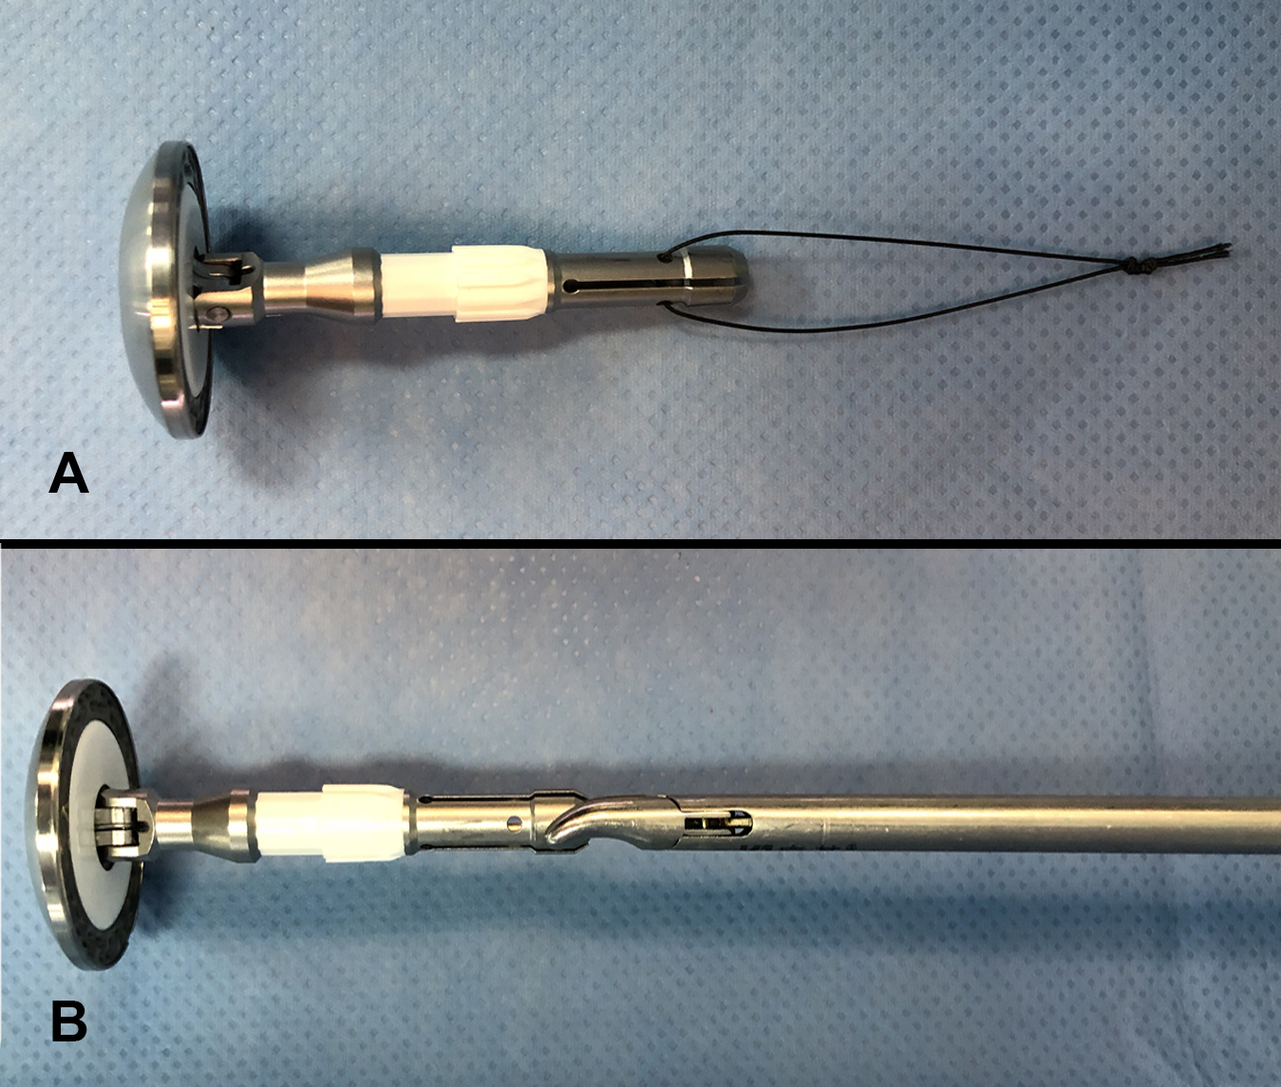Fig.1 A: The anvil secured with a suture loop at its central rod for laparoscopic anvil placement at stomach; B: The anvil held by the laparoscopic needle holder for laparoscopic anvil placement at jejunum.
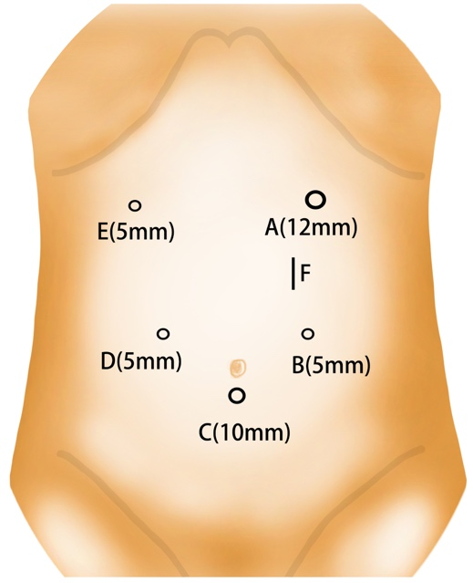
Fig.2 Trocar placement in TLDG. A, B, D, E Four ports for manipulation; C Camera port for laparoscopy; F Approximately 2.5 cm incision on the left middle clavicular line for putting into anvil, specimen extraction and circular stapler introduction.
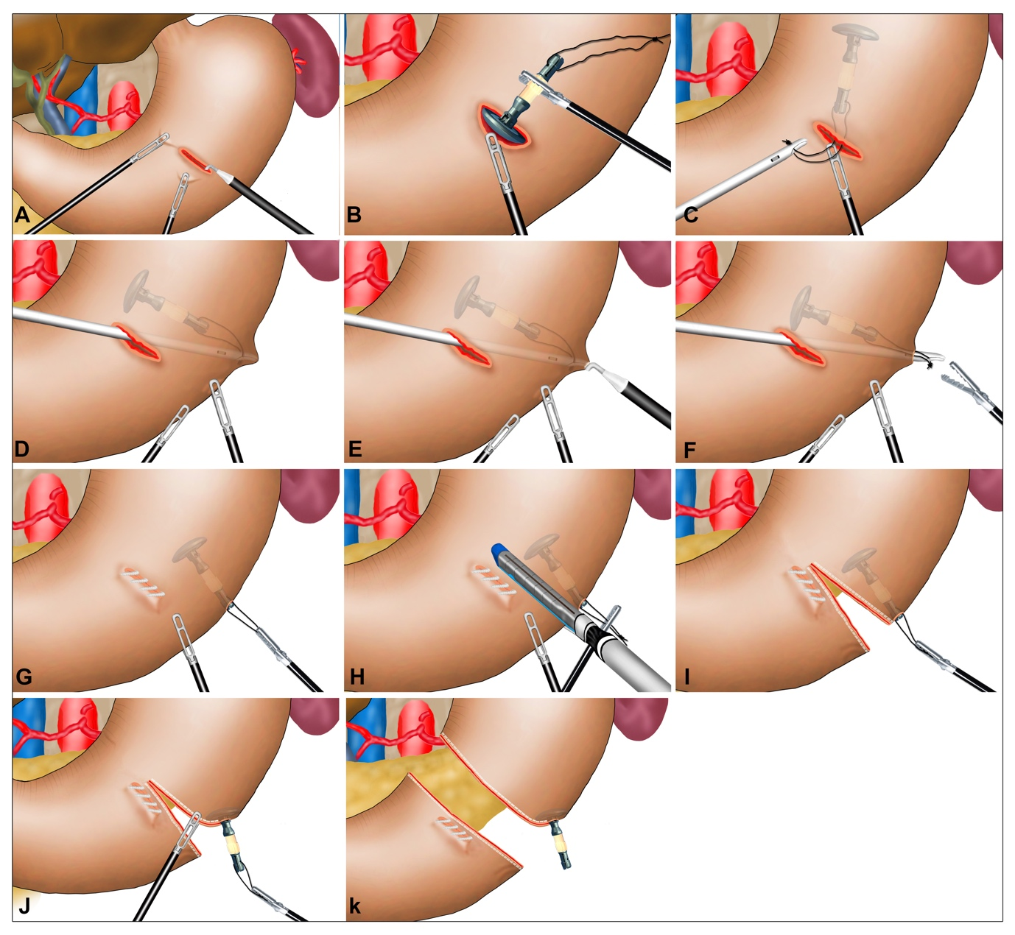Fig.3 Schematic outline of intraluminal poke technique for anvil placement at stomach. A An approximately 2.5 cm anterior gastrotomy distal to the planned transection line; B The anvil secured with a suture loop at its central rod is introduced inside the stomach; C The laparoscopic needle holder clips the suture loop within the bottom of its tip; D Carrying the clipped suture loop and anvil, the laparoscopic needle holder is advanced to the planned position of the greater curvature and pushed out by its head; E Electrocautery is accurately applied at the protruding gastric wall to generate a small opening; F Only the head of the laparoscopic needle holder is poked out; G Pull out and straighten the suture loop until the tip of the central rod approaches the cut gastric wall; H, I The first linear stapler is performed close to the root of the suture loop; J Completely pull out the central rod of the anvil after firing the first linear stapler; K Completed anvil placement and distal gastrectomy after the applications of the following 1~2 linear staplers.
Fig.4 Schematic outline of intraluminal poke technique for anvil placement at jejunum. A The jejunum is transected 25 cm distal to the Treitz ligament and the anvil held by the laparoscopic needle holder is inserted into the distal jejunal lumen; B The anvil is delivered to the planned position of 25~30 cm from the distal jejunum end; C An intestinal grasper holds the segmental intestine where there is the intraluminal central rod at the planed position and the laparoscopic needle holder is released; D The intestinal grasper is twisted to push up the anti-mesenteric border of the jejunal wall by the upper tip of the central rod, with assistance of another grasper on the proximal segmental intestine; E Electrocautery is applied at the protruding anti-mesenteric jejunal wall to generate a small opening; F The central rod of anvil is poked out through the opening of the jejunal wall; G The central rod of anvil is thoroughly pulled out; H The anvil placement at jejunum is completed.
Fig.5 Schematic outline of circular-stapled gastrojejunostomy and jejunojejunostomy. A The two anvils in position for anastomoses, which indicates the “anvil-first” anastomotic procedure; B The circular stapler is inserted into the distal jejunum limb and coupled with the anvil at the stomach for gastrojejunostomy; C The circular stapler is put into the proximal jejunum limb and coupled with the anvil along the jejunum for jejunojejunostomy after completing the gastrojejunostomy; D The completed intracorporeal classic circular-stapled Roux-en-Y anastomosis after distal gastrectomy using the “intraluminal poke technique”

Recent Publications:
- Ziqiang Zhang, Hongyuan Xue, Yuanqiang Dong, Jian Hu, Tao Jiang, Liubin Shi, Jianjun Du. Inhibition of GKN2 Attenuates Acute Gastric Lesions through the NLRP3 Inflammasome. Advances in Wound Care, 2019, Proof Completed. (Corresponding author)
- Jianjun Du, Hongyuan Xue, Lizhi Zhao, Jin Hua, Ziqiang Zhang. Intracorporeal Roux-en-Y anastomosis during Laparoscopic Distal Gastrectomy: A Safe, Simple “Intraluminal Poke Technique” for Anvil Placement. J Surg Oncol. 2019; 119:464-471.
- Yonggang Xu, Jin Hua, Jipeng Li, Liubin Shi, JianboShuang, Jianjun Du. Long-term outcomes of laparoscopic versus open gastrectomy for advanced gastric cancer: a large cohort study. Am J Surg. 2019 Apr;217(4):750-756. Epub 2018 Jul 19. (Corresponding author)
- Yonggang Xu, Jin Hua, Jipeng Li, Liubin Shi, Jie Yuan, Jianjun Du. Laparoscopic versus open gastrectomy for gastric cancer with serous invasion: long-term outcomes. J Surg Res 2017, 215: 190-195 (Corresponding author)
- Ziqiang Zhang, Jie Zhu, Yuanqiang Dong, Hongyuan Xue, Tao Jiang, Wenshuai Li, Diannan Xu, Liubin Shi, Jianghong Yu, Jun Zhang, Jianjun Du. Global transcriptome-wide analysis of the function of GDDR in acute gastric lesion. Molecular Medicine Reports, 2017, 2017;16:8673-8684 (Corresponding author)
- Zhanwei Zhao, Fei Wang, Cheng Fang, Gang Wang, Jianbo Shuang, Guanghui Chu, Sijun Hu, Lin Chen, Jianjun Du. A possible role of GDDR in the development of Helicobacter pylori-associated gastric cancer. Tumor Biol. 2016; 37:10303-10315. (Corresponding author)
- Fang C, Zhang Z, Liu C, Wang G, Wang F, Zhao Z, Li W, Hua J, Shuang J, Du J. Gastrointestinal Factor GDDR Attenuates Epithelial-Mesenchymal Transition in Gastric Cancer via Inhibiting AKT Signal. Dig Dis Sci 2016; 61:1941-1949. (Corresponding author)
- Wang Q, Du J, Yu P, Bai B, Zhao Z, Wang S, Zhu J, Feng Q, Gao Y, Zhao Q, Liu C. Hepatic steatosis depresses alpha-1-antitrypsin levels in human and rat acute pancreatitis. Sci Rep. 2015;5: 17833. (Co-first author)
- Du J, Shuang J, Li J, Li J, Hua J. Intracorporeal Circular-Stapled Esophagojejunostmy after Laparoscopic Total Gastrectomy: A Novel Self-Pulling and Holding Purse-String Suture Technique. J Am Coll Surg. 2014; 218: 67-72.
- Cheng Fang , Jin Hua , Jipeng Li , Jianyong Zhen , Fei Wang , Qingchuan Zhao, Jianbo Shuang, Jianjun Du. Comparison of long-term results between laparoscopy-assisted gastrectomy and open gastrectomy with D2 lymphadenectomy for advanced gastric cancer. Am J Surg 2014; 208:391-396. (Corresponding author)
- Du J, Shuang J, Li J,Zhao Q,Hong L,Du X,Wen J,Hua J. Totally Laparoscopic Billroth II Gastrectomy with a Novel, Safe, Simple, and Time-Saving Anastomosis by Only Stapling Devices. J Gastrointest Surg. 2012; 16:738-743.
- Chu G, Qi S, Yang G, Dou K, Lu Z, Du J. Gastrointestinal tract specific gene GDDR inhibits the progression of gastric cancer in a TFF1 dependent manner. Molecular and Cellular Biochemistry. 2012; 359:369-74. (Corresponding author)
- Shuang J, Qi S, Zheng J, Zhao Q, Li J, Kang Z, Hua J, Du J. A case-control study of laparoscopy-assisted and open distal gastrectomy for advanced gastric cancer. J Gastrointest Surg. 2011; 15:57-62. (Corresponding author)
Comments:
Prof. Jianjun Du is invited as a speaker of world-gastroenterology-2019 Osaka Japan.

